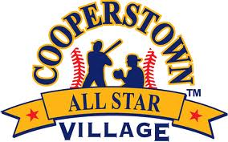
Cooperstown All-Star Village
Home Run Derby odd
All teams on Field 29
Date
Week 5
# | Team | Player Name | Outs | HR
1 | I-5 Baseball | Mathew Perez | 5 | 0
3 | Scorpions Team Easton | Julian Curry | 5 | 0
5 | Kingsway Knights | Christian Fanelli | 5 | 3
7 | So Cal Swat/Birds | Gavin Lorge | 5 | 4
9 | Boulder County Baseball | Stryker Leick | 5 | 0
11 | River City Baseball | Aidan Leonard | 5 | 0
13 | Orange Crush | Jackson Rodriguez | 5 | 0
15 | Prospects Wofford | Christian Ferrier | 5 | 1
17 | Passaic Valley Jr Hornets | Frankie Juliano | 5 | 0
19 | Santa Clarita Heat | Carter Lawson | 5 | 0
21 | Carlsbad Clash | Finn Burke | 5 | 1
23 | South County Mavericks | Colson Estre | 5 | 7
25 | Colorado Cobras | Johnny Konarowsky | 5 | 2
27 | Redland Rebels | Ethan Estrada | 5 | 1
29 | Bonnie-Robins | Jonathan Feliciano | 5 | 5
31 | Outlaws-Apopka Travel Ball | Nico Posluszny | 5 | 17
33 | Santa Cruz Mavericks | Bryce McDonald | 5 | 0
35 | Elite | Henry Alden | 5 | 1
37 | Cherry Creek Bruins | Eli Gompers | 5 | 1
39 | Orinda Renegades | Tres Buster | 5 | 0
41 | Timbergrove Thunder | Khris Fuentes | 5 | 2
43 | Ostingers Black | Max Stockton | 5 | 1

