Intercongregational Men’s Club Softball Fall Season 2016
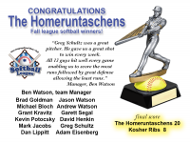[Delete Image
Congratulations to our 2016 Fall Season Team
Homeruntaschens

