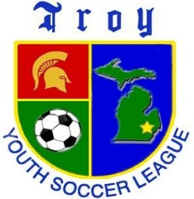
Troy Youth Soccer League
Pre-K Program

The purpose of our Pre-K program is to have fun while promoting socialization and learning to be part of a team. Participants will learn basic soccer skills and how to play the game. TYSL provides a structured no-pressure introduction to soccer.

When: Spring and Fall seasons
Time: Saturday Mornings
Location: Jaycee Park
Duration: Six sessions each season.
Spring Season April- June
Fall Season September- October
Cost: $150 which includes a T-shirt & TYSL bag for first-time participants and an end-of-season medal & treat for all participants.
Equipment Required: Shin Guards, Athletic Shoes or Cleats & a Size 3 Soccer Ball.
Parent volunteers (Wranglers) help direct each team of six players. You can volunteer to Wrangle during registration.

Please Register On-line: ww.tysl.info
Questions: Please call 248-524-0170
Email: tysl@tysl.info
Website: www.tysl.info
Hours: Tuesdays & Thursdays 3 a.m. -7 p.m. Saturdays 9 a.m.-12 p.m.

TYSL has been an All-Volunteer Troy Community Organization since 1974.

