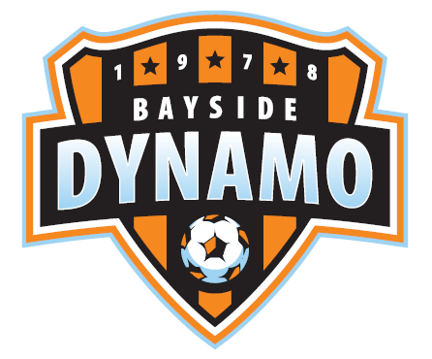
BAYSIDE FC
Medical Waiver and Photography Release

I recognize the possibility of physical injury associated with soccer, and hereby release, discharge, and otherwise indemnify Bayside FC Soccer, and their sponsors, and its affiliated organizations, and the employees and associated personnel of these organizations, against any claim by or on behalf of the soccer player named below as a result of that player’s participation in soccer programs and/or being transported to or from the same, which transportation I hereby authorize. Bayside FC Soccer Club welcomes and appreciates photo contributions from the game fields to help illustrate in print and Web based publications. I give permission and consent for player listed below to allow photographs/video to be taken during Bayside FC Soccer Club’s Playdate games or camp activities. I further give permission and consent that any such photographs may be published and used by Bayside FC Soccer Club and its agents, to illustrate and promote the Bayside FC Soccer Club.

Players Name Parents Signature Date

--------------------------------------- ----------------------------------------------------- ---------------

