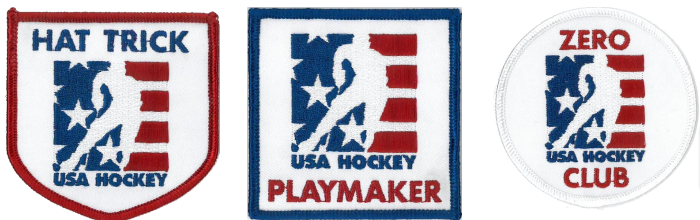
The association will submit the form below to receive one of the following awards, one time per season:
- Hat Trick Award (3 Goals in 1 Game) - 1 Per Season
- Playmaker Award (3 Assists in 1 Game) - 1 Per Season
- Zero Award (Shutout, no goals allowed by a goalie in a game) - 1 Per Season

