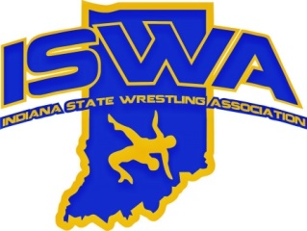
INDIANA STATE WRESTLING ASSOCIATION, INC.

P.O. Box 157, Beech Grove, IN. 46197 Phone 317-780-1885

2024-25 Logistics Director Report
There were many events that required either lodging and/or transportation. Hotels were booked to be as convenient as possible for the Teams and provide the best value. There were no issues with any of the hotels and most went above and beyond to help accommodate our Teams. Bussing was provided by Miller Transportation, who do an excellent job communicating and providing services wherever we need them. Flights to Utah were booked through Delta. Delta Group Booking was very easy to work with and was very helpful when making any ticketing adjustments. This year, we obtained corporate accounts with Enterprise Rent-A-Car and Budget Car Rentals. This helps streamline the billing process and well as provide discounted rentals for trips. These accounts were extremely helpful for the Boy 16u trip in Utah and Fargo.
- 2025 ISWA Folkstyle State Championship Nexus Park, Indianapolis ** New Venue
- 2025 Heartland Duals Mid American Center, Council Bluffs IA
- 2025 ISWA Freestyle / Greco State Championship Avon HS, Avon, IN
- 2025 14U National Duals – Boys Greater Philadelphia Expo Center, Oaks PA
- 2025 16U National Duals – Boys Zions Bank Real Academy, Herriman, UT
- 2025 Jr National Duals – Boys Baird Center North, Milwaukee, WI ** New Venue
- 2025 14U, 16U and Jr Women’s National Duals Grand Park Events Center, Westfield, IN
- 2025 USAW Kids Freestyle & Greco Roman Nationals Alliant Energy PowerHouse, Cedar Rapids, IA ** New Venue
- 2025 Junior and 16U Nationals Championships – Boys and Girls Tournaments Fargo, ND
Many of the events were held at the same location as 2024 which helped with the trip planning. Heartland Rooms have already been reserved, in our preferred hotel for 2026. As soon as the event dates for 2026 are released, hotels and bussing / car rentals will be reserved .
SiteSearch was utilized again this year for setting up room blocks for Team and Parents. We will continue to utilize them for events in 2026. Site Search was very helpful in finding a hotel for Women’s Nationals to accommodate the large group.
ISWA will be hosting the Women’s Nationals again in 2026. Early planning is the key to this event since there is a potential that (4) Indiana Team and the associated coaches will need housing in the same hotel.
Respectively submitted,
Melissa Strayer

