Dear Local Business Owner:
Parkway Little League is a 501(c)3 non-profit organization. For 70 years, Parkway has offered a safe place for St. Paul area kids to learn the game of baseball, good sportsmanship, and interaction with others in a positive environment.

Our program is expecting over 200 players, ages 4-12 for the upcoming season, with our reach extending to St. Paul, Woodbury, Oakdale, Cottage Grove, Hudson, Fridley, Shoreview, North St. Paul and everywhere in-between. Our teams attend tournaments across the state, and we host over 30 teams during our yearly tournaments. Parkway will have hundreds of families pass through its gates in 2024 coming to watch their child play ball between the months of April to October.

Advertising in a family-friendly environment is a good fit for all businesses. Please help us enhance your business’ visibility, reputation and community support as well as helping kids get outside and play ball. We are offering three different packages for sponsors to get involved this year:

Gold Level
- Division Sponsorship: $1500 (likely sold out for 2024 season)
A Division Sponsor will have their name and logo on all the team’s jerseys at one of our four levels of baseball (Tee-Ball, Machine Pitch, International League and American League). They will also have a 8' x 4' sign displayed prominently on our centrally located batting cages as well as a 8’ x 4’ sign on one of our 4 field’s outfield fences.

- Program Sponsorship: $1500
A Program Sponsor will have 8’ x 4’ signs on all of our four field’s outfield fences and will also have a 8' x 4' sign displayed prominently on our centrally located batting cages for a total of five signs. This package offers maximum sign visibility for your business throughout the entire park.

Silver Level
Field Sponsorship: $300
A Field Sponsor will have an 8' x 4' sign on one of our four field’s outfield fences. This package offers visibility for your business on one field. Multiple Field Sponsorships may be purchased for additional fields.

With Parkway being a non-profit organization, sponsors are a huge part of our revenue to keep the program affordable to the families of our players. At no additional cost, we will add your businesses information to our website as well as highlight your business on our Facebook page as one of our sponsoring businesses for 1 week as a showcase. We also offer all our families printed lists of all sponsoring businesses to further encourage them to visit and purchase from you.

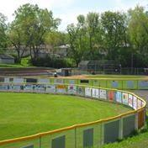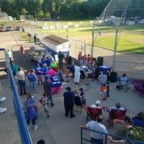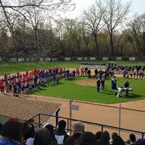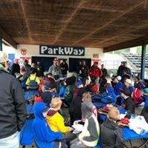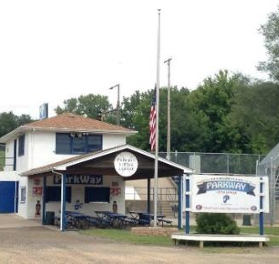

If you are interested in sponsorship at any level or would like to discuss a donation, please contact either our Sign Sales Manager, Ken Sabota at parkwayprez@comcast.net or our President, Candice Schintz at President@parkwaybaseball.com

Thank you for supporting Parkway Little League youth baseball!

