
Grafton High School
Home of the Black Hawks

Scott Mantei, Principal
Kevin Moore, Associate Principal / Athletic Director
Mike Kalina, Associate Principal

GENERAL REMINDERS FOR THE 2021 NSC JV CONFERENCE TRACK AND FIELD MEET AT GRAFTON HIGH SCHOOL

GIRLS’ MEET: MAY 18th
BOYS’ MEET: MAY 19th

STARTING TIME: The stadium will open at 3:15. Field events will begin at 4:00, and running at 4:30.

ADMISSION: There will be no admission fee this year. We ask that fans park in the west parking lot at GHS (see photo).

CONCESSIONS: Pre-packaged concessions will be available throughout the event. Concession stand is located adjacent to the track, near the restrooms.

SAFETY PROCEDURES: Fans are respectfully asked to distance as well as possible throughout the day. Seats in both home and away bleachers have been pre-marked. Please have a facial covering if being socially distant is not possible.

Thank you!

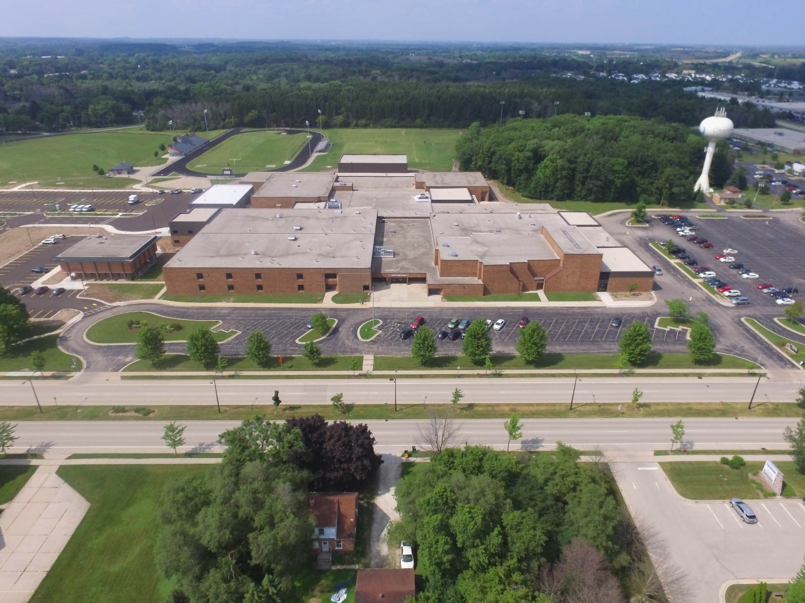

Home and Visitor Parking

Figure 1

