BLOCK 1 | 5 min / 5 min | Warm-Up  - Running Drill  - Groups of 3 (4x3?)  - Take 3 steps-takes a look then continue to through the base turn and watch then shuffle back.
BLOCK 2 | 5 min / 10 min | Practice Kick-Off  - Take a Knee  - Safety – Attitude/Effort = Fun/Try your Best  - See It, Do it, Practice it  - Ask questions/make mistakes (what to do if you make a mistake)  Practice Schedule
BLOCK 3 | 10 min / 20 min | Batting Mechanics  - Hit Stick Introductions (26” ¾” PVC Pipe)  - 4-S’s: Stance/Stride/Pivot(squish)/Swing
BLOCK 4 | 20 min / 40 min | Hitting Drills  - Coach Pitch – Real balls – groups of 4
BLOCK 5 | 10 min / 50 min | Fielding Drill –  - Fielding Position – creeper steps, butt-down/hands out (show your glove the ball), alligator, funnel, step throw  - Throw to a coach
BLOCK 6 | 10 min / 60 min | Wrap-Up  - Relay Race  - Practice Review  - Pictures:  - Sat 5/4: 930A (Be there at 915) – Wayzata Chev – Uniform only (no cleats, bats, gloves)  - Game Details:  - Sun 2:30P @ KL Elementary  - Show up at 2:15 – warm-up  - Jersey Handout

Demo Videos:
- Throwing: https://youtu.be/J4Ti-3oVLZI
- Fielding: https://youtu.be/KOHyJnxUz_k
Homework
- Grip – 4 seam Grip (2 or 3 fingers ok)
  - Find the “C” on the ball, place two (or three) fingers across “C” (C can face left or right).
  - Just practice picking up a ball, finding the C and placing fingers across and thumb underneath touching lace on bottom.
  - See Pic below:
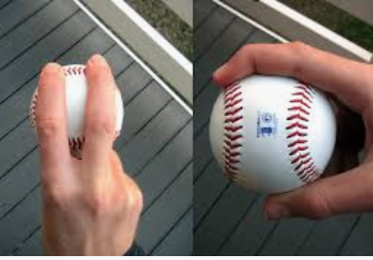
- Hitting 4”s – Stance (Shoulder width apart, bath on shoulder, elbows relaxed), Stride (Small step towards pitcher), Squash the bug (Turn back foot like your stepping/squashing a bug), Swing (Full hard swing)
- Fielding – NO glove, just roll ball to player. Don’t worry about form yet, just have fun.

