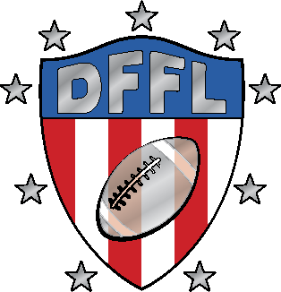
Parent’s Code of Ethics Pledge

I hereby pledge to provide positive support, care and encouragement for my child participating in the Dothan Flag Football League by following this Parent’s Code of Ethics Pledge:

• I will encourage great sportsmanship by demonstrating positive support for all players, coaches, and
officials at every game, practice or other youth events.
• I will place the emotional and physical well being of my child ahead of any personal desire to win.
• I will insist that my child play in a safe and healthy environment.
• I will provide support for coaches and officials working with my child to provide a positive, enjoyable
experience for all.
• I will remember that the game is for children and not for adults.
• I will do my very best to make youth sports fun for my child.
• I will ask my child to treat other players, coaches, fans and officials with respect regardless of race, sex,
creed, or ability.
• I will not yell at or degrade my child or the other teams’ players, coaches, fans or officials.
• I will support my coaching staff by attending all games and practices, and by picking up my child up on
time at all events.

_______________________________ ________________________
Parent/Guardian Signature Date

_______________________________ ________________________
Parent/Guardian Signature Date

Player’s Code of Ethics
I hereby pledge to provide positive support, care, and encouragement for my teammates and other
players participating in the Dothan Flag Football League:
• I will encourage great sportsmanship by demonstrating positive support for all players, coaches, and
officials at every game, practice or other youth events.
• I will not yell at or degrade my team or the other team’s players, coaches, fans or officials.
• I will place sportsmanship ahead of my personal desire to win.
• I will insist that I play in a safe and healthy environment.
• I will support my coaching staff by trying to attend all games and practices.
• I will remember the game is for me and my teammates, and not my coach, parents or other adults.
• I deserve to have fun during my sports experience, and I will alert parents or coaches if it stops being
Fun!

_______________________________ ________________________
Player’s Name (Please Print) Date

