How to Navigate DIBS
- Log into www.wayha.com. From this home page, click on the DIBS tab.
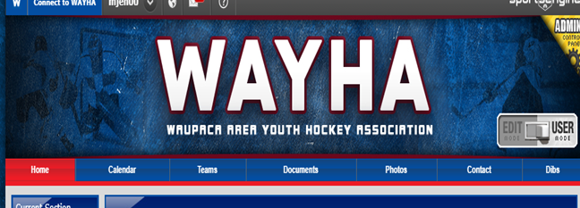
- Once in the DIBS tab you will see a few things. If you have signed up and claimed DIBS you will see an active DIB session. When you claim a DIB try and use the same child each time. This will tell you how many DIBS you have completed and how many more you need.
- To see available DIBS click on the 2020-2021 season link.
- Once in the 2020-2021 season you will need to change the date if you know what the date you are looking for is. Then click filter Dib items.
- After you click Filter Dib Items you will see a list of available DIBS. Each DIB will list how many credits it is worth, if it is claimed and by who, and the date and time.
- Click on which DIB you would like to claim.
- You will be brought into a screen with more details about this DIB. If you want to claim this you will click Claim this DIB item.
- A box will come up with information that is needed before you can claim the DIB. You will enter the athlete(try and pick the same child each time if you have multiple) the person’s name that is going to fulfill the DIB, the phone number and email address. You will be sent an email reminder about the DIB event. You will typically have 2 days in which you are able to cancel the event if you can no longer accomplish it. You will also again see the detailed information about the event you are claiming.

- Once you claim the DIB your name will be on the DIB schedule with a claimed status. You will also receive email conformation.

DIB Completion

- Once you have fulfilled your task you need to complete the item in the DIB program. To do this you need to go into DIBS and into the 2020-2021 season. You will need to change the date to the date you signed up for and fulfilled the DIB. You will need to find your name and click the item you completed.

- After you click on your item you will need to click verify completion.
- After you click verify completion there will be a box that pops up. Click request completion verification.
- You will be redirected to sports engine DIBS screen. This page has your information. You will see each DIB item that you have claimed and how many you have completed. You will also it will have a status of completed, completion, or claimed.
Claimed: You are signed up for this DIB and have not completed this yet. Either you have not finished the task or have not completed it out in DIBS.

Completion: You have completed your task and have gone back into DIBS and verified the completion. You are now waiting for an administrator to verify and complete your task.

Completed: You have completed the task, you have verified completion in DIBS and an administrator has verified and completed your task for credit.

