The 2025 Porter Parent Football Association (PPFA) Newsletter – Week5
The LTHS Porter Parent Football Association (PPFA) is a volunteer group dedicated to enhancing the football experience for players. Our goal is to foster a positive, memorable environment for each player, achieved through support for both the players and coaches. The PPFA funds its efforts through various fundraising initiatives, including spirit wear, player sponsorships, and volunteering.
- Twitter @LockportFootba1 - Facebook @ LTHSFootballBoosters  - Lockportfootball.com
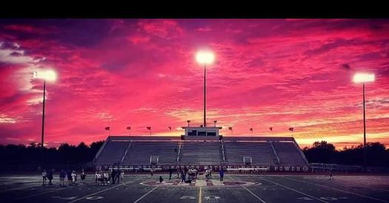Every Week
Varsity Players Pasta Dinner – Every Thursday @ Cooms Corner
Week5 Pasta Dinner: 9/25 @ 4:30pm **Parent Volunteer and/or Dessert Donation**
** Ask-a-Porter ** - 10Q with Owen Wilczak
Game Schedule/Results
Varsity: Porters @ Naperville North: Fri 9/26 @ 7:00pm Game Preview
Porters lose to Lincoln-Way East on 9/19 (14-49) Game Recap
Sophomore: Porters @ Naperville North: Fri 9/26 @ 4:30pm Porters lose to Lincoln-Way East on 9/20 (0-41)
Freshman A: Porters @ Naperville North: Sat 9/27 @ 9:00am Porters A lose to Lincoln-Way East on 9/20 (13-27)
Freshman B: Porters @ Naperville North: Sat 9/27 @ 11:00am Porters B unknown to Lincoln-Way East on 9/20 (x-x) ?
News and Notes
Check PPFA social media accounts to volunteer for the “All Program Pasta Dinner” on 10/2 @ LTHS Cafeteria.
PPFA Board Meeting: 10/21 (Tuesday) @ 7:00pm – LTHS (Porter Room)
Save-the-Date: 10/2 - All Program Pasta Dinner 10/31 - State Playoffs (first round)
**Lost and Found** Missing a PPFA 2025 Newsletter? Click HERE

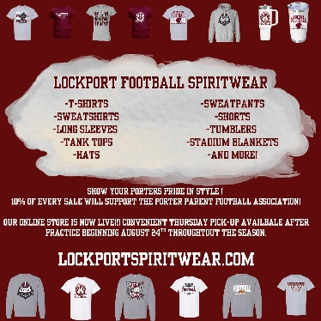
Order your 2025 Lockport Football Spirit wear HERE
Helpful Links
Spirit Wear Game Digital Tickets IHSA Football Info 8to18

