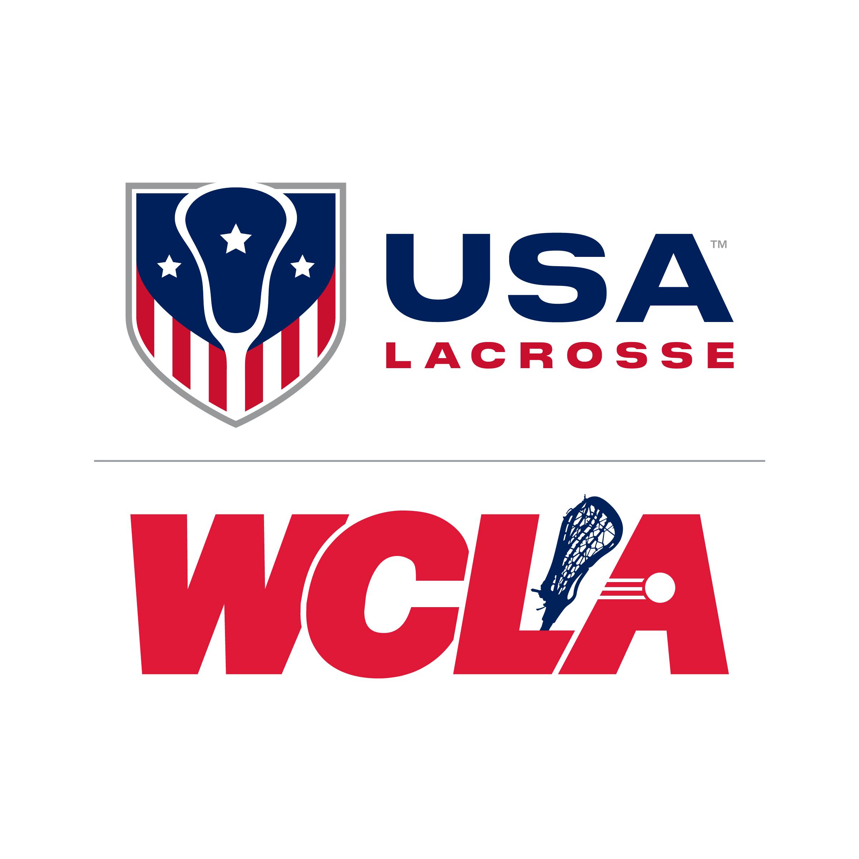USA Lacrosse – Women’s Collegiate Lacrosse Associates (WCLA)

Student Athlete Eligibility Verification Form – For Spring 2024 Season

DUE: PRIOR TO FIRST GAME OR MARCH 1ST whichever is earliest.

Directions: The Head Coach or President of each USAL WCLA team shall complete the entire form, obtain each student-athlete’s signature, and submit the form for the verification, signature, and seal of the Office of the Registrar for their Institution. All players in a program who meet USAL WCLA Student-Athlete eligibility requirements should be included on this roster regardless of intra squad division into A, B and/or C teams for local play purposes.

Student Athletes: By signing this form you are authorizing the release of your Educational Records to the USL WCLA, its member conferences and officers for use by said persons and organizations for the express purpose of verifying your eligibility and academic standing now and AT ANY TIME DURING THE USAL WCLA SEASON OR PLAYOFFS.

No student athlete who fails to appear on an Eligibility Verification Form or fails certification by the school registrar shall be allowed to participate in a USAL WCLA contest. FORM MUST BE COMPLETED ENTIRELY. Form must be TYPED. Team President and Head Coach MUST review the WCLA Operating Procedures & Bylaws in advance of the regular season to ensure compliance with the WCLA Eligibility Rules.

Form MUST be certified for the semester/quarter that begins regular season (Winter or Spring).

SCHOOL NAME: ________________________________________ League: [AWLL, CPWLL, MWLL, NWLL, NWWLL, RMWLL, SWLL, TWLL, WWLL]
Information MUST BE typed and players should be listed in alphabetical order.
Strike through any unused cells before turning in to Registrar for verification.

Official Team Roster
Last Name | First Name | Middle Initial | Student I.D. Number | # of Years College Lacrosse Previously Played (0-3) | Academic Year  (Fr / So / Jr / Sr / Grad) | Receiving  Lacrosse  Scholarship?  (Yes or No) | Signature of Each  Student - Athlete
XXXXXXXXXXXXX | XXXXXXXXXXXXXX | XXXXXXXXX (Strike through unused lines) XXXXXXXXXX |  |  |  | XXXXXXXX | XXXXXXXXXXXXXXXX
Form continued on page 2 Use additional forms if necessary (all must be completed entirely, including certification).
Last Name | First Name | Middle Initial | Student I.D. Number | # of Years College Lacrosse Previously Played (0-3) | Academic Year  (Fr / So / Jr / Sr / Grad) | Receiving  Lacrosse  Scholarship?  (Yes or No) | Signature of Each  Student - Athlete
XXXXXXXXXXXXX | XXXXXXXXXXXXXX | XXXXXXXXX (Strike through unused lines) XXXXXXXXXX |  |  |  | XXXXXXXX | XXXXXXXXXXXXXXXX

Player Exception Declaration
Player Exception Declaration – Players must be enrolled as an undergraduate or graduate student at the college, university, or similar institution with which her team is affiliated. Each player must be a full-time student at her university and be in good standing as defined by each institution. An exception is allowed for a player in her final term prior to graduation so that a player with eligibility remaining may participate in organized practice sessions and play with her team while enrolled in less than a minimum full-time program of studies, provided the student is: (i) Enrolled in the term and (ii) She is taking the credits necessary for graduation. For players listed on the OFFICIAL TEAM ROSTER who meet this exception criteria, please declare them in the fields listed below.

Player Name/#: ____________________________ /___ Year: __________ Anticipated Graduation Date: _________________

Player Name/#: ___________________________ /____ Year: __________ Anticipated Graduation Date: _________________

Player Name/#: ___________________________ /____ Year: __________ Anticipated Graduation Date: _________________

Player Name/#: ___________________________ /____ Year: __________ Anticipated Graduation Date: _________________

Head Coach / Player Representative Signature
- NOTE: Playing an ineligible player, or a player not listed on this Verification Form, in any WCLA contest may result in a forfeit.
- Players NOT listed on the above roster as of March 1 are NOT eligible for the WCLA National Tournament.
- You are encouraged to email the WCLA Eligibility Chair with your questions about a player’s eligibility. Appeals for hardship or special circumstances must be sent to the WCLA Eligibility Chair prior to first competition or prior to March 1 (earliest date) for review by the WCLA Leadership.
- Please read the mailing deadline and hardship information on page 4 of this form prior to signing.

Head Coach / Player Representative Certification: I certify that I have examined the current USAL WCLA rules of player eligibility within the WCLA Operating Procedures, and all listed players listed above are eligible. I understand that failure to comply with these eligibility rules may result in game forfeits.

Signature: _____________________________________ Date: ________________

Registrar’s Office Instructions
- Please certify this form with the official stamp/seal of Registrar in the box below (if no stamp/seal exists, include acknowledgement on official letterhead of Registrar’s Office).
- Please do not certify this document if there are rows on this form that are not filled or struck-through.
- For players not meeting the definition of a fulltime student according your university’s definition of full time, please indicate this by crossing the name of the player out and making a notation in the margin next to their name.

Registration Certification: I verify that the above Student-Athletes listed are current Full-Time students according to the Records of the Office of the Registrar of this Institution.

*Signature: _____________________________________________ *Date: ____________________________

*Name (Printed): __________________________________________ *Title: ____________________________

Phone: _______________________________ Ext: _______________ *Email: ___________________________

*Academic quarter/ semester for which this certification applies (circle one): WINTER 2023 SPRING 2024

*Dates for the academic quarter/semester above: Begin Date: ________________ End Date: ________________

*Required fields

Please place official Registrar seal or stamp within this box.
(if no stamp/seal exists, include acknowledgement on official letterhead of Registrar’s Office).



MAILING AND DEADLINE INFORMATION

Each team is responsible for getting the original form to their League Leadership in enough time so that their league can meet the final March 1 deadline. A designated league representative will collect eligibility forms from all their members and mail the forms in one package to USA Lacrosse. If you are unable to work with your league leadership to coordinate delivery to USA Lacrosse of your team’s form, you as a team are still required to send your form directly to USA Lacrosse by March 1 or prior to your first game.

Email a scanned copy to wcla@usalacrosse.com and copy your league (be sure to shade any raised school seals using crayon).

League: _____________ League Contact: _______________________________

League Address: ___________________________________________________

City:_______________________, State: _______ Zip: _____________________

League Email: _____________________________________________________

HARDSHIP REQUEST INFORMATION

The WCLA Eligibility Chair and your League President must receive requests for Hardship Waivers no later than February 15 to ensure eligibility for nationals. Athletes in question should not participate in any official WCLA games until approval is received. Game participation prior to approval could result in forfeits. The Eligibility Chair will require proof and possibly documentation for the waiver to be considered. Please see the Committee Page (About WCLA) on the WCLA Website for the WCLA Eligibility Chair’s contact information.

PLEASE MAKE A COPY OF THIS ENTIRE FORM, COMPLETE WITH REGISTRAR SIGNATURE, FOR YOUR TEAM’S RECORDS

