SAC - MT
Meeting Minutes
10.14.2025

Call to Order: Josh Burnham (SACC) called to order the regular meeting of the SAC-MT at 11:35 a.m. via Google Meet. Present members: Josh Burnham, Denis Berry, and Sharon Mozer.

Announcements:
- Financials - N/A

Old Business:
Montana State Championships - March 20-22, 2026
- After the venue fell through with Billings Gymnastics School. The state re-opened the bid for a new host and venue. One bid was reviewed from Helena Athletic Club (HAC).
Motion to have the Helena Athletic Club (HAC) host the 2026 Montana State Championships on March 20-22, 2026. The location is in Butte, Montana at the Butte Civic Center.
Motion: Sharon Mozer
Second: Denis Berry
PASSED

New Business:
1. The board will resume meeting once a month. Currently the second Thursday of the month at 9:00 a.m is scheduled.

2. State Camps went well. The camps covered Levels 3 through 10, and Xcel Silver through Sapphire. Level 2 and Bronze did not participate.

3. Qualifying Scores for 2026 season
Motion to keep all state qualifying scores the same but allow seniors in any Dev levels and Xcel divisions to compete in the Montana State Championships regardless of scores.
Motion: Denis Berry
Second: Sharon Mozer
PASSED
*NOTE: Seniors producing a qualifying Regional score at the State Meet, may advance to the Regional Championships.
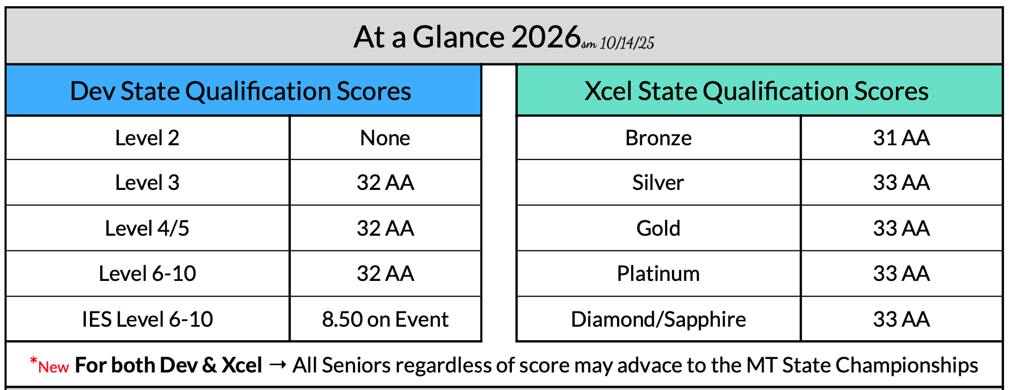

4. For athletes Levels 6/7/8, an event specialist must be declared by the Drop Back Date or Declaration Date. They may compete as an Individual Event Specialist (IES) at Regionals if they receive a 9.0 on the event(s) at the state meet.

5. Drop Back Date/Declaration Date
Motion to move the drop back date to the third Monday in February.
Motion: Sharon Mozer
Second: Denis Berry
PASSED

6. New committee member and end of term for current members - Sharon will review the timeline for current appointed members.

7. Josh is asking committee members to be familiar with the entry and mobility between Dev and Xcel, primarily Xcel Gold to Dev Level 6/7 (R&P→Chapter 9, Development Program, page 64).

Adjournment: Motion to adjourn at 12:23 p.m.
Motion: Sharon Mozer
Second: Denis Berry
PASSED
Next Meeting: November 13 at 9:00 a.m. via Google Meet
Minutes submitted by Sharon Mozer

