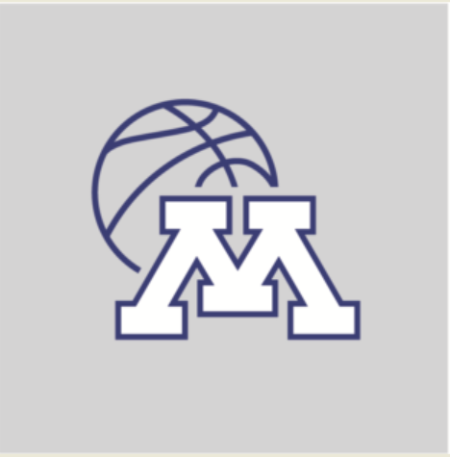

Minnetonka Girls Basketball Association
Website: www.tonkabuckets.org

MGBA Board Minutes
March 10th, 2022
Minnetonka Girls Basketball Association meeting minutes
7:00 Call to Order (MHS Writing Center)
Approval of February Minutes
Treasurer’s Report - Brian Ross
- Paid $5,700 in Minnetonka facilities for the Snow Globe Classic tournament.
- General liability insurance increased to additional $697 for abuse and molestation coverage. The insurance may be going up, but it’s covering more.
- Discussed the need to assure that future Spring gym spaces are being notified to MGBA so we know who is still under insurance contract.
- Taxes will be coming. May 31, 2022 is the end of our fiscal season.
High School Update - Kim Hoehne
- High school girls basketball head coach position was posted this week.
- MGBA has encouraged families to put feedback and comments in the survey put out by the Athletic Director. MGBA has no input with the hiring of the new coach.
- Discussed ways to liaison between high school and youth programs.
- High school summer camp dates, at this time, are still tentatively scheduled.
General Season Overview - Kim Hoehne
- Overall, it appeared the teams had a competitive and positive season.
End of Season Survey Results - Katie/Kim
- 65 people responded to the end of season survey. Reviewed data and discussed follow-up questions based on results.
Spring Team/Practices Update - Chris Hamdorf
- Two teams have requested gym space for Spring time under the contract of MGBA.
Player Development Discussion - Kim Hoehne
- Discussed opportunities for player development: Her Next Play, Shooter’s Challenge, Trainers
- Chris Fitch brought forward ideas for off season player development. Discussed ways to communicate off-season opportunities to players/families . Discussed organizing a committee for player development.
Marketing/Recruitment - Kim Hoehne/Chris F
- Kim encouraged the board to think about ways to market participation in girls basketball.
DEI Discussion/Next Steps- Brian/Kim/Katie
- Diversity/Equity/Inclusion ideas were brought forward to address with players, parents and coaches.
MGBA Appreciation Night - Katie Martin
- April 7th is appreciation night set for coaches, team managers and committee members.
Adjourned
Due to MGBA Appreciation Night, April 7th, our next Board meeting will be on Thursday, May 12th at the High School in the Writing Center

