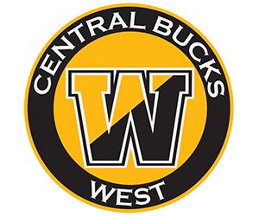

On behalf of the Central Bucks West Football Parents Club Inc, a 501 (c) nonprofit organization, and the entire 2026-2027 Central Bucks West Football Team, we would like to ask you for your sponsorship for one of our biggest fundraisers of the year, Designer Bag Bingo. Should you choose to sponsor us, we will provide you with our Federal Tax ID and receipt for your charitable tax deductions.
250 local women and men will attend our event at St. Cyril’s of Jerusalem in Jamison. 100% of the proceeds raised goes directly to the players, coaches and team needs throughout the regular and postseason. The money raised is used for supplemental uniforms, coaches’ equipment and uniforms, underprivileged players who cannot afford their equipment, etc.

Sponsor levels | Ad in our Program | Listing on WestFootball.com with link to your website | Recognition at our Sponsor Night Game | Social Media Post | Banner at Venue
$1,000 War Memorial Sponsor | X | X | X | X | X
$500 BUCK Sponsor | X | X | X | X | X
$250 Gold Sponsor | X | X | X | X | X
$125 Black Sponsor | X | X | X | X | X
$75 West Side Sponsor | X | X | X | X | X
Donation/ Raffle Item | X | - | - | X | X
We could not successfully continue to fund our legendary football program without our generous sponsors. If you have any questions, reach out to us at cbwfootballbagbingo@gmail.com.
Again, thank you for your generous donation to our team.
Sincerely,
Jennifer McGuire
215-651-9111
Senior Co-President
Bingo Chair

Venmo: @cbwestparentsclub Subject: Bingo

Please make a check payable to: CB West Football Parents Club and write “BINGO” in the memo line.
Mail to:
CB West Football Parents Club
c/o Jennifer McGuire
PO Box 1342
Doylestown, PA 18901

