

CRYHA Meeting Minutes
June 30th
Scheduled Start time 8:00 PM
CRIC, Coon Rapids, MN

Meeting called to order by Jeremie Bresnahan at 8:04 PM
Board Members; Attendance was taken and the following were present:

Jeremie Bresnahan, President | Jenny Moe, Registrar
Mandi DeGrote, Vice President | Stacy Johnson, Equipment Manager
Holly Bachman, Treasurer | Steve Ellenson, Tournament Director
Todd Bushy, Recruiting and Retention | Jim Boden, Player Representative
Don Ruotsinoja, Secretary | Sue Erickson, Gambling Manager
Sarah Barsness, Fundraising Coordinator | Assistant Gambling Manager (Vacant)
Dan Bieurance, Boys Traveling Director | Scott Brown, ACE Coordinator
Tim Matsche, House/Mite Director | Kelly Sartwell, Volunteer Coordinator
Geoff Spah, District 10 Representative | Kelli Rolstad, Referee-In-Chief (Appointed during meeting)
Jen Shirshov, Girls Traveling Director | Brian Alphin, Ice Scheduler
Brian Peterson, Sponsorship Coordinator | Steven Moe, Boys High School Coach
Brian Mountin, Website Coordinator | Jim Koltes, Girls High School Coach
Number of Members present: 20

Guests:
Board Vacancies – assistant gambling manager,

Agenda:

- Filling Board Vacancy – Referee in Chief
  - Nominations for the vacant position taken from the floor – Jeremie Bresnahan
    - Todd Bushy Nominates Kelli Rolstad
  - 2nd call to the floor for Nominations – Jeremie Bresnahan
  - 3rd Call to the Floor for Nominations – Jeremie Bresnahan
  - No further Nominations called from the floor, Kelli Rolstad is appointed to fill the vacancy by the Board of Directors unopposed
  - Introduction to the Board by Kelli Rolstad

- Call to order
  - Attendance
  - Quorum reached
  - Meeting minutes
  - May’s regular meeting agenda

MOTION made by Sarah Barsness to accept May 19th regular meeting minutes; Motion 2nd by Todd Bushy; Vote - UNANIMOUSLY approved. None opposed Motion passes

Motion made by Geoff Spah to accept May 22nd Special Meeting of the Board Minutes. Motion 2nd by Jim Boden; Vote- UNANIMOUSLY approved. None opposed Motion passes

Motion Made by Todd Bushy to accept June 23rd special meeting of the membership minutes, motion 2nd by Kelly Sartwell; Vote- UNANIMOUSLY approved. None opposed Motion passes

- Presidents Report- Jeremie Bresnahan
  - District 10 Presidents meeting minutes were submitted to the board by email. Locker room photography policy was large topic. As of now it’s a $1000 fine but discussion among associations is ongoing.
  - CRYHA information security
    - Because of past issues, Quick Books, Sports Engine and G Suite master account administrations will be designated to specific members of the Executive Board. Access to view accounts will remain the same

- Treasurer Report- Holly Bachman
- Presentation-
  - CRYHA financial accounts are still transitioning from Wings to Spire
  - Current net revenue is $70,600 for the year
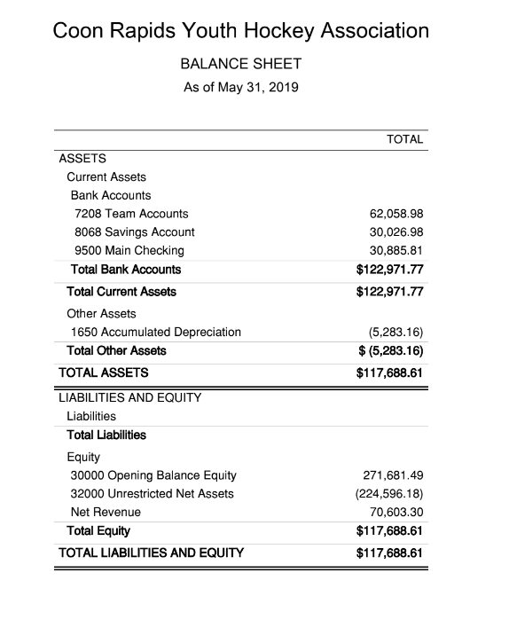

MOTION made by Mandi DeGrote to approve the above financials; MOTION seconded by Todd Bushy; UNANIMOUSLY approved. None opposed, Motion passes.

- Gambling Report- Sue Erickson
- Presentation to the Board
  - E-tab sales are up regular pull tab sales are down. Reasoning historically due to vacation time of the year.
  - Account Checking is at $47,000
  - Gambling pays City fee’s on a quarterly basis. Amount is 5% of the Gross sales
  - CRYHA is to buy 2 security cameras for $850 and this is in estimated expenses. CRYHA will retain ownership of the camera’s

MOTION made by Sarah Barsness to approve report on May’s 2019 gambling activity; MOTION seconded by Mandi DeGrote; Vote- UNANIMOUSLY approved. None opposed Motion passes.

MOTION made by Sarah Barsness to approve June 2019 estimated allowable expenses up to the amount shown for June, 2019 ($149,500.00); MOTION seconded by Geoff Spah; UNANIMOUSLY approved. None opposed, Motion passes.

MOTION made by Holly Bachman to approve (previous month) income, allowable expenses and required taxes and contributions; MOTION seconded by Todd Bushy; UNANIMOUSLY approved. None opposed, Motion passes.

- Additional Commentary- Sue Erickson
  - New Bingo games at sites implemented. One previous game is disallowed
  - Gambling has a new accountant assigned – Amy Kerr
  - Scoops and CR’s have upcoming golf tournaments. CRYHA has participated in the past and suggest we participate in this year’s events.
  - Gambling needs volunteers to assist in this year’s audit. Two are needed. Audit will take place on August 8th
    - Todd Bushy and Mandi DeGrote Volunteered during the meeting

- Hockey Operations Report- Dan Bieurance, Jen Shirshov, Tim Matche, Todd Bushy
  - Boys Traveling – Dan Bieurance
    - Hockey Op’s committee has narrowed down what the coaching needs are for the upcoming season
    - We are currently soliciting coaches on Minnesota Hockey Publications
    - Hockey Op’s is not opposed to paid non parent coaches for the squirt level this season.
    - Coach’s interview committee will be 5-6 people and interviews will take place mid-July. Hockey Op’s committee is expecting to interview up to 15 candidates.
  - Girls Traveling- Jen Shirshov
    - Struggling to find Girls team coaching candidates
    - Both CRYHA and Champlin Park associations work together to recruit
    - Co-op will run a B team only this season
  - Mite/ U-8’s – Tim Matsche/ Todd Bushy
    - Preseason camp is shortened from 40 hours to 19 hours of ice this season. Thought was it was too long in the past. Camp will start October 12 after travelling tryouts.
    - Camp days will be Tuesdays, Thursdays, Saturdays and Sundays
    - Association has a goal to recruit 50 new players this season. Looking for everyone to participate in recruiting new players to our association!
    - CRYHA will have a shortage this season in the A/B level.
    - Registration will open 1st of July

- Unfinished Business – None to be addressed this meeting due to time
- New Business
- 2019/ 2020 CRYHA Budget – Holly Bachman
  - Access to the budget is on our Google Drive
  - Holly presented proposed budget created by the budget committee to the Board
  - Slight adjustments were made to the budget during discussion and presentation
    - Hockey Palooza was added to the season budget
    - CRYHA Gambling sites golf tournament registration fees were added to the seasons budget
  - Budget will remain on the google drive for members of the Board to continue to view. Will provide copy for other members to view upon request

Motion made by Geoff Spah to accept the proposed 2019/ 2020 CRYHA budget as amended in the meeting. Motion seconded by Todd Bushy; Unanimously Approved; None Opposed. Motion Passes.

Good and Welfare

- Scheduling Ice- Jeremie Bresnahan
  - CRYHA suffered a $1000 loss for un-utilized ice set aside for STP camps that never materialized. Loss could have been much more significant had scheduled ice not been recognized within cancellation period. Ice cancelation is not good and typical practice and jeopardizes our great relationship with CRIC. This is a reminder that ordering and scheduling ice on behalf of CRYHA is only to be done by our Ice Coordinator and the Current President and Vice President of the Association. No other member of CRYHA has authorization to order ice for the association.
- Bylaw Committee - Jeremie Bresnahan
  - A bylaw committee will be formed during July
  - Bylaws need to be amended to be compliant with affiliate agreement
  - Proposed amendments will be made during bylaw committee meetings
  - Proposal will be presented to the board at July meeting
  - Ratified proposal will be posted to view for our general membership and the CRYHA membership will vote to ratify amendments on by special meeting August 25th
- Web site Access- Brian Mountain
  - No policy in place in who owns CRYHA emails
  - No security on who owns shared drive. Policy should be established on who manages drive all other members should be limited to commentary only
  - Please upload CRYHA documents to appropriate shared drive so not to lose information
  - Website- new board members now have access to manage their assigned portion of the site. Any questions contact Brian, he can walk you through how to use and edit your portion of the site.
  - Brian is willing to create a page for you is requested
  - If you submit something for Brian to upload, please provide a word document not a PDF. This is for resolution quality
  - Social Media –
    - Video’s need to uploaded to you tube before it can be linked to web site
  - Would like to see teams utilize team pages more through messaging and scheduling (through ical). This drives the website hits up and helps in sponsorship
  - It was requested by Jeremie that Brian draft a proposal on his concerns and present it to the board at the next meeting for discussion

Next Meeting
Meetings will be scheduled on the last Sunday of each month throughout the hockey season but are subject to change. Future meetings are scheduled to take place at Coon Rapids Ice Center but are also subject to change. Our next meeting will be on Sunday, July 28th @ 8:00 pm at Coon Rapids Ice Center.

Future Meetings
2019 Meeting Dates (subject to change):
6:30 Start: (Start time will be 8:00 pm for meetings in BOLD)

July 28, 2019
August 25, 2019
September 29, 2019
October 27, 2019
November 24, 2019
December 29, 2019

MOTION made by Todd Bushy to adjourn meeting; MOTION seconded by Holly Bachman; UNANIMOUSLY approved

Meeting called at 10:20 PM

Minutes submitted by: Don Ruotsinoja, Secretary

These minutes are current, true and accurate:

President: Jeremie Bresnahan
Vice President: Mandi DeGrote

Signature: _________________________
Date: ______________, 2019

CRYHA May Financials
