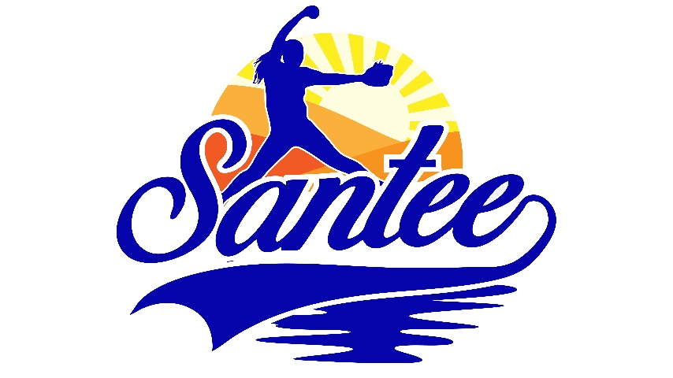
MINUTES TO BE APPROVED AT THE NEXT BOARD MEETING. THESE MINUTES ARE NOT CURRENTLY POSTED AND SHOULD NOT BE DISTRIBUTED UNTIL APPROVED BY USASSCS BOARD.
Board Meeting Minutes December 8, 2025
Location: Santee City Hall
Attendees Shown with Marked Box
Guests:
President | Erik Ruiz | x | Awards | Janis Aiello | x
1st VP/ Field Scheduler/Fall Ball Coordinator | Chris Klima | x | Field Prep | Trevor Henton | x
2nd VP | Kelli Timanus |  | Field Prep/Uniforms | James Timanus
Treasurer | Tiffany Lynch | x | Field Prep | Shane Hanson
Secretary/Safety Coordinator/Head Scorekeeper |  |  | Field Prep | Brad Allen
Tax Advisor | Lori Britt |  | Field Prep/Equipment | Shane Frary | x
Player Agent | Lance Craw | x | Field Prep | Eric DeChant | x
UIC/Parliamentarian | Bryan Scholar | x | Head Team Parent Coordinator | Shahday Galloway | x
Webmaster/Social Media/All-Star Coordinator | Alexis Ruiz
BOTH Tournament Coordinator/Picnic Coodinator/Social Media Coordinator | Karly Dwyer |  | Snackbar #1 | Katja Moskowicz | x
Sponsorships | Kylee Scholar | x | Snackbar #2 | Ashley Knepp
Field Prep | Erik Medrud | x | Snackbar #3 | Victoria Brennan | x

Meeting called to order: 7:08 PM
Meeting Minutes
Shahday Galloway motioned to approve minutes from November 2025. Tiffany Lynch seconded the motion.

- Financial Update (Tiffany L)
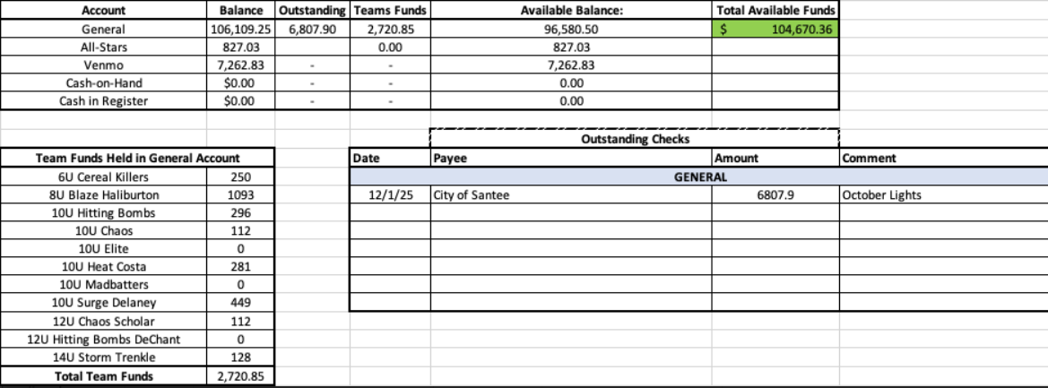

  - Outstanding check for lights for October 2025
  - Net proceeds of about $15,000 from the snack bar during the fall
  - Approved adding Katja Moszkowicz to the bank account as a signer
- Spring Registration
  - 142 players as of 12/8/25
  - Manager interviews will take place in early January
- Fields
  - Infields on 2 fields will be worked on during the week of December 15
  - Pictures have been sent to the city on the gopher problem on the fields
  - Purchasing supplies for the spring season
  - Pitchers’ areas and batters’ boxes will be clayed and have time to cure before the season begins

- Sponsorships
  - Idea for spring rec sponsorship banner contest where the team that brings in the most banners would earn a pizza party – More details later
- It was voted that a 14U manager will be banned from taking any teams until January 2027
- Opening Day committee being formed
Next Meeting: January 5

