Duals Registration through USA Wrestling
- Login to www.usawmembership.com
- In the top menu, hover over USAW EVENTS and select “EVENT REGISTRATION.”
- Fill out the data fields to search for the event you are looking for. Find the event in the results listed and select the blue “REGISTER” button.

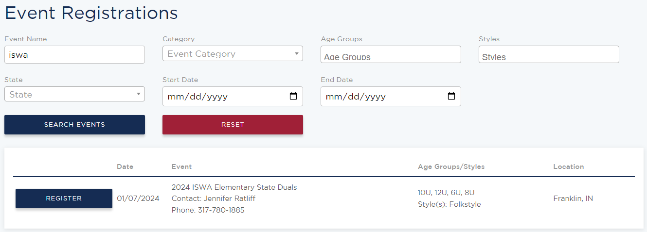

- Choose “SELECT PROFILE” next to the profile you would like to use to complete the registration. It must be a profile affiliated with the team you are registering.
- Select the appropriate division and team options in the drop boxes. Check the acknowledgements and select “SAVE & CONTINUE TO CHECKOUT.”
- Enter payment information and select “FINALIZE CART.” Your team is now registered for the dual. See additional instructions for entering duals rosters through the club admin.
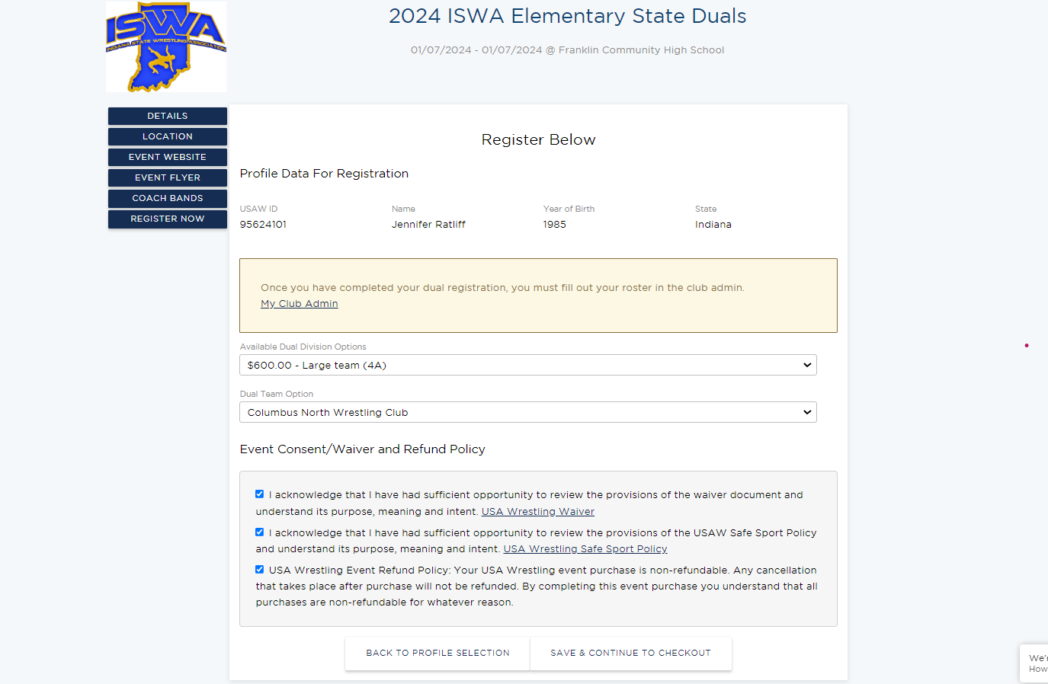
Alternatively, you can also access event registrations by hovering over USAW events and selecting “EVENT SEARCH.” Complete the search fields to find your event. Select the blue “VIEW” button next to the event you’d like to register for. On the event page that opens, select “REGISTER NOW” from the left menu then repeat steps 4-6 above. Both methods lead to the same registration page.
