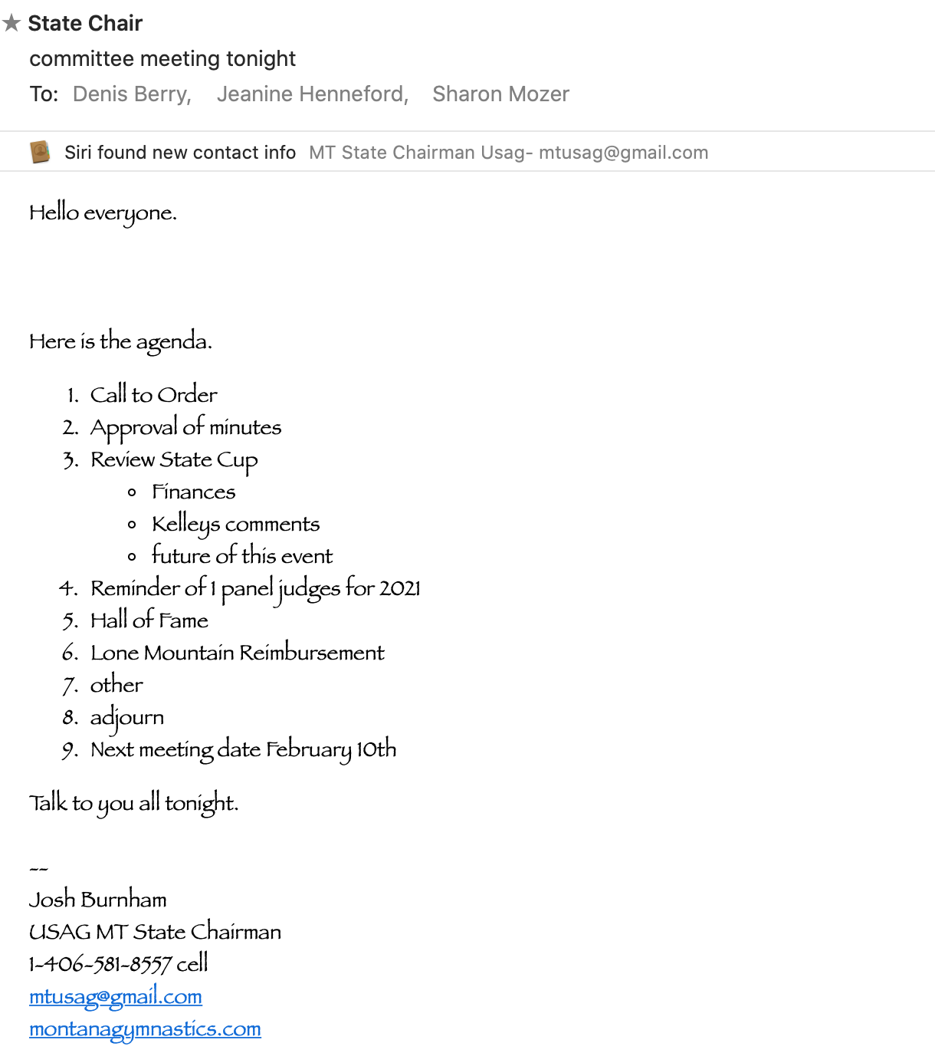

SAC - MT
Meeting Minutes
January 20, 2021

Call to Order: Josh Burnham (SACC) called to order the regular meeting of the SAC-MT at 8:55 p.m. on January 20, 2021.

Roll call: Josh Burnham, Jeanine Henneford, Denis Berry, and Sharon Mozer.

Announcements:
- Financials - No updates at this time.

- Moved to approve Minutes from 12/16/20.
Motion: Denis Berry
Second: Jeanine Henneford
PASSED

Old Business:
- Review State Cup 2021
  - Finance - Judges’ expenses $8,500.00, and Meet Host $3,500.00. Entries from the meet were around $27,000.00. Gate fees were $1,780.00 (usually around $4,000.00). After expenses paid, the meet netted around $16,000.00.

  - Kelly Durbin of MISMO (meet host) expressed that the $3,500.00 fee that the state committee paid to the host gym was just enough to break even with their usual Fri/Sat/Sun income.

  - Future for the State Cup - the board wants to continue to run this meet as a state fundraiser. Keeping this meet as an in-house format will result in a stronger fundraiser, with less hassle with all the logistics.

  - Moving forward, the board will create guidelines for running the state cup in order to make clear on what is expected from the meet host in terms of logistics/expenses. Denis Berry will head up the project to create the guidelines.

- 1-Judge Panel for 2021 is allowed for the WDP Levels 4/5 and Xcel Platinum/Diamond.

- Hall of Fame of Montana - A few ideas were discussed including a VIP pass for retired coaches. The board will develop a criteria list on google docs. Jeanine Henneford and Denis Berry will be heading up the project.

- Reimbursement to Lone Mountain Gymnastics of $2,500.00 has been approved through the Regional Chair. The reimbursement was from a few years ago.

- State Championships 2021
  - Location - Event Center in Belgrade, MT
  - Estimated 760 athletes
  - Will run Thursday - Sunday
  - Josh will order medals for the event

New Business:
- To allow Xcel and WDP to compete in a virtual competition for mobility purposes for the 2021 competition season only.
Motion: Sharon Mozer
Second: Jeanine Henneford
PASSED

Adjournment:
To have the meeting be adjourned. The meeting adjourned at 11:30 p.m.
Motion: Sharon Mozer
Second: Denis Berry
PASSED
Next Meeting: 2/10/2021
Minutes submitted by Sharon Mozer

