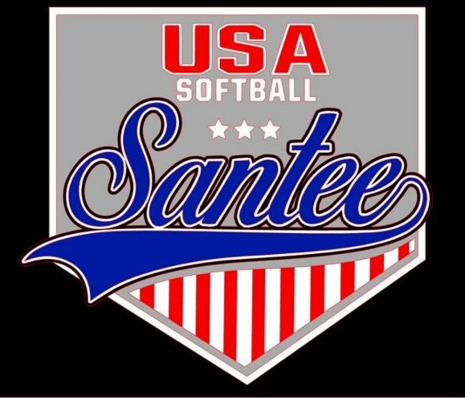
MINUTES TO BE APPROVED AT THE NEXT BOARD MEETING. THESE MINUTES ARE NOT CURRENTLY POSTED AND SHOULD NOT BE DISTRIBUTED UNTIL APPROVED BY USASSCS BOARD.
Board Meeting Minutes April 24, 2024
Location: Ruiz House
Attendees Shown with Marked Box
President | Jay Strandberg | x | Field Prep | Kevin Hopkins | x
1st VP/ Field Prep | Erik Ruiz | x | Field Prep | Trevor Henton | x
2nd VP | Kelli Timanus | x | Field Prep | James Timanus | x
Treasurer | Tiffany Lynch | x | Field Prep | Nate Anderson
Secretary/Safety Coordinator/Head Scorekeeper | Bryan Scholar | x | Field Prep | Brad Allen | x
Tax Advisor | Lori Britt |  | Field Prep/Equipment | Shane Frary | x
Player Agent | Lance Craw | x
UIC/Parliamentarian | Felicia Leca | x | Head Team Parent Coordinator | Dana Hisaw | x
Field Scheduler/Fall Ball Coordinator | Chris Klima | x | Uniform Coordinator | Erik Ruiz | x
Webmaster/Social Media/All-Star Coordinator | Alexis Ruiz | x | Picnic Coordinator/Pictures | Kat Vecchione | x
BOTH Tournament Coordinator | Kayleigh Ponciano-Ahue | x | Snackbar #1 | Amy Ramirez | x
Sponsorships | Kylee Scholar |  | Snackbar #2
Awards | Janis Aiello | x | Social Media Coordinator | Sophia Vigil | x

Meeting called to order: 7:30PM
Meeting Minutes
2024 All Star Manager Results
14U Gold – Chris Klima
12U Gold – James Timanus
12U Silver – Kelli Trenkle
10U Gold – Josh Teague
10U Silver – Bronson Ponciano – Ahue
10U Bronze – Justin Galloway
8 Gold – Shane Frary
8 Silver – Bryan Scholar
8 Bronze – Shane Hanson

Managers to send Top 6 Older/Top 6 Younger to player agent, Lance Craw by Friday, 4/26

