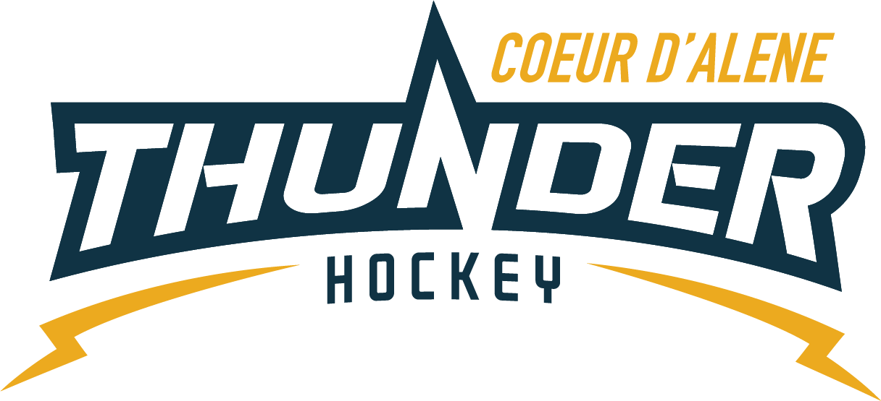

CDAHA

Meeting minutes
Location: ZOOM/Frontier Date: March 4, 2021
Attendees: Bob Nelson, April Hocking, Meghan Smith, Bart Barrett, Jarrod Hansen, Matt Fisher, Josh Leppert, Matt Creighton, Torsten Langley, Matt Crieghton
Time: 7:00PM
- Call to order
Bob Nelson, President called meeting to order 2/04/21 7:03PM
- Roll call
Elliot and Jarrod absent, guests: Jackie G, Jackie P, Kody Carpenter, Will Higgins, Jeremy G, Kevin Carnahan.
- Approval of minutes from last meeting
Minutes tabled will be sent via email
- Open issues
  - TRESURER UPDATE
    - In the green for what we budgeted and have more skaters than we budgeted for.
    - Will begin mock budget for next season to be sent to committee and new BOD
  - Spring/Summer Ice
    - Need to dial in time slots, youngest to oldest
    - Times may vary and need to mention that in registration
    - Will there be a check in desk, and who is running that
    - Kody would like to help coach
  - Elections
    - Timeline will be 3/24-3/28
    - Announce April 1
  - Next Season
    - July 1 for registration is our goal opening date
    - Budget should be complete by then
    - Waiting on Canada to open to continue with West Kootenay plans
    - Kami still on board for scheduling
    - What is plan for tournaments next season as far as Association covering
    - Money needs to be tailored to each division, then built into registration
      - Table for future bod
    - Will Saraa and jerseys/practice jerseys be built in? approx. $750 for practice jerseys or $25 per jersey
    - Where will overages go
  - Job Descriptions
    - Please assign someone to write these up. Matt C would like to meet with each position to dial these in.
  - Disciplinary Amendment
    - Matt C still needs to send

- Adjournment
8 PM
Minutes submitted by: April Hocking
Minutes approved by: CDAHA BOD
- Next Meeting
  - April 8, 2021 7PM

