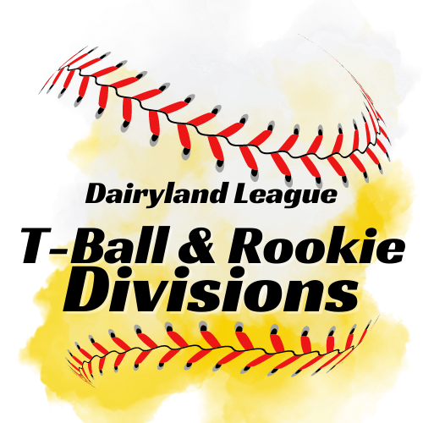

T-Ball Rules

Rules to be altered should be determined and agreed upon by both coaches PRIOR to the game start time. Game start time begins at the conclusion of the Coaches Meeting at home plate.

- All hitters will hit from a batting tee. The tee should be adjusted to a height that allows batter swing level or down on the ball.
- All players on the roster,, who are present for the game shall be put into the batting rotation. Players will continue to bat in that order whether playing defense or sitting on the bench.
- No Bunting allowed.
- Pitcher should be in contact with rubber and making pitching motion before the batter swings at the ball.
- An inning is over when all players have batted. The last batter of the inning, once reaching first base safely, must continue to circle the bases until he or she is either tagged out or reaches home plate, either of which will end the inning.
- Batters may advance farther than first base if the hit ball allows them to do so, otherwise, players are allowed to advance only 1 base at a time.
- THree complete misses of the ball while batting constitutes a strike out.
- Maximum of 5 swings to put the ball in play. If not in play on the 5th swing, the batter is out.
- If a batter hits part of the ball and part of the batting tee, it is a fair ball if it goes into fair territory. If it does not go fair, it becomes a foul ball and counts towards the swing count.
- No stealing or leading off is permitted.
- Teams may play all players on the field defensively , but they should be stationed with only 5 players inside the baselines. All other players should be playing at the edge of the grass or outfield areas.
- Each player present must play the minimum of two innings defensively.
- A coach may be stationed beyond the infielders in order to provide instruction to all defensive players. Coaches may also be on the field to coach runners.
- We strongly encourage coaches to rotate their players so all team members get an opportunity to play all defensive positions.
- Only approved tee balls are legal. Bats must be 26” or shorter. Bats should be USA bat approved or carry the USA bat sticker. 26’ wood bats are also legal.
- Wood bats must have a non-slip material on the handle at least 10” in length from the knob handle of the bat.
- A regulation game is 3 innings or an hour, whichever comes first.
- We strongly discourage keeping score of the game.
- Coaches and Players, Home & Away, are responsible for cleaning up their respective dugouts after each game.
- Unsportsmanlike conduct will not be tolerated. If a coach, player, or fan is ejected from a game (coaches discretion), he or she must leave the park immediately. Further problems from that team may result in a forfeit of the game.
- Players and coaches should shake hands, or line up on the foul lines and wave, at the conclusion of each game to exhibit good sportsmanship.

