
VOLLEYBALL SUMMER CAMP CURRICULUM
MONDAY
9:00-9:15am – Introduction
- Welcome
- Coach Introductions
- Goals of camp: Improve mechanics, develop volleyball IQ and boost confidence
- Talk to them about camp raffles at the end of the week and how to win a raffle ticket
- Rules – Rule 1 – “Have Fun” | Rule 2 “Mistakes are Great”
- Eyes, Ears, Marshmallows
- “Good Day|Great Day”

9:15-9:30am – Stretching (Static then Dynamic)
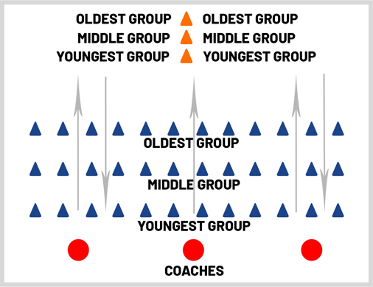

- Static – neck rolls, arm rolls, tricep extension, arm across chest stretch, hip rolls, hamstring stretch, touch toes
- Dynamic (moving) – butt kickers, high knees, karaoke, love shuffle, Frankenstein’s, open gates, sprints
  - Make sure to make it fun by having groups compete in counting – who is loudest? Have kids do “loudest whisper” “quietest scream” “count in different languages” “count in accents” and more

9:30-9:33am – WATER

9:33-9:50am – Ladder
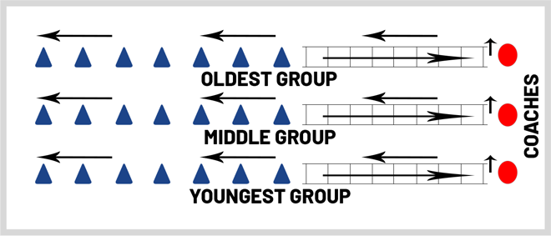

- Ladder exercises include: kangaroo hops, two feet in each square (individually), skier, flamingos, hopscotch (out/in), side shuffle both directions and Icky Shuffle
- Game – Ladder of Doom!
  - Round 1 – Each player has six seconds to get through ladder without touching it or they are eliminated (kangaroo hops)
  - Round 2 – Each player has five seconds to get through ladders without touching it or they are eliminated (skier)
  - Roud 3 – Each player has four seconds to get through ladder without touching it or they are eliminated (two feet in each square)
  - Etc.

9:50-9:53am – WATER

9:53-10:15am – Shipwrecked (https://www.youtube.com/watch?v=evDMydE8eAM)

10:15-10:25am – SNACK BREAK

10:25-11:10am – Fundamentals (three 15-minute stations)
- Passing (https://www.youtube.com/watch?v=lmBivrHbf8Y)
  - Progression Drill (https://www.youtube.com/watch?v=T8uXyXQ6OYA)
    - On Knee
    - Standing
    - Moving Forward/Backward
    - Moving Side to Side
- Setting
  - Progression (https://www.youtube.com/watch?v=qaGfW9fes7Y)
    - On Knees Catching Ball in Setting Position
    - On Knees – Actual Setting
    - Standing
    - Moving Forward/Backward
    - Moving Side to Side
- Serving
  - Underhand (https://www.youtube.com/watch?v=E65rysfSWNQ)
    - Right Foot Back, Left Foot Forward – Rock
    - Introduce Arm Swing (no ball) – Hold with left hand in front of right arm
    - Hold the ball the ENTIRE time (no tossing) – Rock with arm swing with ball in hand
    - Hand Position – Wrist pointing towards ceiling
    - “ROCK AND POP”
      - Partner Passing across net

11:10-11:13am – WATER

11:13-12:00pm – Tournament Day 1 (Evaluations)
Split up the kids into four teams – have team one play two with three playing four. Roughly 10 minutes in switch teams two and three. Finally, switch teams one and four so that everybody plays each other. At the end of the evaluation create four teams with as much parity as possible for a tournament the rest of camp.

12:00-1:00pm – LUNCH (half-day dismissal at 12:00pm)
  - First 30-minutes everyone must sit – final 30 minutes can be used to play on the courts.

1:00-1:20pm – Catch Reaction Game (Catch Reaction Drill) (https://www.youtube.com/shorts/qt_SebbfqNY)

1:20-1:40pm – Plank Races (https://www.youtube.com/watch?v=wSxTAQuQjKk)

1:40-1:45pm – WATER

1:45-2:20pm - Battleships (https://www.youtube.com/watch?v=6b57d4aCNQM – 3:43)

2:20-2:35pm – SNACK BREAK

2:35-3:35pm - Controlled Scrimmage (https://www.youtube.com/watch?v=LPY13epIU8c&list=PLxMXcGaIQ5-P_gRWZsQPfqnJTnsAk16xy) – 10:19)

3:35-3:40pm – WATER
3:40-3:55pm – Cool Down Stretch

TUESDAY – WEAR YOUR FAVORITE JERSEY TO CAMP DAY

9:00-9:10am – Welcome
- Welcome
- Sports story/game from previous night?
- What does hydration mean and why is it important?
- Rules – Rule 1 – “Have Fun” | Rule 2 “Mistakes are Great”
- Eyes, Ears, Marshmallows
- “Good Day|Great Day”

9:10-9:25am – Stretching (Static then Dynamic)
- Static – neck rolls, arm rolls, tricep extension, arm across chest stretch, hip rolls, hamstring stretch, touch toes
- Dynamic (moving) – butt kickers, high knees, karaoke, love shuffle, Frankenstein’s, open gates, sprints
  - Make sure to make it fun by having groups compete in counting – who is loudest? Have kids do “loudest whisper” “quietest scream” “count in different languages” “count in accents” and more

9:25-9:28am – WATER

9:28-9:47am – Ladder
- Ladder exercises include: kangaroo hops every 3 squares, three feet in each square (individually), skier backwards, flamingos, hopscotch on one foot (out/in), side shuffle both directions and Icky Shuffle backwards
- Game – Team vs. Team
  - Have each team compete against each other! First person done WITHOUT touching the ladder wins their team a point.
    - Round 1 – Kangaroo
    - Round 2 – Skier
    - Round 3 – Two feet in each square
    - Round 4 (Bonus Round) – each team nominates one participant to compete for the championship. Whoever wins the race wins the entire game for their team – Icky Shuffle

9:47-9:50am – WATER

9:50-10:15am – Air|Land|Sea (https://www.youtube.com/watch?v=y07Su0b9_GM)
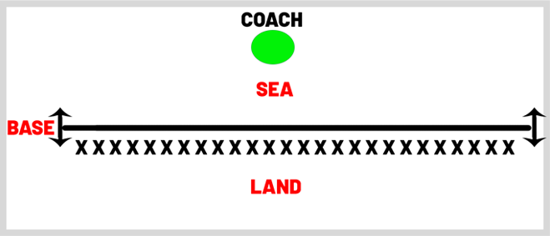
- Land – behind line
- Sea – in front of line
- Air – Jump straight up
- Tornado – 180 degree turn
- Earthquake – crotch down with hands over head
- Base – On Line
- Griddie

10:15-10:25am – SNACK BREAK

10:25-11:10am – Fundamentals (three 15-minute stations)
- Passing
  - Shuffle Step (https://www.youtube.com/watch?v=U2q7J6PwWP4 - :57 marker)
  - Pass to Self/Pass to Partner (https://www.youtube.com/watch?v=WoIwx3S9wpM - :06 marker)
- Setting
  - Self-Setting
  - Bump/Set/Bump with Partner (give and go)
- Serving (Overhand) (https://www.youtube.com/watch?v=TDyvSUVM6tk&t=102s)
  - Toss N Drop (https://www.youtube.com/watch?v=g5sX0LCitgs)
  - Toss N Trap
  - Serve

11:10-11:13am – WATER

11:13-12:00pm – Tournament Day 2
- Team 1 vs. Team 2
- Team 3 vs. Team 4
Play sets to 25 – if there is a third set play to 15 (or until time runs out)

12:00-1:00pm – LUNCH (half-day dismissal at 12:00pm)
  - First 30-minutes everyone must sit – final 30 minutes can be used to play on the courts

1:00-1:20pm – Reaction Game (https://www.youtube.com/watch?v=wSxTAQuQjKk - :16 marker)

1:20-1:25pm – WATER

1:25-1:50pm – Serve or Die (https://www.youtube.com/watch?v=bWuUN6ZiXG8)

1:50-1:55pm – WATER

1:55-2:45pm – Progression Drill (https://www.youtube.com/watch?v=pz8JYCi-nZk)
- 1 Pass
- 1 Pass, 1 Set
- 1 Pass, 1 Set, 1 Hit

2:45-3:00pm – SNACK BREAK

3:00-3:40pm – Scrimmage

3:40-3:45pm – WATER

3:45-4:00pn – Stretch

WEDNESDAY – CRAZY SOCKS DAY

9:00-9:10am – Welcome
- Welcome
- Sports story/game from previous night?
- What off the court things should we be doing to be high level athletes
  - Eating the correct foods, hydrating, sleeping
- Rules – Rule 1 – “Have Fun” | Rule 2 “Mistakes are Great”
- Eyes, Ears, Marshmallows
- “Good Day|Great Day”

9:10-9:25am – Stretching (Static then Dynamic)
- Static – neck rolls, arm rolls, tricep extension, arm across chest stretch, hip rolls, hamstring stretch, touch toes
- Dynamic (moving) – butt kickers, high knees, karaoke, love shuffle, Frankenstein’s, open gates, sprints
  - Make sure to make it fun by having groups compete in counting – who is loudest? Have kids do “loudest whisper” “quietest scream” “count in different languages” “count in accents” and more

9:25-9:28am – WATER

9:28-9:47am – Ladder
- Ladder exercises include: kangaroo hops every 3 squares forward – 1 back, , skier backwards, flamingos, hopscotch on one foot (out/in), side shuffle both directions and Icky Shuffle backwards, Firestarters, Riverdance
- Game – No Mercy
  - Essentially a combination of Ladder of Doom and Team vs. Team. First person at each ladder races; first person to finish WITHOUT touching the ladder moves on to next round. Anyone that touches ladder is automatically eliminated. Play until one person remains.

9:47-9:50am – WATER

9:50-10:15am – Kansas|California|New York
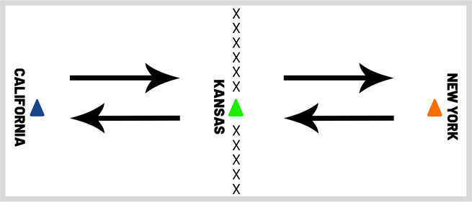

All campers start in line with the “Kansas” cone. The coach will yell one of the three states (California, Kansas or New York); campers must run to that state and stop directly in line with that cone. Last two campers to the correct state are eliminated each round. If campers are on a state (i.e. Kansas) and coach yells “Kansas” anyone who leaves the state is eliminated. Coaches can say multiple states in which campers must run to each state in the correct order.

10:15-10:25am – SNACK BREAK

10:25-11:10am – Fundamentals (three 15-minute stations)
- Passing
  - Pass to Self/Pass to Partner (Over Net)
  - Pass to Self/Backwards Pass to Partner (Over Net)
- Setting
  - Self-Setting
  - Block/Dig/Set (https://www.youtube.com/watch?v=U2q7J6PwWP4 – 5:00 marker)
- Serving
  - Moving back serving drill (https://www.youtube.com/watch?v=6xbCPt8HKm0)

11:10-11:13am – WATER

11:13-12:00pm – Tournament Day 3
- Team 1 vs. Team 3
- Team 2 vs. Team 4
Play sets to 25 – if there is a third set play to 15 (or until time runs out)

12:00-1:00pm – LUNCH (half-day dismissal at 12:00pm)
  - First 30-minutes everyone must sit – final 30 minutes can be used to shoot on hoops.

1:00-1:30pm – Hyperventilate (https://www.youtube.com/watch?v=ivYqXEjhKu0 – 1:49)

1:30-1:35pm – Water
1:35-2:00pm – Jailbreak (https://www.youtube.com/watch?v=6b57d4aCNQM – 2:14)

2:00-2:15pm – SNACK BREAK

2:15-3:00pm - Controlled Scrimmage (https://www.youtube.com/watch?v=LPY13epIU8c&list=PLxMXcGaIQ5-P_gRWZsQPfqnJTnsAk16xy) – 10:19)

3:00-3:05pm – WATER

3:05-3:40pm – Scrimmage with Coaches

3:40-3:45pm – WATER

3:45-4:00pn – Stretch

THURSDAY – CRAZY/FUN HAIR STYLE DAY

9:00-9:10am – Welcome
- Welcome
- Sports story/game from previous night?
- What should we focus on during game? How do overcome obstacles?
- Rules – Rule 1 – “Have Fun” | Rule 2 “Mistakes are Great”
- Eyes, Ears, Marshmallows
- “Good Day|Great Day”

9:10-9:25am – Stretching (Static then Dynamic)
- Static – neck rolls, arm rolls, tricep extension, arm across chest stretch, hip rolls, hamstring stretch, touch toes
- Dynamic (moving) – butt kickers, high knees, karaoke, love shuffle, Frankenstein’s, open gates, sprints
  - Make sure to make it fun by having groups compete in counting – who is loudest? Have kids do “loudest whisper” “quietest scream” “count in different languages” “count in accents” and more

9:25-9:28am – WATER

9:28-9:47am – Ladder
- Ladder exercises include: kangaroo hops, skier forward/backwards, flamingos, hopscotch individual feet, side shuffle both directions, Firestarters, Icky Shuffle, Riverdance backwards
- Game – Ladder of Doom!
  - Round 1 – Each player has three seconds to get through ladder without touching it or they are eliminated (kangaroo hops)
  - Round 2 – Each player has four seconds to get through ladders without touching it or they are eliminated (skier)
  - Roud 3 – Each player has five seconds to get through ladder without touching it or they are eliminated (two feet in each square)
  - Etc.

9:47-9:50am – WATER

9:50-10:15am – Cone Game (https://www.youtube.com/watch?v=GsFL_doSXxM)
The game begins with every camper on the sideline with a cone in front of them. The coach will take the kids through a series of directions such as “Hands up”, “Nose”, “Chin”, “Toes”, “Shin”, etc. When the coach says “Cone” all campers will grab their cone and put it above their head. The last person to get their cone above their head is eliminated. If a student touches the cone BEFORE hearing the word “Cone” they are also eliminated. Make this game fun by using words like “Collar Bone” to get the kids to accidentally touch their cone. Try to sneak the word “Cone” into the game to see who’s paying attention.

You can also play a camper vs. camper version as shown in the video link.

10:15-10:25am – SNACK BREAK

10:25-11:10am – Fundamentals (three 15-minute stations)
- Passing
  - Bumping overhand serves (https://www.youtube.com/watch?v=LPY13epIU8c&list=PLxMXcGaIQ5-P_gRWZsQPfqnJTnsAk16xy - 4:35pm)
- Hitting Progression (https://www.youtube.com/watch?v=qD4bvyyCDDA)
- Blocking Drill (https://www.youtube.com/shorts/A5tr2KLroDM)

11:10-11:13am – WATER

11:13-12:00pm – Tournament Day 4
- Team 1 vs. Team 4
- Team 2 vs. Team 3
Play sets to 25 – if there is a third set play to 15 (or until time runs out)

12:00-1:00pm – LUNCH (half-day dismissal at 12:00pm)
  - First 30-minutes everyone must sit – final 30 minutes can be used to shoot on hoops.

1:00-1:40pm – Battleships (https://www.youtube.com/watch?v=6b57d4aCNQM – 3:43)
1:40-1:45pm – Water
1:45-2:20pm – Pass N Go Competition
(https://www.youtube.com/watch?v=6b57d4aCNQM)
- Start with Passing
- Setting
- Serving race with teams competing to 30 (like in video)

2:20-2:35pm – SNACK BREAK
2:15-2:45pm – Champions & Challengers (https://www.youtube.com/watch?v=gQ8GETRH2GY – 1:33)
2:45-3:00pm – SNACK BREAK
3:00-3:40pm – Scrimmage
3:40-3:45pm - WATER
3:45-4:00pn – Stretch

FRIDAY – CAMPER FRIDAY

9:00-9:10am – Welcome
- Welcome
- Raffle (only time where both half-day and full-day kids are at camp)
- Sports story/game from previous night?
- Rules – Rule 1 – “Have Fun” | Rule 2 “Mistakes are Great”
- Eyes, Ears, Marshmallows
- “Good Day|Great Day”

9:10-9:25am – Stretching (Static then Dynamic)
- Static – neck rolls, arm rolls, tricep extension, arm across chest stretch, hip rolls, hamstring stretch, touch toes
- Dynamic (moving) – butt kickers, high knees, karaoke, love shuffle, Frankenstein’s, open gates, sprints
  - Make sure to make it fun by having groups compete in counting – who is loudest? Have kids do “loudest whisper” “quietest scream” “count in different languages” “count in accents” and more

9:25-9:28am – WATER

9:28-9:47am – Ladder
- Game – Team vs. Team
  - Have each team compete against each other! First person done WITHOUT touching the ladder wins their team a point.
    - Round 1 – Kangaroo
    - Round 2 – Skier
    - Round 3 – Two feet in each square
    - Round 4 (Bonus Round) – each team nominates one participant to compete for the championship. Whoever wins the race wins the entire game for their team – Icky Shuffle
- Make the younger groups ladder SHORTER today to even out the competition

9:47-9:50am – WATER

9:50-10:15am – Jailbreak (https://www.youtube.com/watch?v=6b57d4aCNQM – 2:14)

10:15-10:25am – SNACK BREAK

10:25-11:00am – Battleships (https://www.youtube.com/watch?v=6b57d4aCNQM – 3:43)

11:0-11:03am – WATER

11:13-12:00pm – Tournament Day 5 – Championship/Consolation Game
- Two teams with the worst records will play in Consolation Game
- Two teams with the best records will play in Championship Game

12:00-1:00pm – LUNCH (half-day dismissal at 12:00pm)
  - First 30-minutes everyone must sit – final 30 minutes can be used to shoot on hoops.

1:00-1:30pm – Campers Choice Game/Dodge Ball (if you have a set)
1:30-1:35pm – Water
1:35-2:10pm – Campers Choice Game
2:10-2:15pm – WATER
2:15-2:45pm – Champers Choice Game
2:45-3:00pm – SNACK BREAK
3:00-3:40pm – Campers Choice Game
3:40-3:45pm – WATER
3:45-4:00pn – Stretch

