SLPYHA Board Meeting Agenda
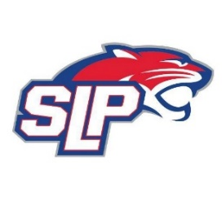
Date: 7/19/21
Bricks
7:00pm

Attendees: Scott Lichter, John Pitzl, Michelle Rice, Mike Mliner, Corey Piekarski, Adam Kiedrowski, Jason Shipman, Kevin Mitties
Guests:

- President Report: Scott Lichter
- Call to order: 7:07pm
- Approve agenda
- Approve minutes from 6/7/2021 meeting, motion: Lichter move: Mliner
- Latest D10 updates
- Golf tournament update
- Registration
- MN Hockey Leadership Conference
- Minnesota Moose billet program
- Vice President Report: Michelle Rice/John Pitzl
- Treasurer Report/Gambling Report: Mike Mliner
  - June gambling numbers
  - Motion by Mliner to move an additional $15,000 from gambling account to hockey account. Moved by Pitzl
- Secretary Report: Corey Piekarski
- Traveling Director Report: Jason Shipman/Adam Kiedrowski
- Tryout schedule
- Girls Traveling Director Report: Kevin Mitties
- Mite Director Report: Mike Fitzpatrick
- Coaching Director Report: Jeremy Flaten/Bob Roloff
- New/ongoing Business:
- Motion to dismiss: 10:02pm, motion: Piekarski move: Lichter

