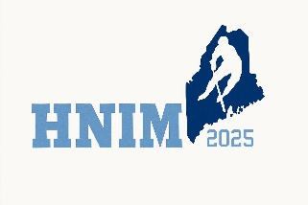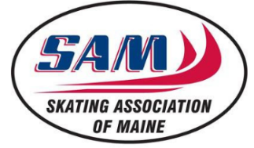
HNIM Social Media Guidelines for Parents
Purpose
These guidelines aim to guide parents in responsibly sharing content related to HNIM events on social media, ensuring the privacy and safety of our players while promoting a positive community presence.
Guidelines
- Player Identification and Imagery
  - Photographs and Videos: When capturing images or videos of players, ensure that they are wearing their helmets to protect their identity.
  - Naming Players: Use only first names when referencing players in any social media posts to maintain their privacy.
- Use of Official Hashtag
  - Hashtag Usage: Include the hashtag #HNIM in your posts related to league activities.
  - Content Monitoring: The league will regularly monitor this hashtag to identify content for potential sharing on our official social media platforms.
  - Implied Consent: By using the #HNIM or #HNIM2025 hashtags, you grant HNIM / Skating Association of Maine / SAM JR Terriers permission to repost or share your content on our official channels.
- Respectful Communication
  - Positive Engagement: Maintain a respectful and supportive tone in all online interactions concerning the league, its players, coaches, officials, and other parents.
  - Prohibited Conduct: Avoid posting negative, derogatory, or inflammatory comments. Such behavior may lead to disciplinary action, including removal from league activities.
- Privacy and Safety
  - Sensitive Information: Do not share personal details about any player, including contact information, medical conditions, or any other confidential information.
  - Third-Party Content: Refrain from sharing images or information about players from other teams without proper consent.
- Reporting Concerns
  - Inappropriate Content: If you encounter any content that violates this policy or raises concerns, please report it to the league officials promptly for appropriate action.

