PERRY MERIDIAN
BELOW, ROBINSON, WOOD MEMORIAL
GRECO-ROMAN & FREESTYLE OPEN
Saturday
April 11, 2020
LOCATION
Perry Meridian High School
401 W Meridian School Road, Indianapolis Indiana 46217
I-465 to US 31 exit south, 31 to Stop 11 road. West (right) on stop 11 becomes Meridian School Road. After you cross St Rd 135 school is on the left.

CONTACT
Randy Amos
Email: pmwc@perrywc.org
317-373-0966
Website: perrymeridianwrestlingclub.com

ENTRY FEE
$20 for one style- $30.00 both styles

AGE DIVISIONS
PEE-WEE-JUNIOR

SANCTION-ELGIBILITY
Tournament is sanctioned through the Indiana State Wrestling Association by USA Wrestling and is open to all 2019-2020 USA Wrestling members

REGISTRATION
Registration will open on March 21, 2020
You must register and pay online at TRACKWRESTLING.COM
Registration will close at 9:00 pm (EST) on April 10, 2020 for both styles
You must register through trackwrestling.com. There will be NO LATE ENTRIES

Tournament Start Times
Saturday Freestyle -8:30 AM-Greco 30 min after

AWARDS
Greco-Custom medals to 1st-2nd-3rd
Freestyle-Custom medals to 1st-2nd-3rd
Custom made Gladiator Helmet for each Age group Leader
Total number of falls in the fastest amount of time.
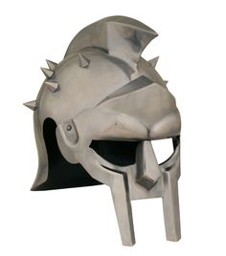
SPECTATOR FEE

$5.00 per person-$10.00 per family (Immediate Family Only)

ADDITIONAL INFORMATION
Concessions available on site
Jim's Wrestling supply will be available for all your wrestling needs.
USA Wrestling Cards will NOT be sold at this event-Order onLine
Not responsible for stolen items or accidents!

