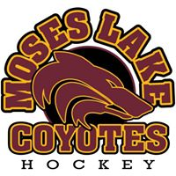

MOSES LAKE YOUTH HOCKEY ASSOCIATION

Required Equipment
✓ Hockey Helmet with full face shield
✓ Mouth guard
✓ Neck guard – Mites
✓ Shoulder pads
✓ Elbow pads
✓ Hockey gloves
✓ Pelvic protector (shorts with pad in front and optional Velcro that holds up socks)
✓ Shin pads
✓ Hockey Socks to start season, game socks will be available
✓ Hockey Jersey to start season
✓ Breezers (hockey pants)
✓ Skates
✓ Hockey Stick

Recommended
✓ Bag to carry equipment
✓ Skate guards

Equipment that you will receive from MLYHA
✓ Coyotes Game Jersey with your first time registration (Hockey team only)

