Accepting Text Message from the League Website
  - This document will provide with directions on how to accept text messages from the league website. The benefits for allowing text messages to come from here is so you as a player can get updates as far as game changes, league news and announcements, updates from coaches, and receive other important information regarding the GVMABL. This also allows your coaches to have a one stop shop to get in touch with each member one their team and not have to worry about contacting every person individually.

Directions if you have NOT already logged into the league website.
- From the Gallatin Valley Men’s Adult Baseball League homepage, CLICK on the Log In to TeamPages link located on the top of the webpage. 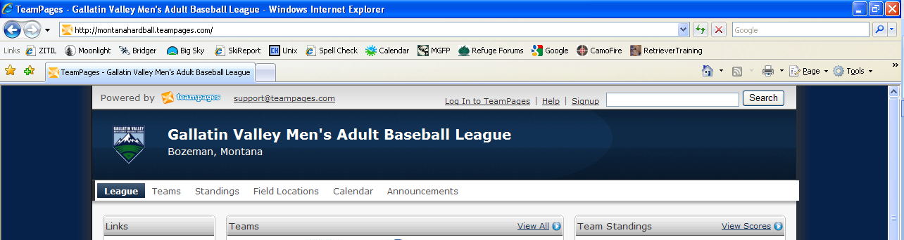

- Next, ENTER your username and password in to the login screen. Click on the Login Now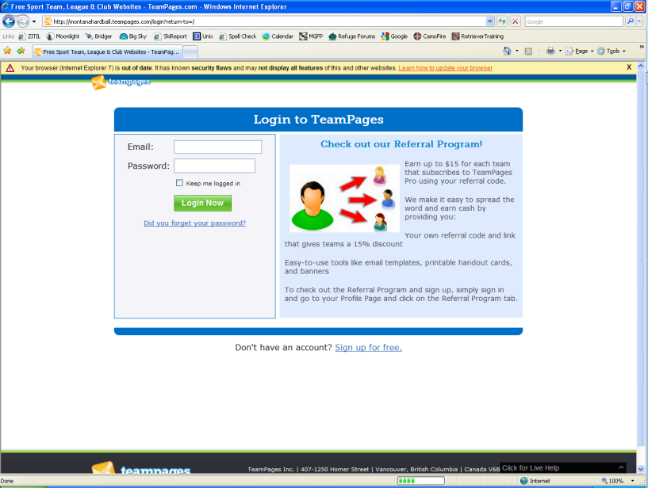

- From your Profile Page CLICK on the Account Settings link located in the Right hand section under My Notifications. 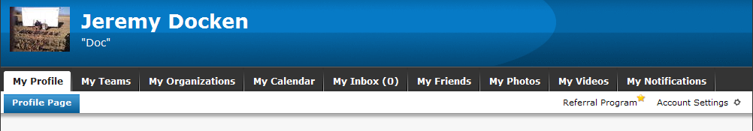

- Under the Account Settings page, scroll down to the SMS Information – Requires Verification section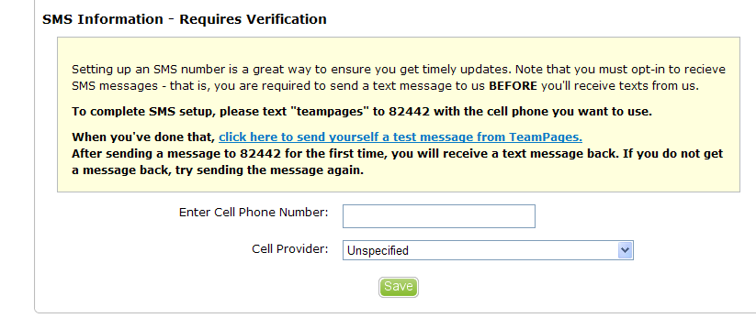

- Next, ENTER in your Cell Phone Number including you Area code, and SELECT your cell phone provider. 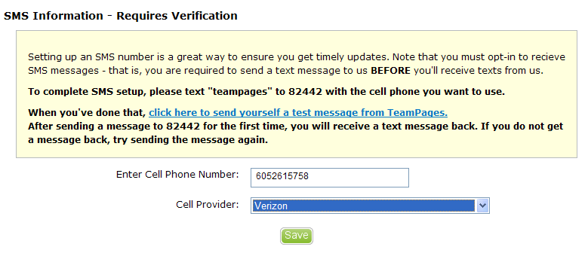

- CLICK the Save Button

- After you have entered in your Cell Phone # and Provider, TEXT “teampages” to 82442. You will then receive a text stating “You subscribed to updates from TEAMPAGES. To unsubscribe reply with TEAMPAGES UNSUB. Text messaging powered by tagga.com”

- To verify your are setup correctly CLICK on the click here to send yourself a test message from TeamPages link located under the Account Settings in My Profile. *Note, it may take a few minutes to receive your text.

Directions if you have already logged into the league Website.

- From the Gallatin Valley Men’s Adult Baseball League homepage, CLICK on the My Profile link located on the top left hand side of the webpage. 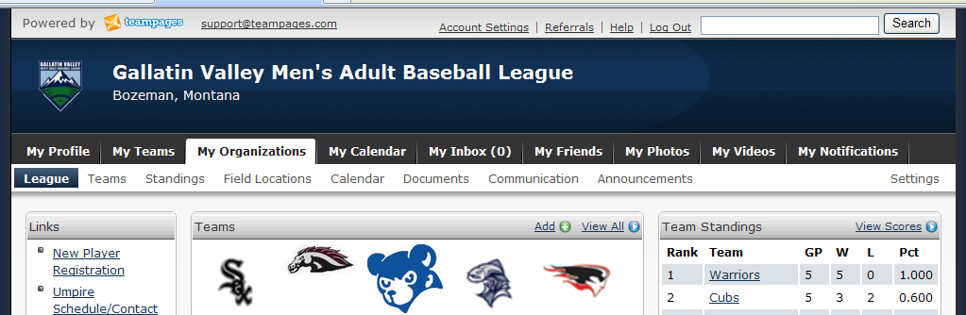

- From your Profile Page CLICK on the Account Settings link located in the Right hand section under My Notifications.

- Under the Account Settings page, scroll down to the SMS Information – Requires Verification section

- Next, ENTER in your Cell Phone Number including you Area code, and SELECT your cell phone provider.

- CLICK the Save Button

- After you have entered in your Cell Phone # and Provider, TEXT “teampages” to 82442. You will then receive a text stating “You subscribed to updates from TEAMPAGES. To unsubscribe reply with TEAMPAGES UNSUB. Text messaging powered by tagga.com”

- To verify your are setup correctly CLICK on the click here to send yourself a test message from TeamPages link located under the Account Settings in My Profile. *Note, it may take a few minutes to receive your text.

