WSWA General Membership Meeting
August 24, 2024
Hal Holmes Center, Ellensburg, WA

Introduction of Board Members and Directors: Jeff Moore, President; Travis (MT) Ayers, President Elect; Beth Michaelson, Secretary; Rene Torres, Coaches Director; LeeAnn Johnson, Operations Official Director; Marcus Requa, Mat Official Director; Dom Duncan, Kids Director; Stephanie Ottow, Women’s Director; Anthony Zuniga, Junior Director; Justin Newby, Executive Director
Meeting called to order at 12:01pm
Motion to accept 2023 General Membership Meeting Minutes was made by MT Ayers and seconded by Nicole Anderson (Moses Lake WC). No objections, Motion carries.
President - Jeff Moore: Groundbreaking year. Broke state record in Freestyle/Greco, Folkstyle State, and NW Regionals participation. Washington received national recognition for our successful hosting of Women's Nationals, and we were recognized by USA Wrestling for our work at the state level. Thank you to the membership.
President Elect – MT Ayers: Encouraged clubs to mentor young officials and encouraged parents to treat officials with respectful behavior.
Mat Official Director – Marcus Requa: 25 upgrades for officials this year, which is a great number. 7 Officials at Fargo. Good representation. Don Miller was awarded the lifetime achievement award at Fargo. No red cards, a handful of yellow cards.
Parents are a challenge for officials. Discussion on how to hold club leadership responsible for parent behavior.
There will be scoring changes for takedowns and nearfall, as well as rules changes around the point of contact.
Treasurer – Justin Newby for Ed Hawthorne: Finances are in good standing. Membership Rate increases due to world championships and LA Olympics, ticket price to enter the Tacoma Dome for Folkstyle State will go up $5. FS/Greco State will be at the Podium in Spokane.
Coaches Director – Rene Torres: Wants to get college kids working with the National Team and build them into national team coaches. Renee went to the Leadership Summit in Colorado Springs and enjoyed the networking opportunities and learning about how other states run their organizations. The highlight was that each session, WSWA was recognized or spotlighted. #3 for membership in the whole country and #1 for growth. Rene felt honored and proud to be a member of WSWA.
*Rene and Jeff present an award to Justin to commemorate our record membership year. (Special thanks to Cherry Creek Wrestling Club and Tim Weinert for providing the award)
Kids Director – Dom Duncan: Western States Tournament moved back to Pocatello. Hopes to get back to having elementary dual teams. Dom is working with 14U to get some teams there. Great bang for buck: lots of matches and 3 styles of wrestling.
Operations Official Director Report – LeeAnn Johnson: Title change from Pairings to Operations to reflect job duties. The PIN system will be used for seeding for state, regionals, and nationals. Track Wrestling events are linked with the PIN system. USA Membership is rolling out a new bracketing system and will be tested at some events this year
Melissa Voss up for P1 upgrade.
Will be offering Trackwrestling trainings again if requested/needed.
Executive Director - Justin Newby:
Contract for hosting Women’s Nationals is ending this year, putting in request for 2-year extension.
Flo Wrestling released USA Wrestling from its contract. USA Wrestling will be starting to test pilot the new bracketing system. WSWA will be running a few tournaments.
Nationals Teams – teams ran well. Athletes have the opportunity to earn money by officiating. Moving to Rudis for team gear for the National Teams. Going to explore the option of allowing kids to stay with parents at Fargo and pricing. Qualifying Coaches and officials’ stipends will be $700 plus $50/day.
Scoring Rules have updated
Kids Nationals requirement regarding State Tournament participation has been waived.
Weight classes for brackets are evaluated regularly and are determined by past data. 14u weight classes changed or both boys and girls: 17 weight classes.
Justin's 3-year vision: keep membership numbers up, focus on customer service. Current project is reviewing processes.
Age Level Reports
Stephanie Ottow: 17 14U Girls traveled to Indiana. Got 5th in Freestyle, 1st year doing Greco. 4 girls got all tournament honors. She had a great time and loves doing it.
Anthony Zuniga: Juniors had two athletes AA at Fargo: Tre Haines and Smokey McClure (finalist)
Duals went well, we were 5 points from making the gold pool. Had 6 training camps. On average had about 30 kids at each one. Getting kids to get together was difficult, but it is improving. Looking forward to next year.
Women did turf wars instead of duals. Won the tournament. Bodi is stepping down. Stephanie has been appointed as the new women’s director.
Voting for Open Positions
Results:
Kids: Dom Duncan
President Elect: Mt Ayers
Secretary: Beth Michealson
Coaches: Rene Torres
Mat Officials: Marcus Requa
Motion to add Safe Coordinator position by Jim Thrall, seconded by Tom Martin: filled by Joel Palabrica
Motion by Scott Phillips, Second by Ruben Navejas to approve the positions as presented and voted on.
New Business:
Chris Feist: We need to continue to elevate wrestling. College wrestlers are counselors are making the camps successful. The board should consider recruiting/retain/pay college athletes to be in camps. Get them into coaching at high schools. Incentive it. They are making an impact on kids' lives as real-life mentors.
Gerald Carpio: The State should fund building college wrestling in Washington and work on supporting our current programs.
Jim Thrall: Is getting more beach wrestling events and would like to get a Beach Wrestling State Tournament.
Scott Phillips: asked if the board had considered doing a qualifier for Folkstyle state?
Meeting Adjourned: 1:38pm
Clubs met to schedule 24-25 Tournament Schedule

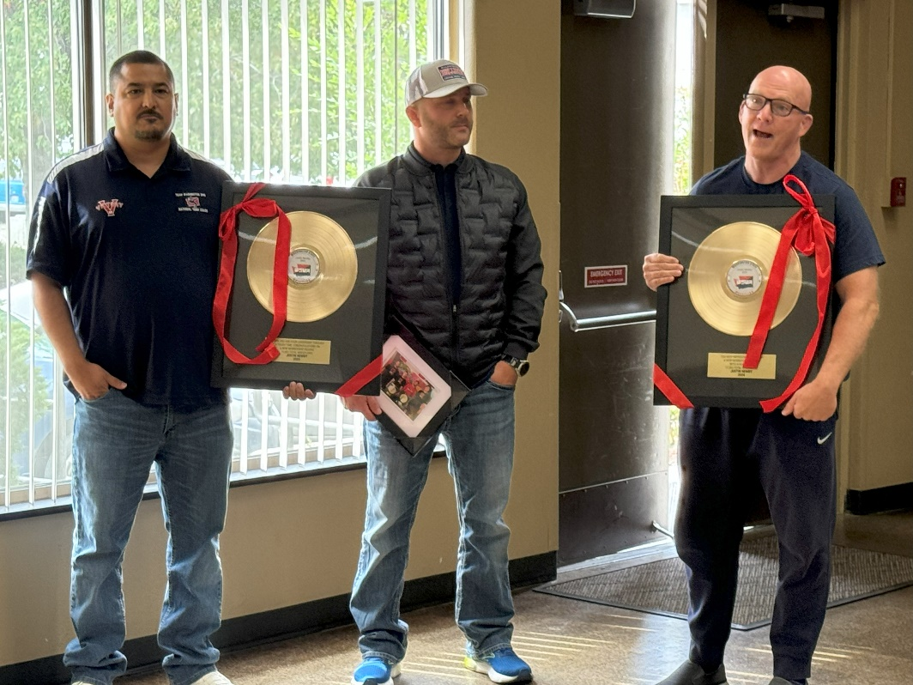
*Rene Torres, Justin Newby and Jeff Moore

