
CALGARY BANTAM FOOTBALL ASSOCIATION (CBFA)
2022 BASELINE and CONCUSSION MANAGEMENT
Recommendation: SHRed (Surveillance in High Schools to Reduce the Risk of Concussions and their Consequences)
About SHRed ( and SHRed-Football )
In North America youth account for over half of more than three million concussions. Reducing the burden of concussions in youth is paramount. SHRed Concussions is a Canadian research study funded by the National Football League’s (NFL) Scientific Advisory Board. There are ten Canadian Universities involved (University of Calgary being one), as well as more than 30 community, government, and industry partners across five provinces. The primary objective of SHRed Concussions is to develop a greater understanding of concussions and their consequences among high school athletes with a focus on Prevention, Detection, Assessment, and Treatment. What are we trying to do?

- how to prevent concussions from occurring
- how to best detect and diagnose concussions
- how to manage concussions to expedite athlete’s return to play
Benefits
- Most up-to-date information and state-of-the-art resources available.
- Sports Medicine Physicians treat all concussed participants – without a referral.
- Connect to a Sports Medicine Physician in the best location for the participant.
- Players will be cleared to play by the Sports Medicine Physician treating them.
- Players signed up through SHRed are covered in CBFA’s off-season and for non-football injuries.
- Information session for Coaches and Coaching Staff provided.
- Capacity to complete baseline for all teams by mid-March, both at the team’s practice location and online.
- Ability to conduct helmet fit assessments.
- Players may benefit and participate in the SHRed program for a full three years.
- Parents may participate in the study if they would like to – the data they provide is valuable to the study.
- Zero cost to the players/families and teams.
Athletes Responsibilities
Participants must create an online account PRIOR to Baseline Testing at SHRedConcussions.ca, (steps below). Through this account participants will complete their five (5) minute weekly sport participation and injury survey. Athletes will also confirm any injury sustained with their study therapist. Prior to any in-person contact practices participants are asked to complete baseline testing which includes baseline measures, online questionnaires, and clinical assessments.
SHRed Online account:
- Parents – go to SHREDConcussions.ca
- Create a “PARENT ACCOUNT”
  - Enter your email and create a password
  - Read and sign the parental consent
- Your will receive an email from SHRedConcussions.ca asking you to verify your email address
- You must login to your account
  - Login at SHRedConcussions.ca
- Click on the “Add Child” tab
  - Enter your child’s name, birthdate, name of football club (NOT school): Calgary Bantam Football, and email
- Your Child (the participant) will then receive an email from SHRedConcussions.ca
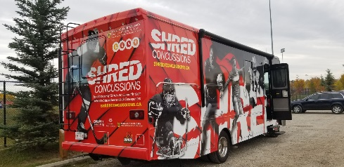
  - Click link in email
  - Read and sign the assent form
- Your Child will then enter a password to create THEIR account
  - Complete ALL baseline questionnaires
  - Remember to login weekly to complete online activity surveys

