2024.2025 14U Indiana Girls National FS Team
Team Leaders & ISWA Title: Patrick Rowles ISWA Girls Director
Coaches: Steve Livingston, Andy Oberlin, Coty McCue
Volunteers & Others You'd Like to Thank: Team Mom Jackie McCue, Table Worker Robert Hammond
Team Results: 14U Indiana had an overall 6-2 record finishing 1st in the Red/Blue Bracket. 17th out of 30 teams in Freestyle. 14U Indiana Girls Greco Roman Team went 3-3 to finish 6th out of 18 Teams.
Roster:
75- Mackenzie Moe (FS 5-3) (GR 3-3)
80- FF
85- Grace Nedelsky (FS 7-0) All American (GR 2-4)
90- Kylie Asa (FS 6-2) (GR 5-1)
95- Achaiah McCue (FS 6-2) (GR 5-1)
100- Reid Bebe (FS 0-8) (GR 1-5)
105- Alexis Rodriquez (FS 4-3) (GR-DQ)
110- Alyssa Livingston (FS 4-4) (GR 2-4)
115- Sadie Bower (FS 3-5) (GR 0-6)
120- Maya Hammond (FS 7-1) (GR 4-2)
125- La’Raya Veazy (FS 6-2) (GR 3-3)
130- Lilly Cline (FS 0-8) (GR 2-4)
135- Madeline Hazelett (FS 6-2) (GR 2-4)
140- Kylee Pearson (FR 5-3) (GR 4-2)
150- Ryanne Fink (FS 5-3) (GR 3-3)
165- Hannah Beasley (FS 8-0) All American (GR 3-2)
180- Amia Quarles (FS 7-1) (GR 5-1)

Narrative: Indiana 14U Girls had a great weekend, as it was the first time competing at a National level for some of them. In Freestyle they were 2-2 on the first day and rallied back to a 4-0 record on day 2, With 2 undefeated All Americans. It was definitely the first taste of National competition for these ladies in Greco Roman, and they did not back down. These young ladies battled to a well deserved 6th place National finish out of 18 Teams with a 3-3 record on the day.

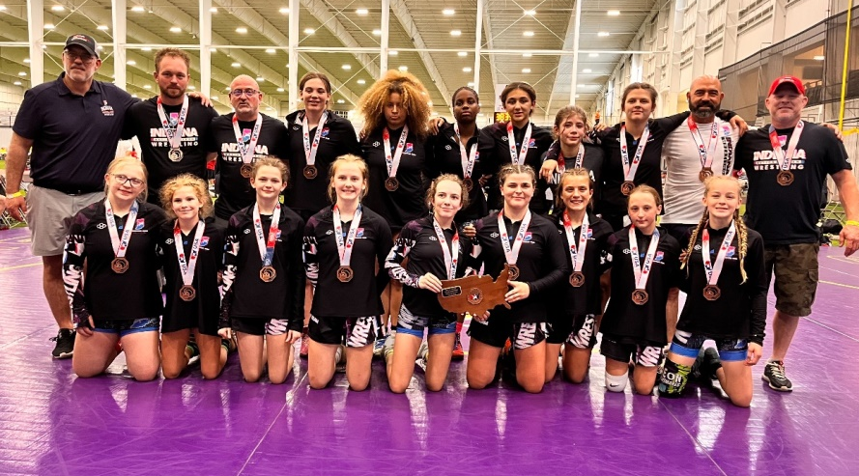
Coach Doug Strayer, Coach Coty McCue, Coach Andy Obelein, Ryanne Fink, Amia Quarles, La’Raya Veazy, Madeline Hazelett, Maya Hammond, Lilly Cline, Coach Patrick Rowles, Coach Steve Livingston
Hannah Beasley, Mackenzie Moe, Reid Bebe, Alyssa Livingston, Kylie Asa, Kylee Pearson, Sadie Bower, Grace Nedelsky, Achaiah McCue

