Past Champions
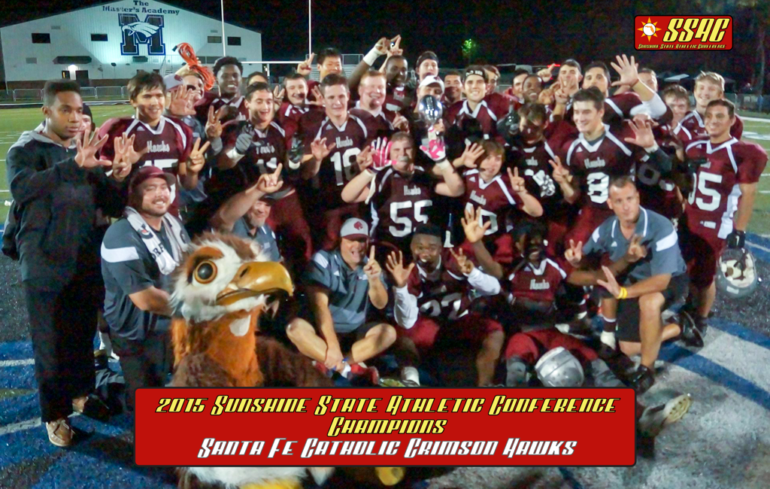

Florida Bowl Champions (Varsity Football)
Year | School | Champs | Runner-Up
2008 | Hernando Christian (10-0, 3-0) | Hernando Christian 22 | Mount Dora Bible 6
2009 | Canterbury School of Florida(St Pete) (9-1, 4-0) | Canterbury 48 | St John Lutheran 7
2010 | St Edwards School (11-1, 6-0) | St Edwards 47 | St John Lutheran 6
2011 | Landmark Christian (11-2, 4-0) | Landmark Christian 40 | Seven Rivers Christian 0
2012 | The Master's Academy (7-3, 5-1) | The Master's Academy 35 | Seffner Christian 17
2013 | First Academy-Leesburg (8-2, 5-1) | First Academy 28 | Orlando Christian Prep 20
2014 | Windermere Prep (11-0, 5-0) | Windermere 48 | Orlando Christian Prep 19
2015 | Santa Fe Catholic (11-0, 7-0) | Santa Fe 33 | Saint Stephen's 0

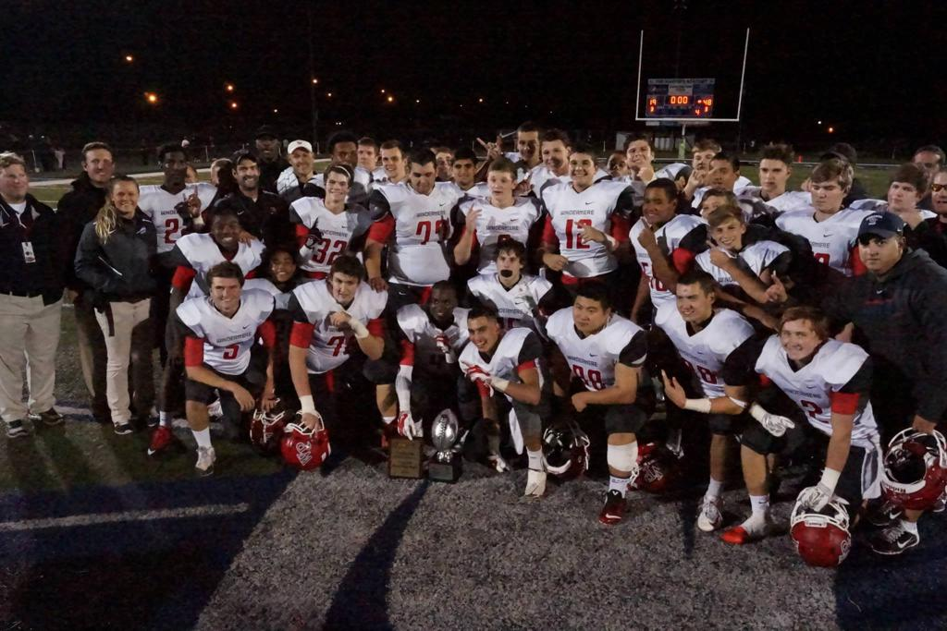
2014 Varsity Football Champions- Windermere Preparatory School

Varsity Boys Basketball Champions
Year | School | Champs | Runner-Up
2014-2015 | International Community School (13-11, 4-1) | ICS 65 | CFCA 56
2015-2016 | Saint Edwards School (10-8, 5-0) | SES 61 | Trinity 52

Varsity Girls Basketball Champions
Year | School | Champs | Runner-Up
2014-2015 | Seven Rivers Christian School (17-5, 4-0) | SRCS 45 | ICS 17
2015-2016 | International Community School (14-8, 5-0) | ICS 48 | Berean 44

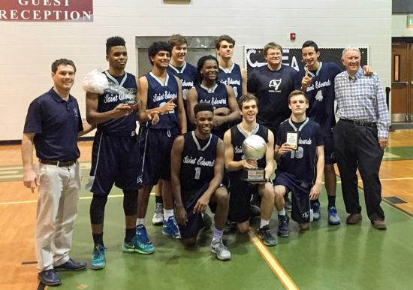
2016 Boys Basketball Champions- St. Edwards School
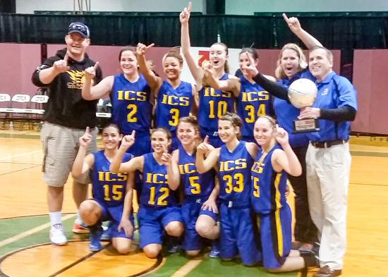
2016 Girls Basketball Champions- International Community School

Middle School Football Champions
Year | School | Champs | Runner-Up
2014 | Ocala Christian Academy (5-0, 4-0) | OCA | Legacy Charter
2015 | Windermere Prep School (7-0) | WPS | Lake Highland Prep

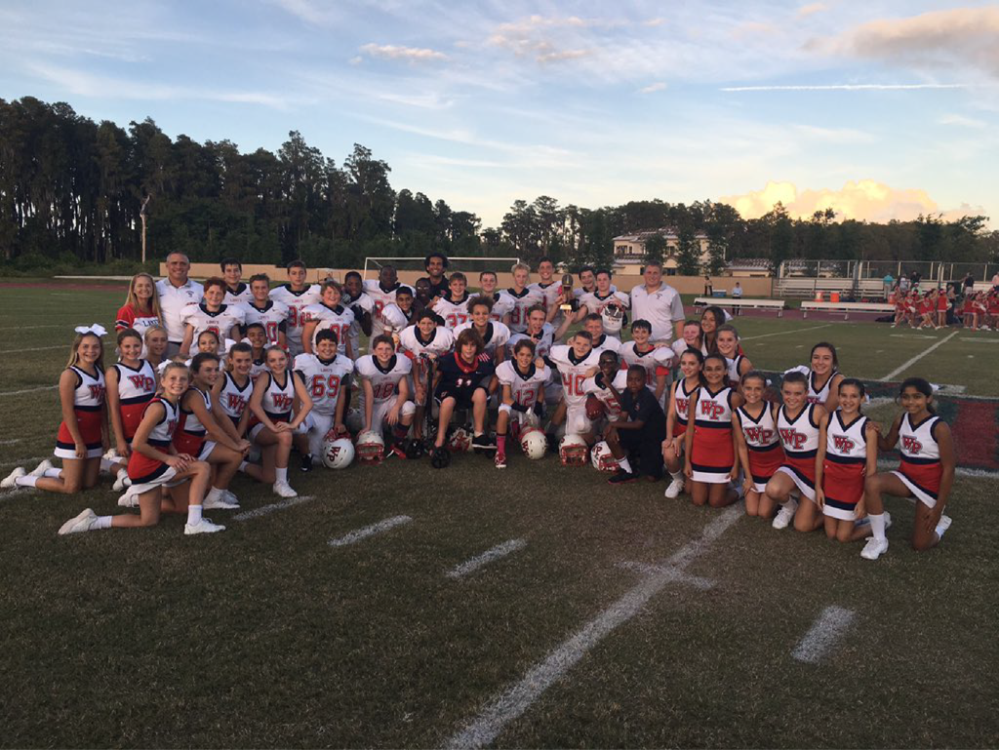
2015 MS Football Champs-Windermere Prep School

