SLPYHA Board Meeting Agenda
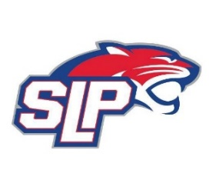
Date: 6/29/21
Bricks
8:00pm

Attendees: Scott Lichter, Michelle Rice, John Pitzl, Mike Mliner, Corey Piekarski, Jason Shipman, Adam Kiedrowski, Kevin Mitties, Mike Fitzpatrick, Bob Roloff
Guests: Will Wackman – SLP AD
Sarah Clark - Registration

- President Report: Scott Lichter
- Call to order: 8:03pm
- Approve agenda
- Approve minutes from 6/7/2021 meeting, motion: Mliner, move: Lichter
- Latest D10 updates
- Golf tournament
- Tryout ice
- Mandatory coaches meeting
- Vice President Report: Michelle Rice/John Pitzl
  - Volunteer hours
  - Hardship fund rules/guidelines
- Treasurer Report/Gambling Report: Mike Mliner
  - Motion by Pitzl to move $50,000 from gambling account to hockey account, move: Mitties
- Secretary Report: Corey Piekarski
- Traveling Director Report: Jason Shipman/Adam Kiedrowski
- Girls Traveling Director Report: Kevin Mitties
  - SLP/Centennial girls co-op update, contract signed today, 6/29/21
- Mite Director Report: Mike Fitzpatrick
- Coaching Director Report: Jeremy Flaten/Bob Roloff
- New/ongoing Business:
- Motion to dismiss: 10:32pm, motion: Fitzpatrick , move: Kiedrowski

