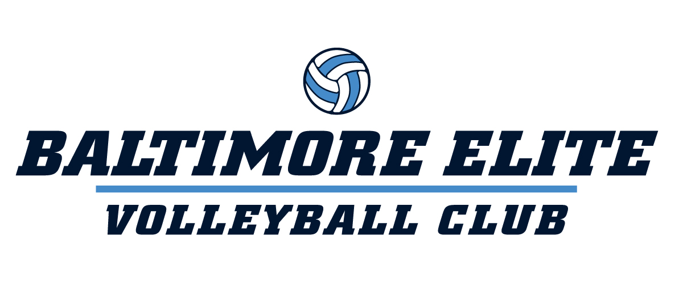

BALTIMORE ELITE SUMMER SETTER’S ACADEMY 2026
Tuesdays/Thursdays
June 23, 25, 30
July 2, 7, 9, 14, 16, 21, 23, 28, 30
August 4, 6, 11, 13
Location: Roland Park Country School
5204 Roland Avenue
Baltimore, MD 21210
Grades 7th-12th
Time: 4:45-6:00pm
Cost: $575

This summer, Baltimore Elite is proud to launch our Setter’s Academy-a specialized training program designed to identify, develop, and elevate the next generation of elite setters. Our Setter’s Academy will provide focused, position-specific training for athletes who want to take command of the court. This program is built for setters who are serious about improving their technical precision, decision-making, leadership, and overall volleyball IQ.

Athletes selected for the Academy will receive:
• Advanced, position-specific skill training
• Emphasis on tempo, consistency, and offensive distribution
• Game-like reps to develop decision-making under pressure
• Leadership development to confidently run a team
• Direct instruction from experienced Baltimore Elite coaches

The Setter’s Academy is more than just training—it’s a recognition of athletes who demonstrate the potential, work ethic, and mindset to lead. Our goal is to build confident, dynamic setters who can elevate every team they step on the court with.

Spots will be limited as we look to invest deeply in each athlete’s development.
************************************************************************************************************
BALTIMORE ELITE VOLLEYBALL SETTER’S ACADEMY REGISTRATION FORM
**Registration on a first-come, first-served basis**
Player Name: ___________________________________________________________________________________________________________________________
Address: ________________________________________________________________________________________________________________________________
Phone: ______________________ Age: _____ Grade and School: _________________________________________________________________________________
Email Address (please include so I can email you confirmation): ____________________________________________________________________________________
Club Experience: Yes____ No____ Club:______________________________________________________________________________________________________
T-shirt Size (adult sizing/circle one): S M L XL XXL

Parent Agreement:
I, the undersigned, understand that participation in volleyball involves physical activity and risk of injury. I release and hold harmless Baltimore Elite Volleyball Club, its coaches, and facilities from any liability related to participation in this academy.
Parent's Signature: ________________________________________________________ Parent's Printed Name: _____________________________________________
Emergency Contact Information: _____________________________________________________________________________________________________________

Questions? Contact Kelli Wilkinson at baltimoreelitevbc@gmail.com or at 443-690-8575 (C). Mail registration form and a check made payable to Kelli Wilkinson to 38023 Water Walk Way, Selbyville, DE 19975. No refunds given after the league begins. Registration forms can also be emailed to baltimoreelitevbc@gmail.com. Go to www.baltimoreelitevbc.com for more details.

