Please read the following instructions carefully; they should furnish all the information you need to help you follow through on your responsibilities.

Reporting Date: Sunday, March 22, 2026
Report To: Lindsay Event Center, 701 Elm Street, Lindsay, NE 68644
Reporting Time:
Coaches/ Officials/ Staff: Please Report by 11:00 a.m.
7th/8th Grade Players: Please report by 11:00 a.m.
Seniors Girls (White 2 & Purple 2): Please report by 12:00 pm
Seniors Girls (White 1 & Purple 1): Please report by 1:30 PM unless you are in the Skills Challenge or 3pt Contest
Seniors Boys: Please report by 1:30 PM

Schedule of Events:
12 pm | 7th/8th Grade Girls Game
1 pm | Senior Girls Team White 2 vs. Team Purple
2:30 pm | Senior Boys Team White 2 vs. Team Purple 2
4 pm | Senior Girls Team White 1 vs. Team Purple 1
5:30 pm | Seniors 3-Point Shootout and Skills Challenge Finals
6:30 pm | Senior Boys Team White 1 vs. Team Purple 1
*3-Point Shootout and Skills Challenge early rounds will be during halftimes of early games.

What to Bring: Black athletic shorts to wear. We will provide T-shirts for the 7th/8th grade All Stars. We will provide a jersey for the Seniors. The seniors will need to return the Jerseys immediately after the games.

Conduct: All players will be under the supervision of the All Star Coaches and WER Staff.

Game Tickets: Admission will be $15 for adults and $5 for those K-12. Any child below kindergarten age will be admitted for free.

Below are the players participating in the 3-Point Contest and Skills Challenge and Roster that Team that you are on:
7th/8th Grade 3pt Contest
Lilly Rader, Creighton
Brynn Fustos, Glenwood
Kingzlee Peltz, Chalk Butte Country
Alexis Weber, Creighton
Jordyn Werner, Archbishop Bergan Catholic
Taya Gowery, Wynot
Brynleigh Anderson, Christ Lutheran
Remy Swartz, Elkhorn

7th/8th Skills Challenge
Naylee Gleeson, Lindsay Academy
Mallory Berg, St. Mary (O'Neill)
Tatum Pfister, Ponca
Mireya Woods, Creighton
Berkley Thompson, Elkhorn
Amelia Gigstad, Wahoo
Ava Robinson, Spirit and Grace Academy
Lyricc Johnson, Beveridge Middle School

Girl’s 3-point Contest
Harley Lubben, Johnson County Central
Mikkel Parker, Omaha Nation (Macy)
Addison Sharpe, Wynot
Brooklyn Mans, Elmwood-Murdock
Karlee Baack, Seward
Taylor Dawson (Wausa)
Sopie Schmidt, Silver Lake
Jaycelyn Hoos, Sumner-Eddyville-Miller

Girl’s Skills Challenge
Taryn Arbuthnot, Sumner-Eddyville-Miller
Desma Walker, Omaha Nation (Macy)
Addison Walter, Cedar Catholic (Hartington)
Miranda McGill, Boone Central (Albion)
Abbi Durow, Millard South
Emelia Daubendiek, Marian
Jaylin Geisen, Wynot
Hayden Korus, Millard South

Boy’s 3pt Contest
Cooper Todd, Ravenna
Kyle McMullin, Clarkson-Leigh
Isaac Rudloff, Battle Creek
Ivan Lyons, Walthill
Colsten Rodriguez, Twin River
Jaxson Ohlman, Shelton
Drew Siems, Tri County
Logan Lienemann, Randolph
Preston Rost, Oakland- Craig
Boy’s Skills Challenge Contest
Jax Bauer, Pierce
Corbin Rodriguez, Twin River
Baron Medina, Holdrege
Wes Swanson, Johnson County Central
Ian McDonald, Lutheran Northeast
Ethan Kuhl, Creighton
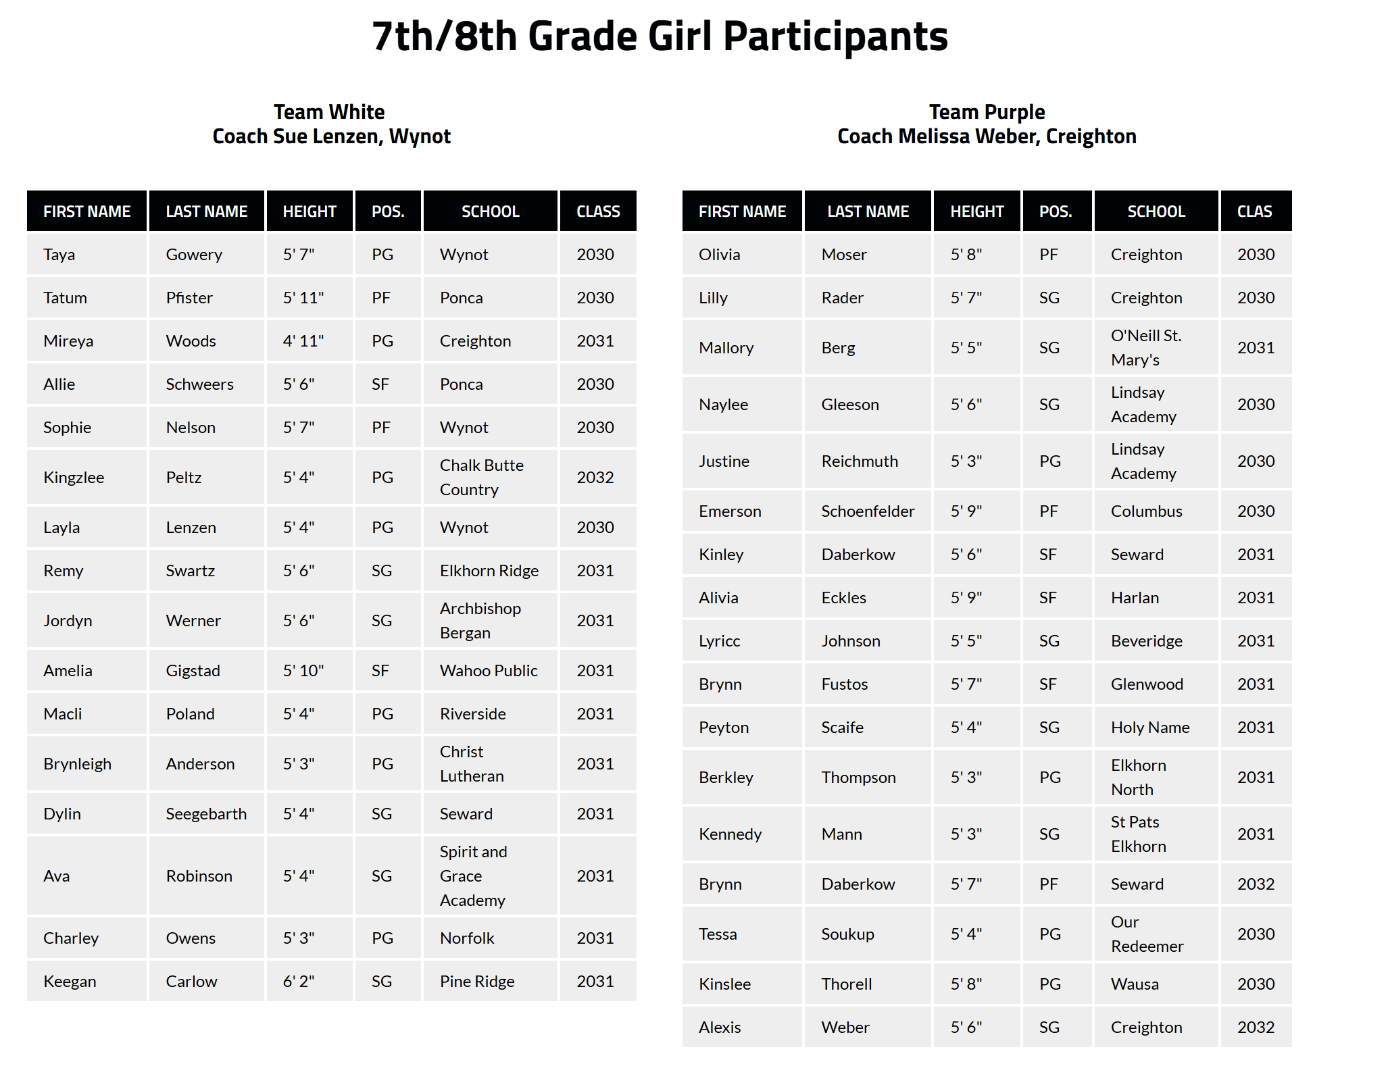
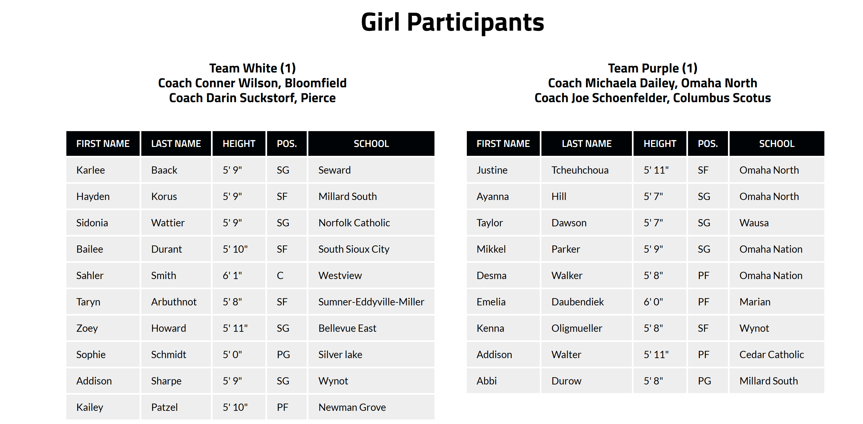
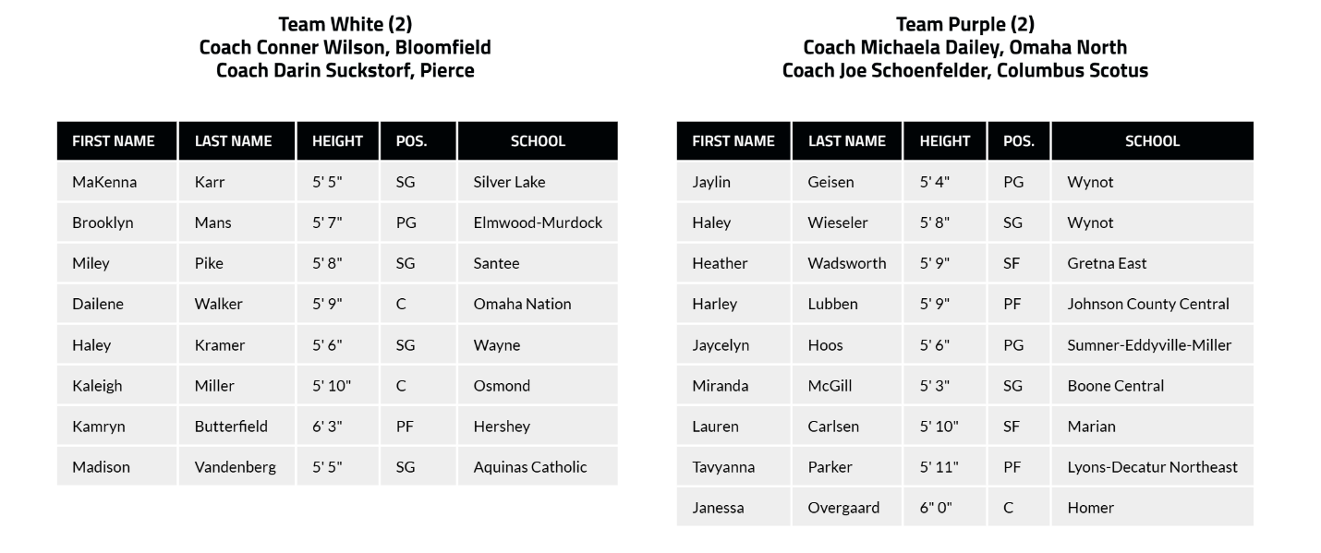
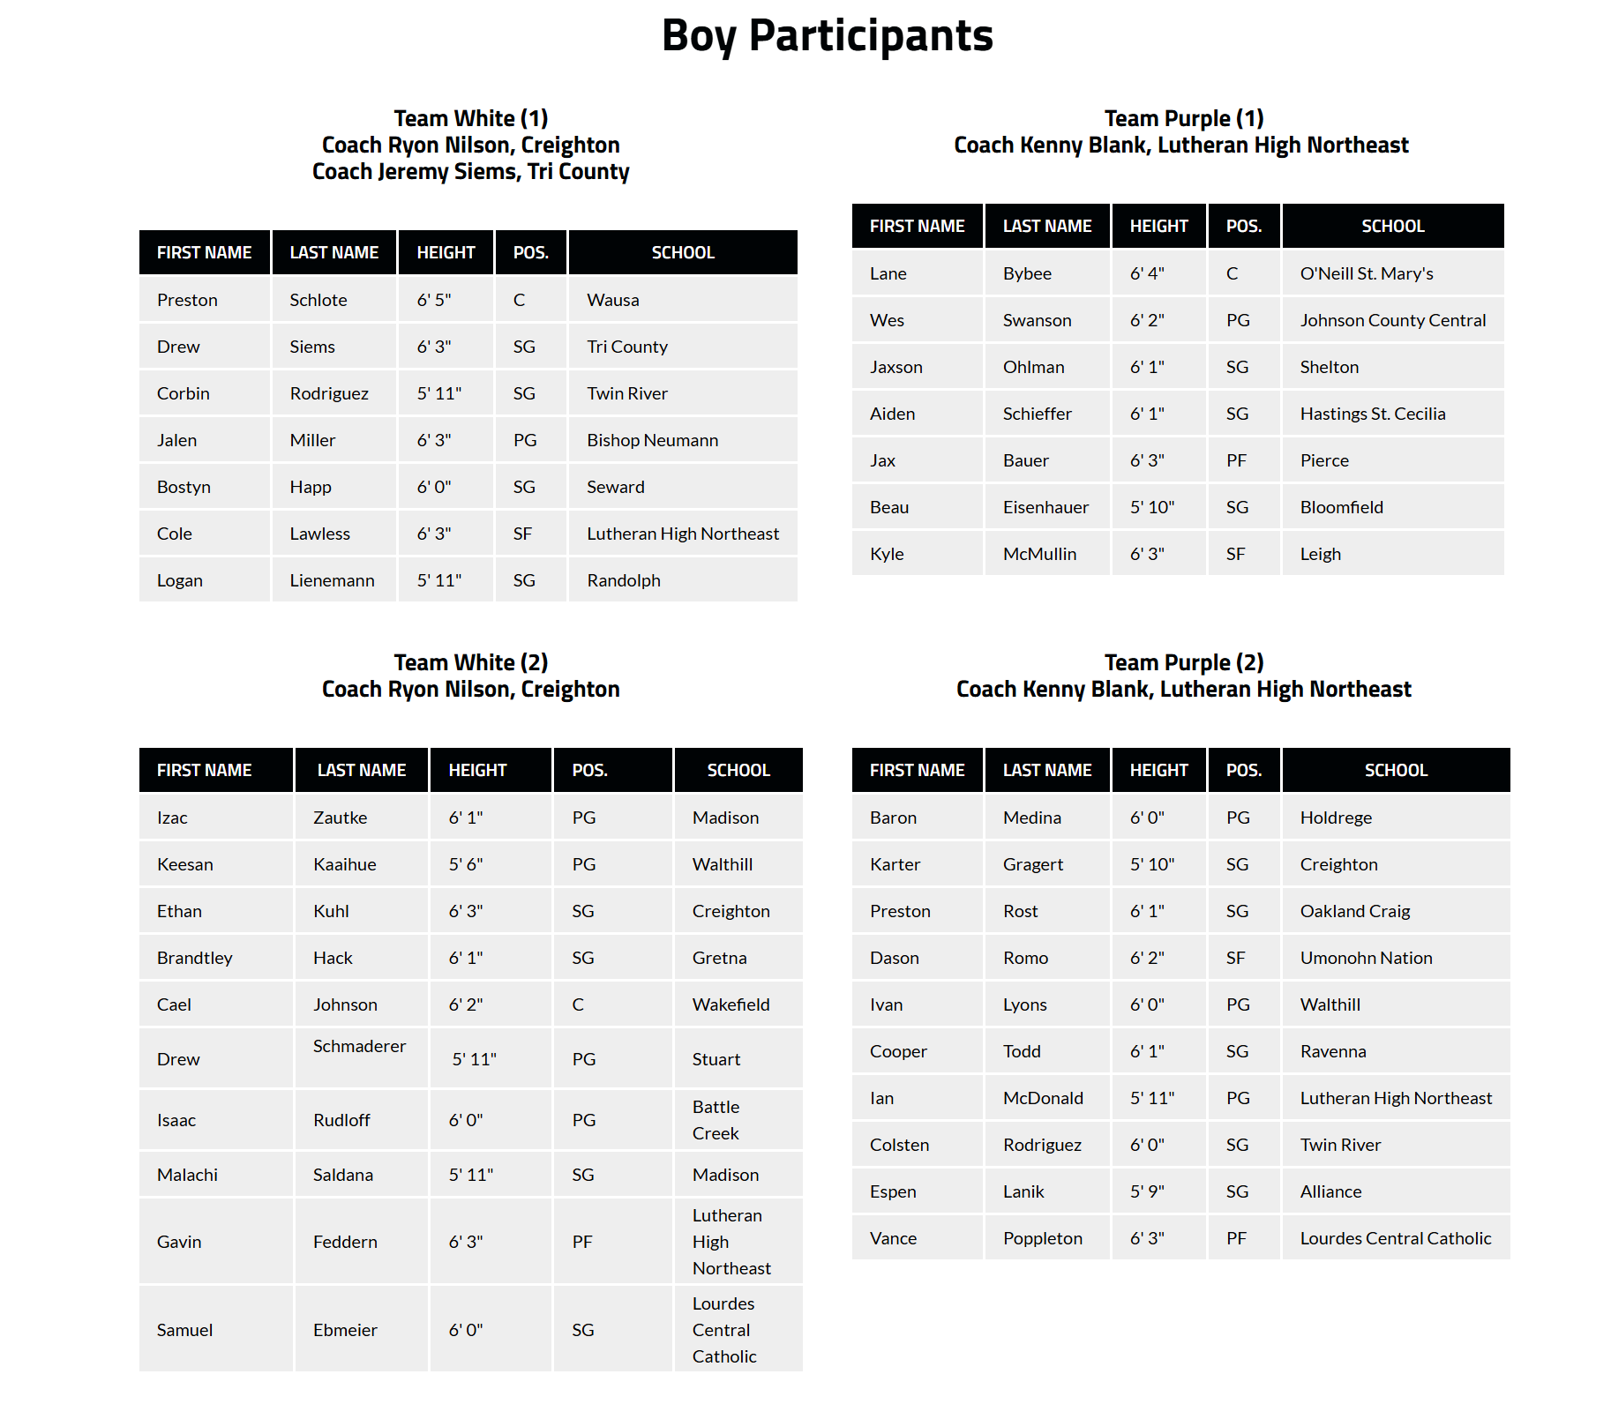
More Information:
Donnie Woods, worldexposurewbb@gmail.com, (402) 885-3148

