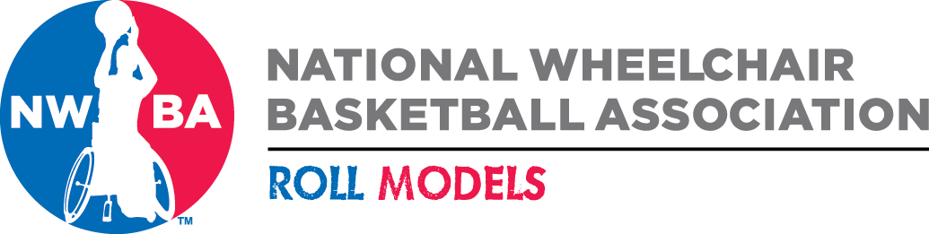

NWBA Team of the Month Nomination Form

Circle
Division: College Men College Women Junior Varsity Prep

Adult Division I Adult Division II Adult Division III Women’s

Team: Month: ______________

City, State: How long team has played:

Team Stats for October:

Team Record for Month (W-L): Season Record (W-L):

Statistical Leaders for Month:

Any records set, if so, please detail:

Nomination Description (Detail accomplishments, ranked teams played, highlight players with stats):

Nomination Submitted By:

Name:

Affiliation:

Please send two photos of nominated team.

Submit Nominations to NWBA by Monday, October 28th at 12:00 p.m. MT.

Send to: Rebekah Markovitz, NWBA, via email: communications@nwba.org

