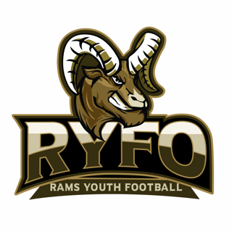
2022 RYFO Cheer Student Coach Application
Open to cheerleaders in grades 8th through 12th.

Job Expectations
- Flexible schedule
- Choreographing half time routine
- Teaching cheers
- Being a role model for youth cheerleaders
- Work on building a strong foundation of cheer fundamentals

If interested or have any further questions, please contact RYFO Cheer Director Lisa Leasure – 724-422-2525.

