MITE TIME CLOCK DIRECTIONS
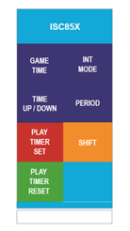
Make sure the screen states down.
If not hit the purple Time Up/Down button.
SET TIME:
1. Press GAME TIME (26 minutes)
2. On number keypad Enter MINUTES, press enter, enter, enter.
3. The press SHIFT & MINS then ENTER. (2 minute shifts)

