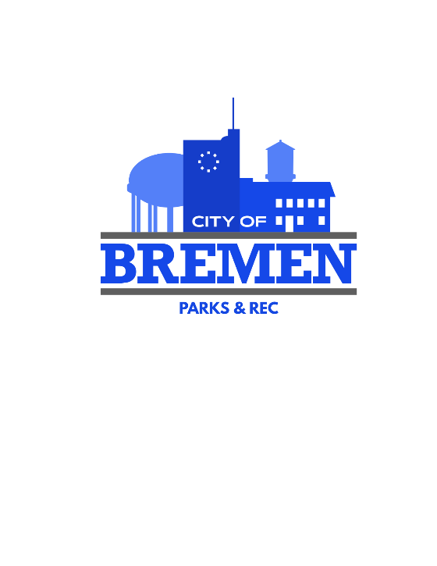
Bremen Parks & Recreation Department
Job Description

JOB TITLE: Leisure Coordinator- Part Time
RATE: $20.64

JOB SUMMARY: Time not to exceed 59 hours a pay period. The Leisure Coordinator is responsible for assisting in planning, organizing, and executing large-scale community events. This role engages individuals of all ages and abilities, fosters partnerships within the community, and creates inclusive, memorable experiences. The coordinator will also play a key role in supporting programming for individuals with special needs, including collaboration with local schools and community initiatives. Will report directly to the Leisure Superintendent.

SUBMITION: Cover letter, Resume, City of Bremen Job Application and letter of references must be turned in via email to mattcodybprd@gmail.com

DEADLINE: All materials should be submitted by 12pm on Friday, May 15th

MAIN DUTIES AND RESPONSIBILITIES
- Must be able to work nights and weekends as needed

- Budget, Plan, and Coordinate events, festivals, and smaller engagements for the community

- Coordinate vendors including food trucks, entertainers, rental companies, and service providers

- Develop and manage event budgets, ensuring cost-effective planning and execution

- Build and maintain relationships with community members, families, and local organizations

- Assist with event marketing through social media, flyers, and community outreach

- Support and participate in community garden activities with individuals with special needs

- Collaborate with the Bremen City Schools to plan and host inclusive events and programs

- Track expenses and provide post-event evaluations and reports

SPECIFIC DUTIES AND RESPONSIBILITIES
Event Planning & Execution
- Plan and execute large-scale community events, festivals, and smaller engagement activities
- Develop creative, innovative event concepts that appeal to diverse audiences
- Manage event timelines, logistics, and day-of operations to ensure smooth execution
- Coordinate vendors including food trucks, entertainers, rental companies, and service providers
Community Engagement
- Serve as a public-facing representative at events and within the community
- Build and maintain relationships with community members, families, and local organizations
Special Needs Programming
- Support and participate in community garden activities with individuals with special needs
- Collaborate with the Bremen City Schools to plan and host inclusive events and programs
- Ensure accessibility and inclusion are prioritized in all programming
Budget & Project Management
- Develop and manage event budgets, ensuring cost-effective planning and execution
- Source and negotiate with vendors to stay within budget while maintaining quality
- Track expenses and provide post-event evaluations and reports
Marketing & Design
- Create promotional materials using Canva and Microsoft Office
- Assist with event marketing through social media, flyers, and community outreach
MINIMUM TRAINING AND QUALIFICATION
- 2 Years of experience in recreation programming or a related area; or any equivalent combination of education, training, experience which provides the requisite knowledge, skills and abilities for this position.
- Experience in event planning, recreation, hospitality, or community engagement preferred
- Strong organizational and multitasking skills
- Excellent communication and interpersonal skills
- Ability to work both independently and collaboratively
- Creative thinker with strong problem-solving abilities
- Computer Skills with Microsoft, Canva, etc.
- Must possess a valid driver’s license.
- Must pass drug screening

