SLPYHA Board Meeting Agenda
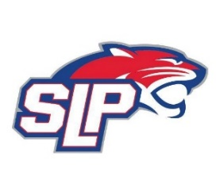
Date: 4/20/21
Fogerty
8:00pm

Attendees: Bob Roloff, Michelle Rice, Scott Kevin Mitties, Chris Mueller Jeremy Flaten Lichter, John Pitzl, Jason Shipman,
Guests:

- President Report: Bob Roloff
- Call to order: 7:30pm
- Approve agenda
- Approve minutes from 3/11/2021 meeting, motion: Lichter, move: Rice
- Latest D10 updates
- Vice President Report: Michelle Rice/Scott Lichter
  - MAP/FHIT Training
  - SLP hosted tournament
- Treasurer Report/Gambling Report: Mike Mliner
  - Season refunds
  - 2021-2022 Budget to be finalized in May
- Secretary Report: Corey Piekarski
- Traveling Director Report: Jason Shipman/Chris Mueller
  - High school involvement next year
- Girls Traveling Director Report: Kevin Mitties
- Mite Director Report: John Pitzl
  - Goalie gear
- Coaching Director Report: Jeremy Flaten
- New/ongoing Business:
  - All new positions have been approved by unanimous vote
  - Scott Lichter – President
  - John Pitzl – Vice President
  - Adam Kiedrowski – Traveling Director
  - Mike Fitzpatrick – Mite Director
  - Bob Roloff – Coaching Director
  - Non-Board Position are Jess Kiedrowski (SKATE Coordinator) and Erika Julkowski (Tournament Scheduler)
- Motion to dismiss: 9:30pm, motion: Mliner, move: Rice

