

INFORMATION FOR ROCK HILL SPORTS CENTER
Palmetto Region Tournaments

Page. 1: General Information
Page 2: Power House Food Court Page 4: Rock Hill Sport Center Layout
Page 3: EverBowl Restaurant coupon Page 5-7: Parking info
Welcome to the Rock Hill Sports Center, in partnership with USA Volleyball Palmetto Region, we host 7-8 tournaments annually. This is one of the finest facilities in South Carolina.

Seating: Seats are provided for Spectators. DO NOT SAVE SEATS: Utilize them while YOUR team is playing. When your team is OFF or working as an officiating team, leave the seats around the court so the participating teams can view their children's play. No sports chairs allowed.

Food: No team food may be brought into the facility. Families may bring in their meals, but teams can
Not bring in and set up team tables. There are limited tables in the large room adjacent to the courts, but these are only to be used to a limited time to have a meal or snack. Teams or families can not “camp out” there for the day or extended time. PLEASE DISPOSE OF YOUR TRASH. The RH Sports Facility does have a canteen

Restaurants: There are a number of NEW restaurants within walking distance.
Power House is similar to a Mall Food Court: https://www.powerhousefoodhall.com/
Also new is : https://www.everbowl.com/acai-bowl-locations/rock-hill
If you desire to make Team Orders: contact: leasing@powerhouserockhill.com or 803-233-0800 Ext 2

Additional restaurants: https://www.cityofrockhill.com/visitors/attractions/restaurants

• Grab and Go Options? Any items on the menu provided can be prepped as a grab and go option with enough advanced notice or prepped as a 'box lunch'. Healthier options from the stalls are highlighted in blue.
• Reservations for Team Tables if they desire to sit together: The simplest answer here would be to simply make the dining mezzanine private during that time and allow the team(s) to have free access to that space as needed. It can comfortably sit about 30 people at a time. Otherwise, the tables and chairs in the food hall can easily be modified to accommodate this or the giant family table in the center of the atrium can be marked as reserved as well. Additionally, and this wouldn't make sense for this January event, but for future events when the weather is warmer, we could do the same setup with our outdoor space behind the building.




ROCK HILL SPORTS CENTER LAYOUT

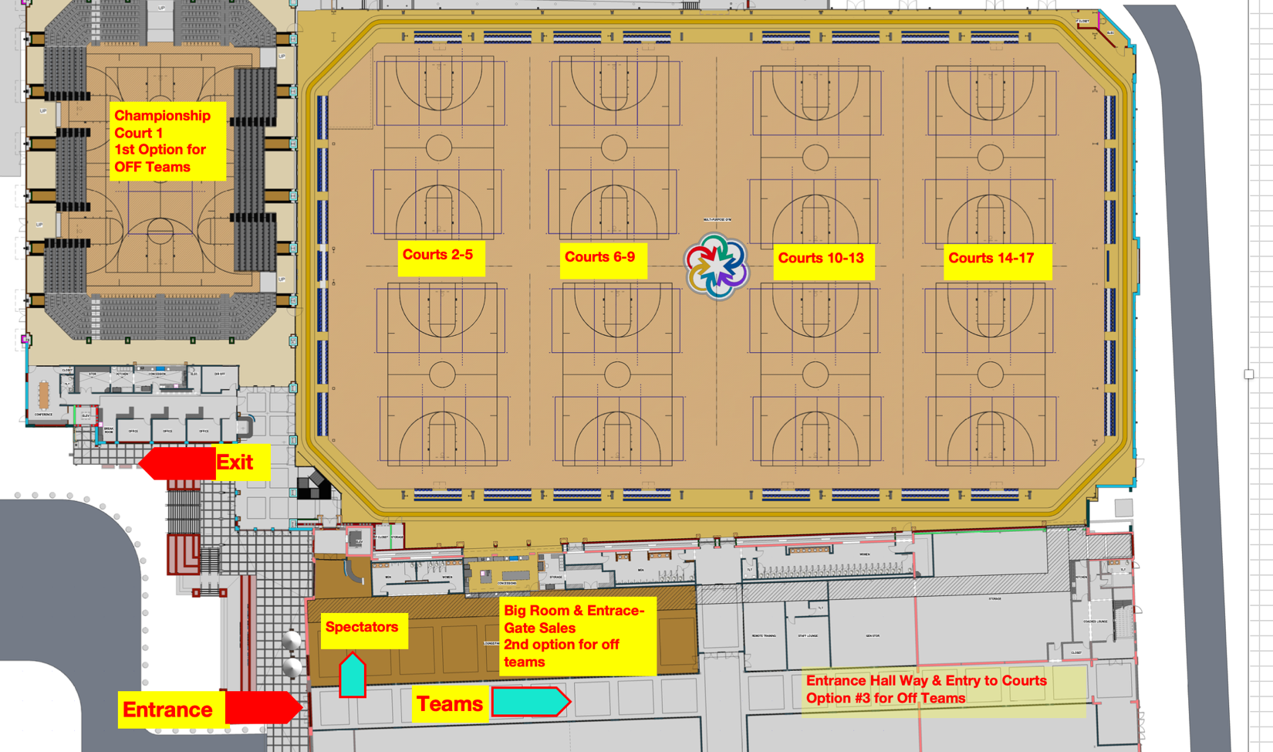

PARKING and HOW TO PAY

Below is some information about how to use the system. You can find QR codes throughout the decks via signage around the entrance, walkways, stairwells, elevators, parking spaces, etc.
Scan the QR code and follow the instructions. You will need to know your license plate number. I suggest to everyone to install the app. That way, your information is saved and on your next visit it only takes a few seconds to check in.

In addition to the attachments, please see below for additional parking details:

- UC Parking Decks A/B and Lowenstein Garage will be part of one parking system:
  - Parking Deck A – 348 Technology Center Way (pay by phone, P3406, via Premium Parking, see attachment), behind Cambria Suites Hotel
  - Parking Deck B – 343 Technology Center Way (pay by phone, P3407, via Premium Parking, see attachment), directly across from Lowenstein Building
  - Lowenstein Parking Garage – 300 Technology Center Way (pay by phone P3408, via Premium Parking, see attachment) underneath Lowenstein Building

- Parking Decks A/B and Lowenstein will be operated through license plate recognition. Therefore, you will need to register your vehicle's license plate, before walking away from vehicle.
  - All plates must be in the system to avoid being automatically flagged as a violator, and being automatically billed parking invoices ($25 fee for noncompliance, plus parking fees owed, plus escalation fees up to $75, and boot removal fee of $100). The registered owner will be billed, and if it is a rental, the rental company will be billed (which will more than likely increase the amount owed by the violator).

- You may pay for parking by scanning the QR codes in the decks (signage in stairwells/walkways) or by texting parking location (P3406 for Deck A, P3407 for Deck B, P3408 for Lowenstein) to 504504 (see attachment). There is also a toll free number: 844-236-2011.

- THERE IS NO FREE PERIOD FOR ON STREET PARKING. Register and pay before walking away from curbside spots.
- Oversize vehicle parking is very limited. Oversize vehicles may be required to park off-site.
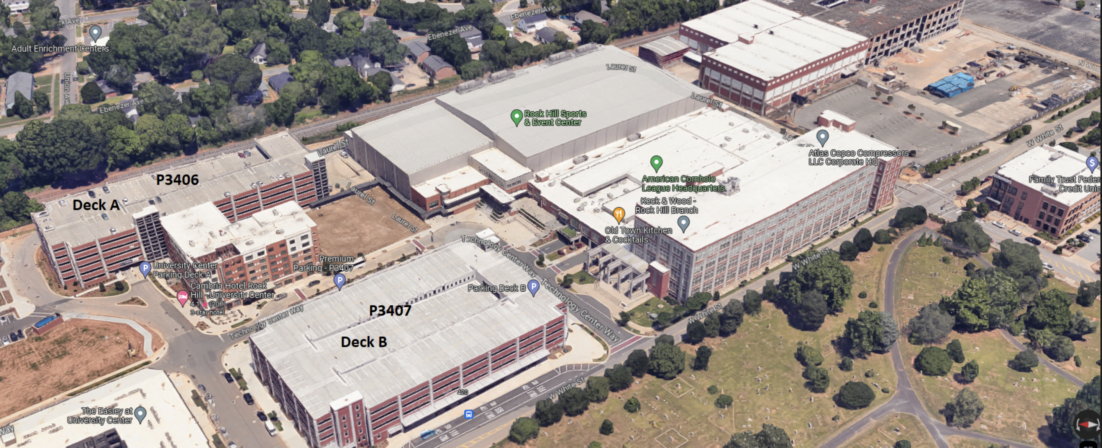

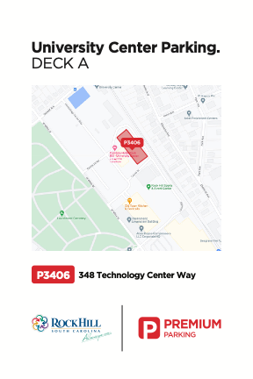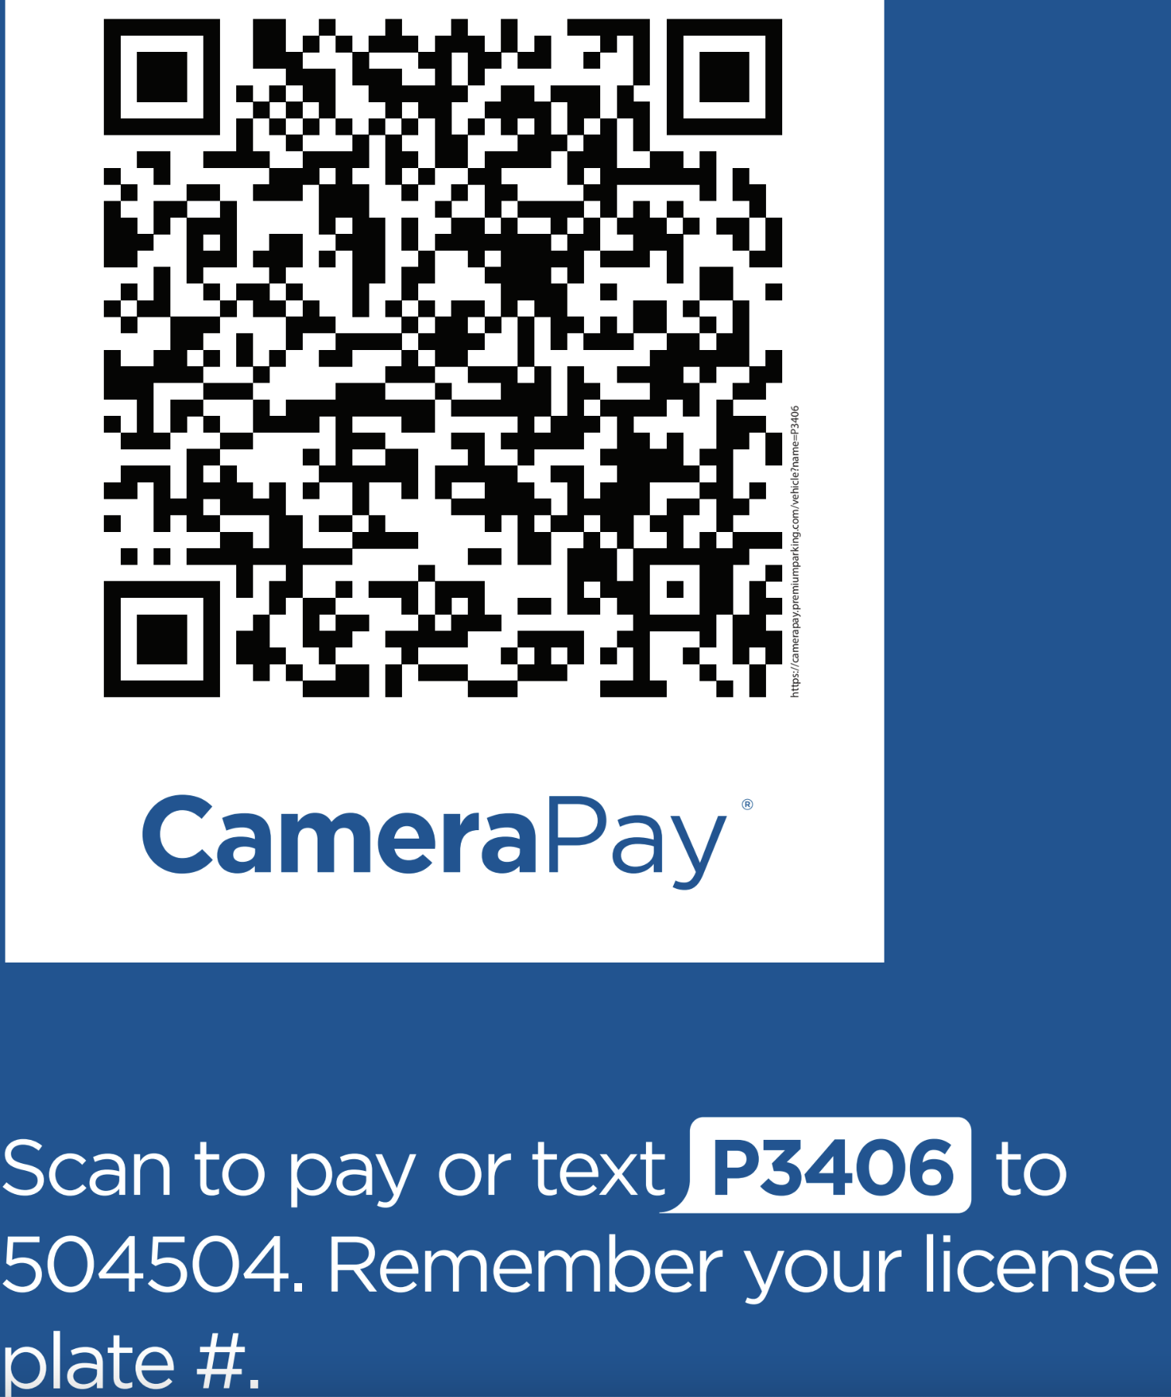
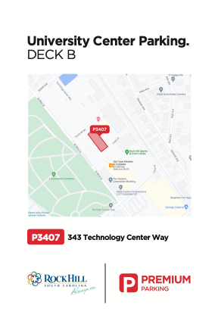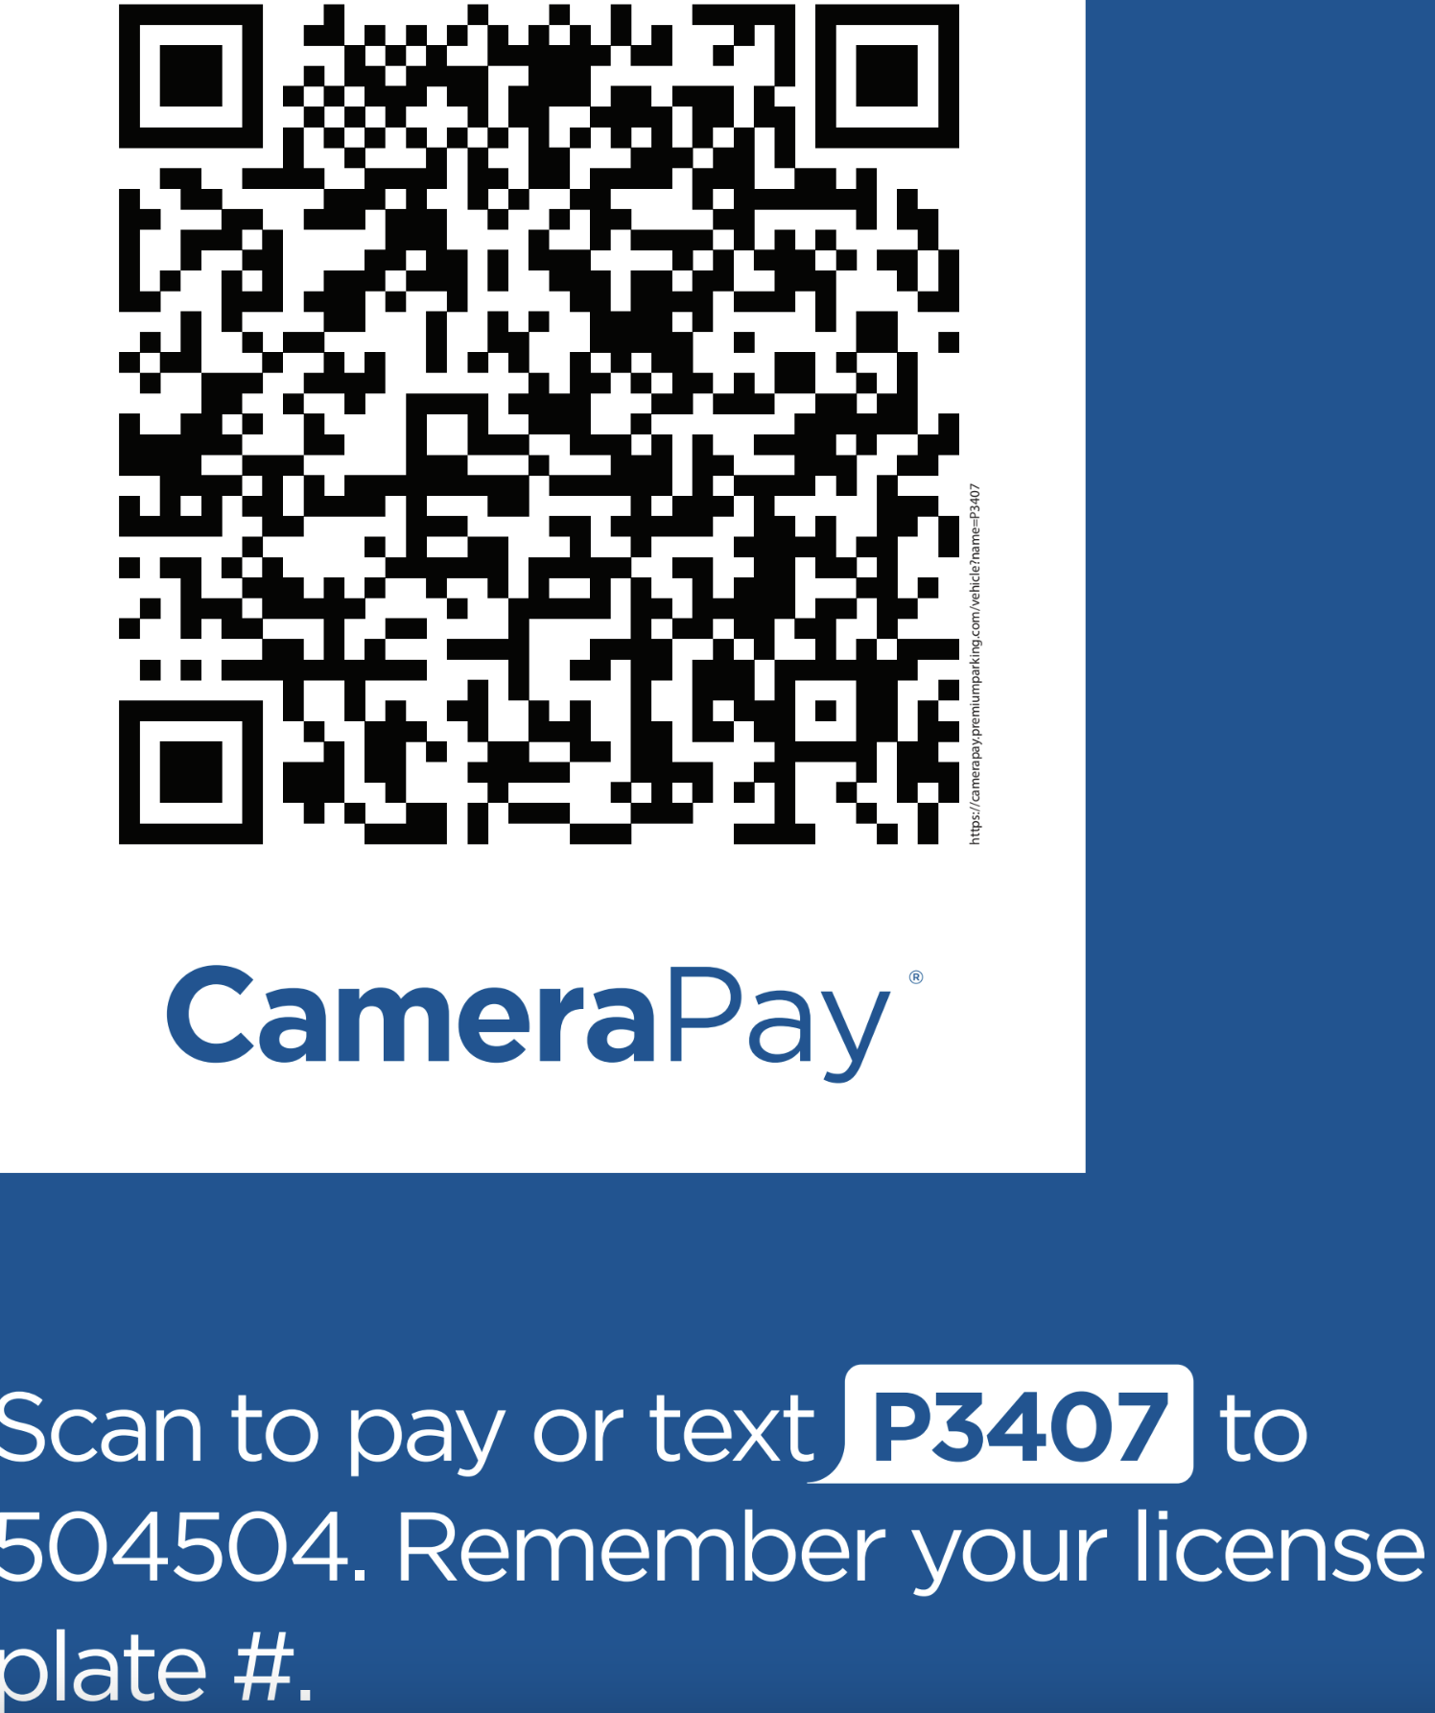
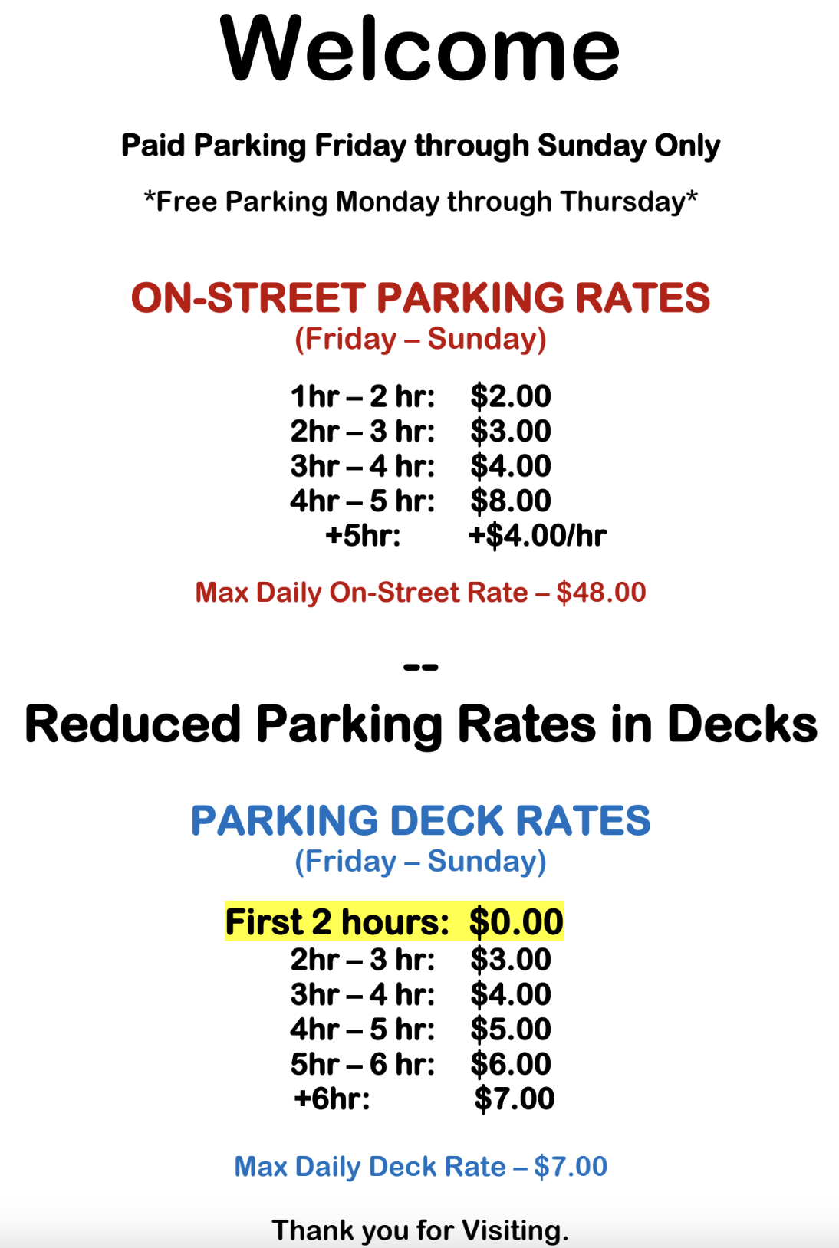
Hotel Information and Room Blocks

Palmetto Region negotiated with the city of Rock Hill and the local hotels to create blocks of rooms at the contracted lowest rates during the weekends of our events. To obtain these rates, you must use the links below.

Southern Classic Club Jan 13-14
https://groups.reservetravel.com/group.aspx?id=68713

Southern Classic Power Jan 20-21
https://groups.reservetravel.com/group.aspx?id=68714

RUMBLE at the Rock Feb 3-4
https://groups.reservetravel.com/group.aspx?id=71362

Winter Heat Mar 2-3
https://groups.reservetravel.com/group.aspx?id=68715

PVA Championships Week 1 Mar 22-24
https://groups.reservetravel.com/group.aspx?id=68724

PVA Championships Week 2 Mar 29-30
https://groups.reservetravel.com/group.aspx?id=68725

