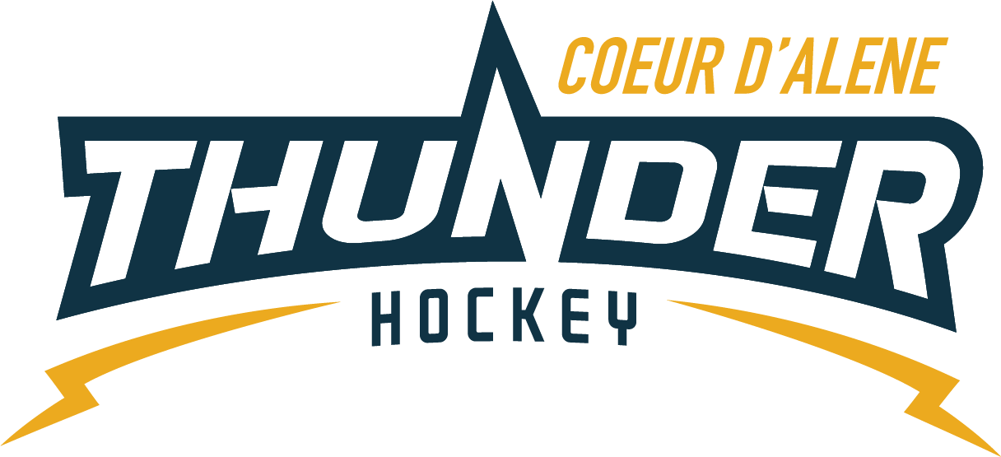

CDAHA

Meeting minutes
Location: ZOOM
Date: May 14, 2020
Attendees: Bob Nelson, Elliot Taub, April Hocking, Meghan Smith, Stacy Veach, Torsten Langley, Matt Creighton, Matt Fisher, Jarrod Hansen
Time: 6:00pm
- Call to order
Bob Nelson, President called meeting to order 5/14/20 @ 6:05pm
- Roll call
As stated above, Bart Barrett absent
- Approval of minutes from last meeting
Motioned by Elliot to approve minutes Meghan 2nd – passed
Motion by Elliot to un-approve minutes to fix financial typo – corrected – motion passed
- Open issues
  - Budget Presentation by Meghan see attachment
Mites $99 half season/$175 full season needed clarification,
Bob to assist with Mite programs
Prices increased across the board to maintain fiscal stability
Projections on assumed numbers returning
$50 off early registration fee
Josh motioned to approve the budget with a contingency on the travel team finding a coach.
After much more clarification Matt F motions to approve April 2nd passed unanimously
  - Committee Update
    - All agreed that things really need to be tidied up in the handbook/website
    - Torsten will chair the committee to get this done with Matt F and Elliott to help
    - They will also edit our Mission Statement
    - All parties agreed this is a must before moving forward with Committee Chairs/Positions this will be tabled to later meeting.
  - State Meeting/P&P udates
    - USA Hockey released their COVID recommendations
    - They also recommend each affiliate come up with their own policy/response.

- New business
  - Need to blast our COVID response when we have a clear understanding as well.
  - When we have clearer understanding move forward with Summer Skates
  - Next Meeting May 28th 6pm
- Adjournment
Bob adjourned the meeting at 7:34pm.
Minutes submitted by: April Hocking
Minutes approved by: Name

