GIRLS HOCKEY
“SNAP SHOTS”
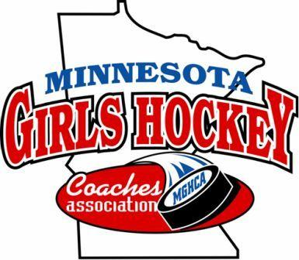
This time of year is always busy for everyone. Hockey season is in full swing with practices, games and bus travel, holiday gatherings with family and friends, gift shopping, jobs and a myriad of other small tasks fill each of our days. It is a fun time of year but it can also be exhausting with everything we as coaches try to accomplish in this short period of time. The MGHCA would like to take a few moments to wish everyone a happy and healthy joy filled holiday season. Cheers and enjoy the spirit of the season!

The Minnesota Girls Hockey Coaches Association (MGHCA) was formed during the 1995-96 season as a way to organize and coordinate activities related to girls’ high school hockey. Over the years, activities and programs have evolved to include programs not only for our coaches but for our athletes as well.
Below is a short checklist of some of the activities and tasks coaches should be preparing for as we near the mid-point of the girls’ hockey season.
- An updated MGHCA nomination form will be sent to all head coaches to fill out and return to the Executive Director as soon as possible. On this form coaches can nominate players for All-State, the HP 15/16/17 Programs, the U18 Festival and the Senior Classic. Information for all of these programs can be found at the MGHCA website and the MN Hockey website for the High Performance programs.
- Volunteers are being sought to help serve on some of committees the MGHCA coordinates.
- The All-State Committee Chair will be sending out preliminary ballots in early January as a first step in our All-State player selection. The full selection process can be reviewed on our website. The nomination form can also be found on the website.
- Nomination forms for Individual and Team Academic honors need to be completed by February 7, 2020.
- Nominations for the Brano Stankovsky Award are currently being solicited.
- MGHCA Hall of Fame nominations are also being sought with an awards banquet tentatively planned for the Fall of 2020. Nominations can be sent to the HOF Chair. Please see the website for the HOF nomination form and the categories for candidates being considered.
- Nominations are being sought for our MGHCA Sportsmanship Award(s). These awards are presented to teams for their overall demeanor during the season. Nominations can be submitted by anyone for any team/program.
- The U18 Festival and the Senior Classic will take place on February 28, 29 and March 1, 2020 at the Super Rink in Blaine. Section GMs will be sending out ballots early in January for the Senior Classic.

The MGHCA recently held an online election for two of the Executive Council positions. The first was for a new President-Elect (Interim). Claire Goldsmith will be joining the MGHCA Executive Council as she was elected to the position of President-Elect. The second position involved the Executive Director position. Tim Morris was re-elected to a three-year term that expires in the fall of 2022.

Submitted by Tim Morris, Executive Director, MGHCA www.MGHCA.com

