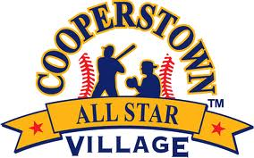
Cooperstown All-Star Village
Home Run Derby #1-17
Week 9
# | Team Name | Player Name | Outs | HR
1 | Marin Baseball Black, CA | Boston Mahigian | 5 | 0
2 | Middletown Lions Orange, NJ | Liam Sheehan | 5 | 1
3 | Poughkeepsie Vikings, NY | Jayden Carr | 5 | 0
4 | Pleasanton Panthers, CA | Mateo Phelan | 5 | 0
5 | Glenside Gladiators, PA | Finn Kott | 5 | 7
6 | East Coat Eagles, MA | Lucas Soars | 5 | 2
7 | Prevail Bynum, CA | Carson Sulsona | 5 | 5
8 | Lake County Sidewinders, IL | Rowan Yarberry | 5 | 0
9 | In The Zone, NJ | Mack Dockx | 5 | 0
10 | Moorpark Baseball Club, CA | Ben Harrison | 5 | 0
11 | Long Island Thunder, NY | Robbie Metzger | 5 | 1
12 | TBSA Patriots, FL | Brayden Howard | 5 | 1
13 | Crescenta Valley Monarchs, CA | Broklyn Park | 5 | 2
14 | Douglas County Timbers, OR | Danner Wertz | 5 | 0
15 | Bergen Crush, NJ | Aiden Rielly | 5 | 3
16 | South Bay Baseball Club, CA | Asher Friedman | 5 | 2
17 | LSW Astros (Team Green), NY | Trevor Smith | 5 | 0

