Senior Night Checklist
Quick Glance: This is a night to recognize all the seniors for their dedication over the years. Each senior will skate around the rink while a song of their choice is played.
Timeframe: Typically, between JV and Varsity game.
PLEASE NOTE: ALL EVENTS SHOULD BE PRESENTED TO BOARD ONE MONTH PRIOR TO EVENT.
Checklist:
- Distribute senior boards and ask them to complete (white cardboard boards)
- Plan parent volunteer for pictures.
  - Picture volunteer should download pictures on google drive and share with secretary to send out to families.
- Plan beverages for the event (not required).
  - Some ideas are: coffee, hot cider or orange drink. At the parent meeting people volunteered to bring bars/cookies for the event. You will need to make sure you napkins and cups. Tony, from the rink, will get the tables for you.
- Plan anything “extra” you want to do. Some ideas are: May choose to have kids submit picture with parent ahead of time. Can print these and put on board or on computer and stream them in the lobby during the game. Could also stream what the kid is ‘thankful about their parent’ on.
- Plan any table or equipment requirements. Contact the Volunteer board member to fill out a request for the city with your requirements.
- Plan if you are going to change the songs to each players’ favorite song. Get play list ready on your phone.
- Get a list of the players’ names and their bio from program. Give the list to the announcer in advance.
- Present activity to board one month prior to event.
- Plan any scoreboard video / songs.
  - All scoreboard items should be determined ahead of time
  - All scoreboard presentations should be on google slide (powerpoint gets distorted)
- Gifts: NA
  - 2023: Moms gave senior gifts in locker room after the game.
- Determine decorations (see examples below)
- Night before:
  - Decorate locker room
  - Decorate hallway to locker room
  - Decorate lobby windows

Example of Senior board and senior board decorations:
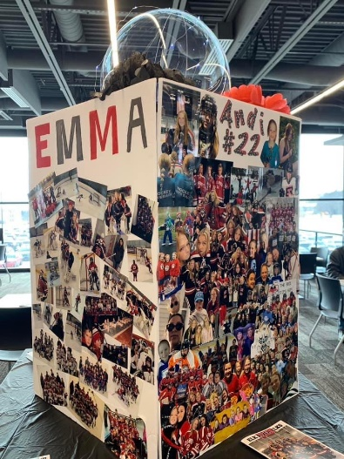

Example of wall art hung in lobby window:
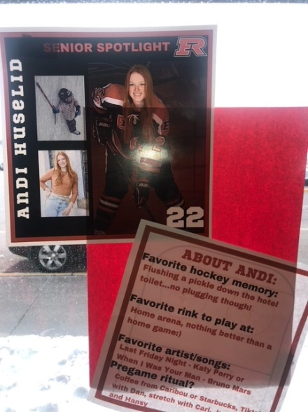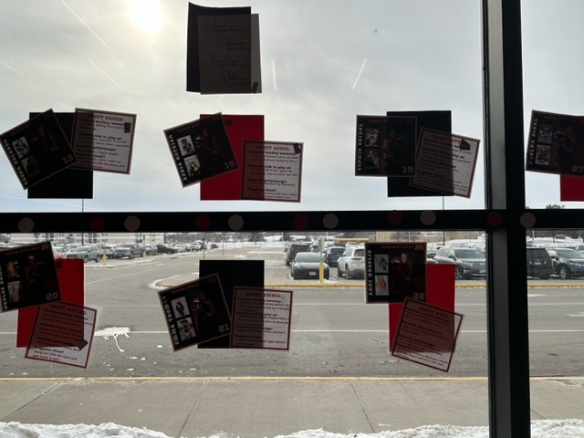

Example of locker room decorations:
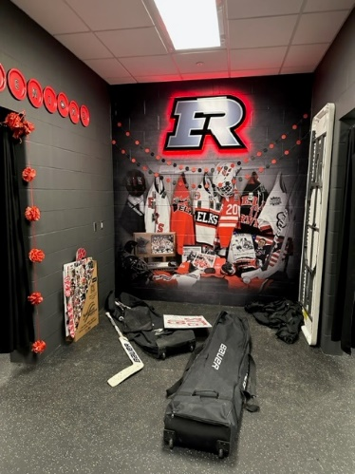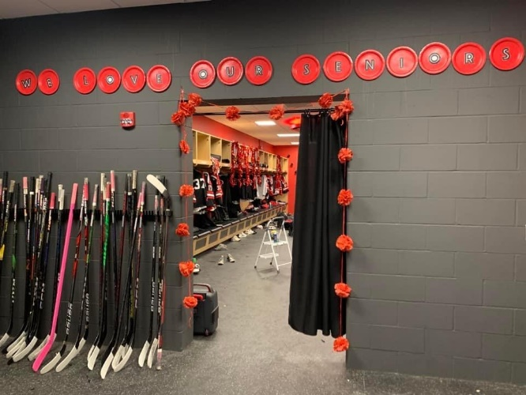
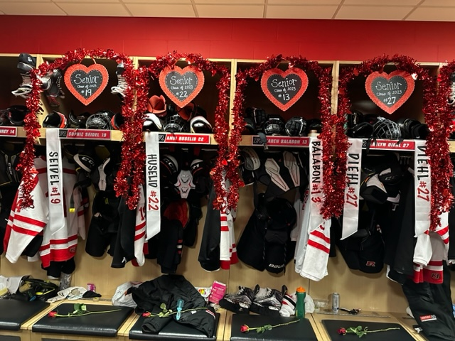

Example of sashes for the seniors:
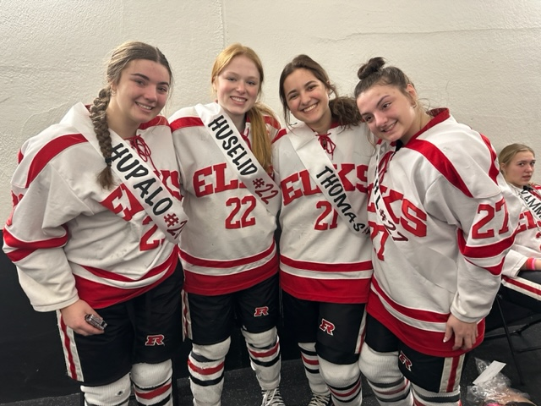

Example of sash to get into rink
