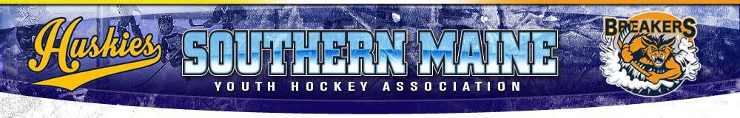
SMYHA Player and Parent Code Conduct

- Players, Coaches and Parents associated with SMYHA are always expected to act with sportsmanship, dignity and respect as a representative of the program, either on or off the ice.
Poor Sportsmanship includes but is not limited to the following:
1. Arguing with coaches, officials, teammates, opponents or spectators.
2. Using threatening or profane language.
3. Baiting or taunting coaches, officials, teammates, opponents or spectators.
4. Unsafe play.
5. Inappropriate behavior on the Ice, bench, locker room or any other Association related activity/activities

- Failure to adhere to the Code of Conduct will result in disciplinary action that will be at the discretion of the coach, the Disciplinary Committee, and/or the Board. Disciplinary action may rise to the point of ultimate removal of the player from the team without refund.

In signing this document, you recognize SMYHA’s Player/Parent Handbook and the policies contained therein.

Players Signature: ______________________________Date: __________

Parents Signature: ______________________________Date: __________

