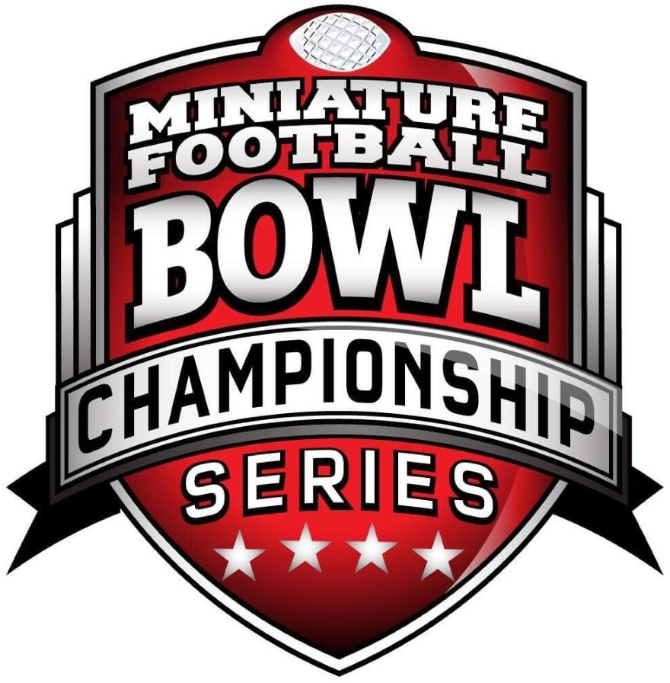

Miniature Football Bowl Championship Series Rule Book
2025
Published
November 4 , 2020

Description:
The Miniature Football Bowl Championship Series (MFBCS) is the premier nationwide College Football Bowl League, intent on gathering Miniature Football hobbyists and coaches from regions representing twelve NCAA Football conferences: ACC, BIG 10, BIG-12, PAC-12, SEC, MWC, AAC, MAC, SOUTHERN, MEAC, IVY and INDEPENDENTS. We represent the highest level of nationwide league competition and comradery, aimed at producing a National Champion each season through regional conference competition and conference finalists qualifying for a National Collegiate Playoff.

The Playoff:
Each conference will compete with teams forming representative NCAA conferences, with the 35% teams from each league will qualifying for the National Bowl Championship Series title. There will also be “at-large” invitations extended to qualifying teams, to round out the playoff field to 48 teams. An NIT play-in tournament will be held on the Friday preceding the Playoff Weekend with the top two finishers qualifying for the 48 team playoffs.

Teams:
Coaches may choose teams that represent the region where they live, on a first come, first serve basis. Non – Conference teams may also be selected, and “petition” the conference for entry and participation. FBS and Football Championship Subdivision (FCS) teams are eligible. There are no duplicates of teams allowed. One team per school is allowed, on a first come, first serve basis.

Dues:
Participation dues are $50 for a coach to secure his/her team, with each additional season staying at $50. Dues are paid to a national MFBCS treasury account, with funds being held in escrow.
Funds are sequestered from each conference to cover the expense of the league website; additionally, funds will be reserved for the MFBCS Championship trophy, Non-BCS bowl trophies, and for individual player award trophies to include the Heisman Trophy. Additionally a small portion of dues will help with supporting rental of the facility where games will be played in the Playoffs. Note that significant funds have been contributed by donors already to offset expenses.

Rule Set:
A slightly modified 2018-19 TOC rule set will be used for this league; with the caveat that all conference games and National playoff games will feature 50 minute halves. Each coach will have three 45 second timeouts per half at his/her disposal.

Stats:
It is mandatory that coaches keep stats for all conference and playoff games. Stats will be collected by conference commissioners, and entered into the website by the Commissioner or his assistant.

Games:
Each conference will play an 8 - 13 game schedule created by the Conference
Commissioner. Conferences will be split into divisions when sufficient teams are involved. Each conference will have a championship game, which will be played on the Friday night of Playoff weekend. Non-conference games are allowed, but each team should complete no more than 12 total games. Final standings in each conference will be determined by intra-conference records.

Conferences:
Each conference is located based upon region, and is capped at 18 teams.

National Playoffs:
The National MFBCS Playoffs will be held in Dallas, Texas, in June 2021. The date will be published once secured. The format is a 48+ team single elimination event. The playoffs will be held on Saturday with the final four slated to play Sunday. Teams eliminated will be paired up Saturday evening for Non-BCS Bowl games. Events will be planned for Friday night to include: The nine Conference Championship games, as well as a banquet and awards presentation. All playoff and bowl games will be played on standardized 48x24" boards created by Roger Fisher, with custom graphics and field covers representing the major bowls and Championship Game.

Qualifying for the Playoffs and seeding determination:
The eleven Conference Commissioners form the committee that decides the qualifiers and
“at-large” invitations.

National Award Winners:
An Awards Committee has been created from miniature football enthusiasts who are not participating in the MFBCS who will determine awardees for all major NCAA football awards including the Heisman Trophy winner.

Forfeits:
The intent is for forfeits to not occur. Forfeits are devastating to existing leagues across the country. They destroy proper seeding of leagues as well as statistics. For these reasons, strict rules will be enforced regarding forfeits. On the first forfeit, the coach is ineligible for post season play, consideration of awards, and loss of voting privileges. For the second forfeit, the coach sustains a one year ban from the MFBCS and loss of rights to their team. The third forfeit is a permanent ban from the MFBCS. This policy is non-negotiable, to include the complete loss of dues.

End of Regular Season Conference Play:
Each Conference must complete their regular season schedule in a timely manner to allow for planning of the National Playoffs, Awards voting, and travel planning. The FINAL DATE for Conference regular season games to be completed is June 15, 2025. If unforeseen circumstances occur, a coach may petition his commissioner to allow for an extension of up to, but NO MORE THAN 48 hours. Games that are not completed by the final date will be reviewed, and a forfeit assigned to one or possibly both coaches. Penalties for forfeits will then be assessed.

MFBCS Commissioner: Bob Owens

Conference Commissioners:
- AAC Commissioner: Paul Bartels
- ACC Commissioner: Dearell Brevard
- BIG 10 Commissioner: Jimbo Dunagan
- BIG-12 Commissioner: Barry Stephenson
- IVY Commissioner: Jeff Priest
- MAC Commissioner: Brandon Trice
- MEAC Commissioner: Bobby Bush
- MWC Commissioner: Jaron Turner
- PAC-12 Commissioner: JC Davis
- SEC Commissioner: Rafiyq McDanul
- SOUTHERN Commissioner: Bryan Nutt
- Independents: None

Table of Contents

Section 1:  Section 2:  Section 3:  Section 4:  Section 5:  Section 6:  Section 7:  Section 8:  Section 9:  Section 10:  Section 11:  Section 12:  Section 13:  Appendix 1:  Appendix 2: | The Field The Ball  Figures and Equipment Game Timing/Overtime rule Plays from Scrimmage Special Teams  Overtime Penalties Fumbles Broken Tackles Fallen Players  Duplicate Numbers Forfeits/Stats  MFBCS Official Stat Sheets Figure Standards  *Credit to TOC Rules Committee for establishing a bulk of the rules found in the MFBCS Rulebook. The MFBCS Rulebook is based largely off of the 2018 - 2019 Tournament of Champions Rulebook.

- - The Field

  - - The Field

    - : Boards from all manufacturers past or present are allowed starting at model 620 and larger. All boards will be inspected and approved by conference officials. League organizers reserve the right to choose their Championship Board.

    - : Fields must operate properly with a smooth consistent speed that does not cause the players to fall excessively.

    - : The field must be level and free from obstructions that protrude to cause a player to change direction.

    - : It is the responsibility of the conference organizer to insure all fields work properly and are consistent with the aforementioned specifications and free from hazard that would cause electric shock or electrocution to any coach using the board.

    - : Any board with frayed wires or improper electrical connections will not be used. If any coach finds a game board in a condition that is unsafe or not within the league game board standards a conference official should be alerted immediately so the board may be repaired or removed from the playing area.

  - - Goal Posts

Official MFBCS Specifications:
Spacing: 4“opening or foam core board that is 4” wide. Crossbar: 1 7/8” from field to top of crossbar.
Uprights: Uprights must be at least 18" - 24" tall.

    - : Homemade goal posts must be to scale. The home team must provide goal posts that correspond with their field and must be approved by conference officials. The MFBCS will provide the goalposts at the Championship Playoffs. The goalpost is a 4" wide TARGET and any field goal or p.a.t. that strikes the TARGET is successful.

- Yard Markers and 10 yard-chains

    - : If not provided by conference organizers, the designated home team is responsible for providing the yard markers and 10-yard chain for their field. Before a game can commence, there must be a verbal agreement between the two coaches who will be responsible for moving both the yard markers and the 10-yard chain.

- Board Speed

    - : The two coaches must mutually agree on the speed of the board. If 2 or more players fall down consistently throughout the game, a third party who is mutually agreed upon, will determine whether the board speed selected by the two coaches is at an acceptable level.

    - : Opposing coaches should agree on the board speed prior to the start of the game. If they cannot agree, the referee or league official will set the speed.

- - The Ball

- The Ball

    - : Miggle, Tudor, Buzzball, 3rd Down and Long foam and felt footballs and other balls of a similar size are allowed. Saturn balls and Oversized (“Big Pill”) footballs are not allowed, which includes the EFDW balls.
Any questions regarding the eligibility of a ball should be brought to the conference officials for review
and approval.

    - : Buzzball magnetic balls and pass placement sticks may be used.

- Players and Equipment

- Weight restriction: Player maximum is 4.0 grams (including base)
    - : Every figure will be weighed prior to the first game of the MFBCS season. The maximum allowable weight per player is 4.0 grams. Substance used to increase player weight must be secure and not protrude from the figure or base. Any weight of that falls off from under the platform or base is eliminated and cannot be reapplied. Metallic paint and metal pins may be used to paint or stabilize custom figures on their platforms. Metallic paint, metal devices, or magnets are NOT allowed to be applied to the base of a figure.
NOTE: The coach of the team under inspection must declare all metal elements to the inspector and its
location on the figure prior to its detection. Otherwise, the figure will be ruled ineligible for play.

    - : Weight can be added underneath the base to bring a player up to a maximum of 4.0 grams, ensuring it doesn’t interfere with player mobility or cause substance or residue to be left on the field. Only non-stick putty may be used underneath the base. Any use of a substance that causes a player to stay immobile, become anchored, or interfere with another player’s ability to move freely will justify immediate removal of the player for the duration of the game. Any subsequent issues thereafter, during the same game, will be justification for forfeiture of the game by the coach in question. To clarify, the maximum weight is 4.0 grams, and not more.

- Figures
    - : Figures from all manufacturers past or present are allowed. A custom pose created from any existing figure in accordance with the rules listed in 3.1 and 3.2.2 is allowed. Any figure can be ruled ineligible if it is determined to interfere with fair game play.

    - : Figures mentioned in 3.2.1 can be manipulated to create custom poses providing they are not disproportionate to the figure. All questionable figures will have their eligibility decided by the commissioner. Questionable figures will not be allowed for game play until the ruling by the commissioner is rendered.

    - : All Figures must comply with the "Figures and Base Size Standards" Appendix (Appendix 2) to this rulebook.

    - : At check-in of any MFBCS gameday, conference officials may place any figure in the

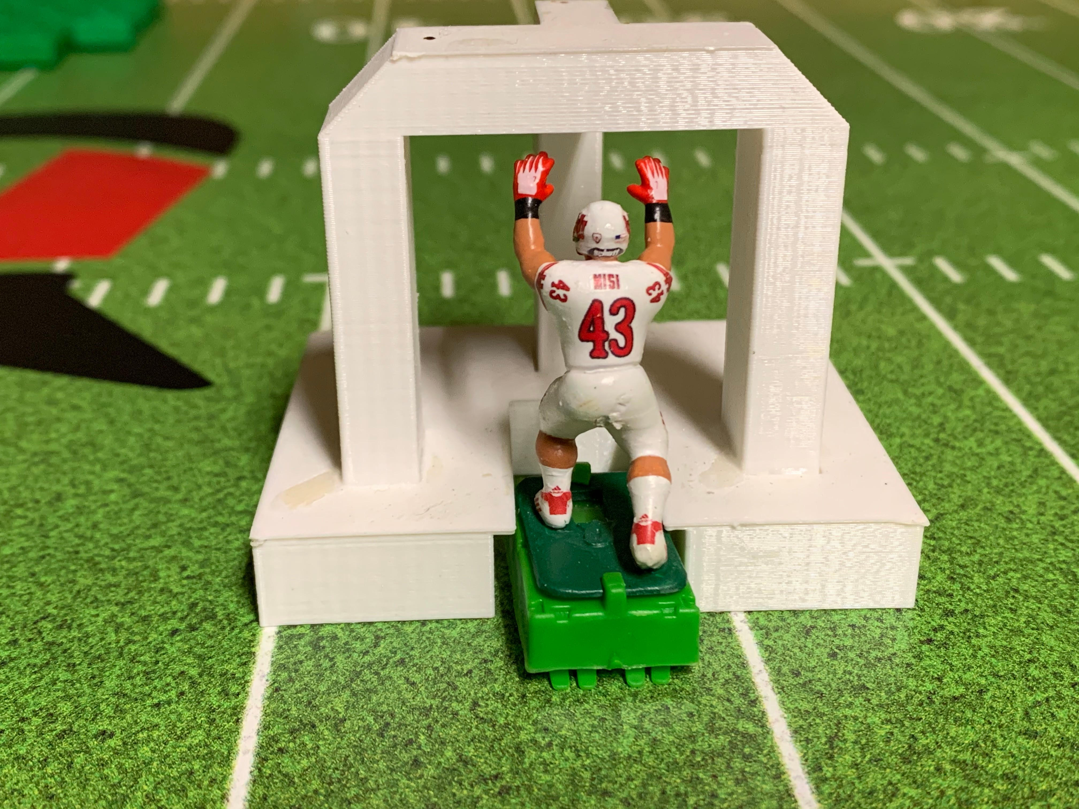
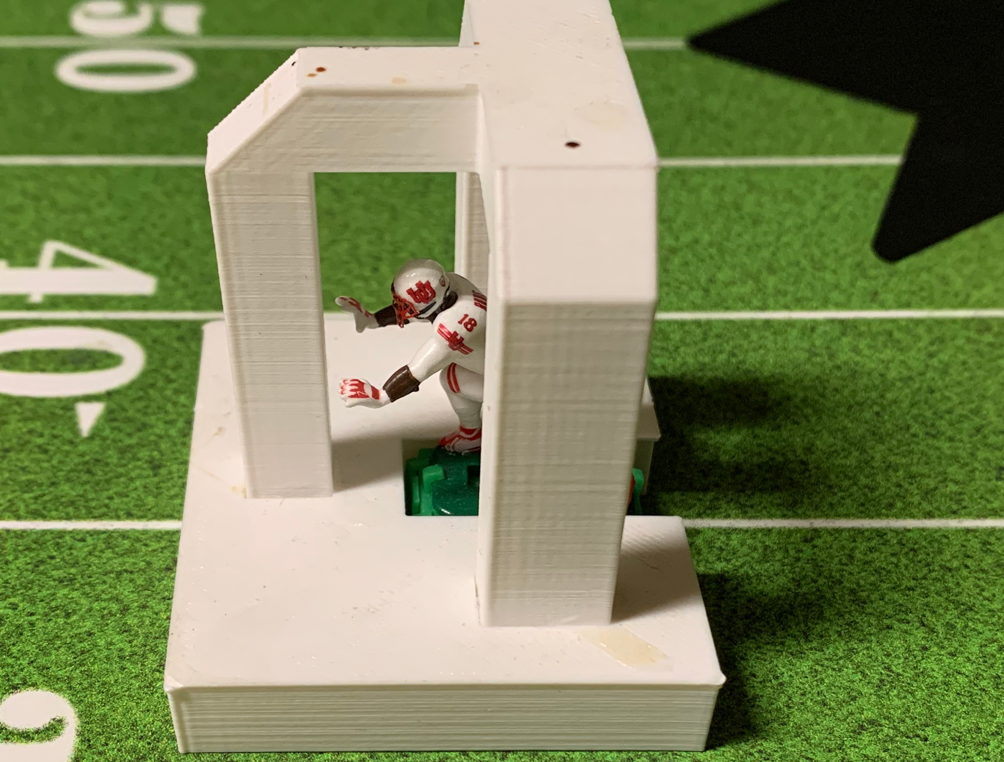
"Combine" (device used to determine if the figure meets the Figures and Base Size Standards requirements).

: Mobile and Stand Still Quarterbacks

Standstill and mobile QB figures must be in normal QB pose, running, passing, under center, etc. Down lineman poses (3 or 4-point stance) may not be used for standstill or mobile QB's. All current production Passing Quarterbacks (PQB) are approved for league play including G-Force TDQ, Carl Coley “Superman Flutie” QB, Gameday, “Gamechanger” QB, Next Level, 808, Stablerizer, and all Tudor Games/Miggle TTQB’s. Stand still QB figures that are not designated must be approved by the league; with the primary criterion that they are the same size or less THAN A TTQB QB PLACED ON A BASE IN HEIGHTH. If any mobile PQB starts off as a running QB, he must remain on the field until the completion of the play, including attempting the pass on a called pass play. The QB may be replaced temporarily by a stationary QB, but then must make the pass attempt. The knob or trigger in the back of the player will be considered as part of the base for contact purposes.

: Extended Arm Figures

Figures that have any portion of both arms that extend to the front edge of their base or beyond are considered "extended arm figures". Additionally, any figure with more than one appendage extending to or beyond the side or rear edge of their base will be treated as an "extended figure". Extended figures may not extend more than 5/16th of an inch outside the figure's base, to include fitting in the Combine measuring mdeavxicime.umThsepmacainxigmwuimdtdhisatnanecxeteanndeexdteanrdmedfiagrumrefi'gsuhraen'sdhsacnadnsbceanspbreaedxtaepnadret dfrboemyoenadchitostbhaesreisis55//1166thth inches. Thies measurement is typically taken Thumb to Thumb. Defenders with wider spacing cannot be used as cover corners. These measurements can be determined using the Combine measuring device.

: Offensive and Defensive Linemen

Offensive and defensive linemen with extended arms cannot be interlocked at any time at set-up. There must be at a “minimum” 5/16” spacing or 1/3rd of a Flat Proline base length between each lineman. This measurement is base side to base side; and no arms or legs can be overlapping at the start of the play. Repeated
violations will result in a 5 yard penalty with loss of down. The maximum spacing between offensive line figures is the length of a standard flat front proline base.

: Custom Figures
The figure can utilize any pose, providing it has all of the following intact:
- Two arms
- Two legs
- One head
- One torso
- At least one foot of the figure must be affixed to its platform.

NOTE: Custom Figure Poses can increase a figure’s height from its original form as long as it meets the
prescribed height standards in 3.2.9.
    - : Height of Figures - See Figure and Base Size Standards Appendix (Appendix 2).

    - : Figure Numbers and Uniforms - Players must have numbers on both sides of their jerseys to distinguish them. If numbers are not affixed to both sides of the jersey, that player is ineligible for game play. The conference officials, on a case-by-case basis, may grant waivers. Reminder: The college numbering system is an open format, unlike the NFL which has a fixed numbering system.

Figures that are not painted to match the uniform of the figures fielded in the game by a team/coach are not permitted on the field; including stationary safeties. The “Passing QB” (PQB) and “Kicker” are exceptions to this rule.

    - : Passing Quarterback (PQB) includes any manufactured quarterback such as the Tudor/Miggle TTQB, G Force TDQ, Gameday, "Game Changer QB", Next Level, 808, Stablerizer, and the Carl Coley Superman QB, may be used as well as Pass Placement equipment (“Sticks”). Any other PQB must be evaluated and confirmed as legal by the MFBCS Commissioner Committee, based primarily on height and availability from the manufacturer.
    - : Roster Size - Maximum roster size for a coach’s team is 60 players, not including TTQBs, TDQs, PQBs, Stationary Figures and Kickers. The roster size is 60 players, and the total number of figures (excluding kickers, passing qb figures, and stationary figures) allowed is 60. A coach may utilize more than one figure for an individual player on the roster; but the figures tallied cannot be greater than 60. (You can have 4 Reggie Bush figures, but they take 4 spots out of your 60 figure count)

: Uniform Colors
Dark Jersey’s will be worn to represent the offensive team. White (light) Jersey will be used for the defensive team. For kickoffs, kicking team will be in white (light) jerseys and return team in dark. For onsides kicks, a mix of dark and white jerseys are allowed.

: Referee Figures
Referee figures that are manufactured, or custom, are allowed on the field during the game. The figures are to be placed on bases (without magnets) to keep them from falling over. The referees may be used to spot players when adjustments must be made during a play from scrimmage. The switch may be turned off and the referee can be moved out of the way in the event a player is going to run into the referee or does run into him.

- Bases

    - : All bases, from all manufactures, are allowed with exception to any bases that prohibit proper spacing i.e.; Giant Tudor bases made prior to 1967 and any similarities produced by other manufacturers.

ITZ Blitz bases are allowed but NOT the sideways base or Commander base. NEW ITZ BASES IN 2024 INCLUDING M2 BASES ARE ALLOWED BUT NOT THE WIDE BASES!
    - : Prongs may be altered on bases, but the outside of the base may not be altered in any way. All bases can be inspected and are subject to review by the commissioner.

    - : Bases may not be altered as to increase their height from the original form.

    - : Bases must remain on each player during the game and cannot be changed with another player or rotated directionally on their base. Players that spin freely on their original base are allowed.

    - : Magnets, nuts or bolts cannot be added to a player’s base at any time, which includes a stationary QB. See section 3.1.

: As of the 2021/22 Season, ITZ Bullet bases are allowed at any and all positions to include the Offensive and Defensive lines.

    - : No chemical alterations are allowed to any base (i.e. - boiled bases).

    - : No Frankenstein bases. Frankenstein bases have a portion of one base cut off and applied to another (i.e. - a section including the prongs cut from a speed type base and glued under a boat base platform).

    - : All bases must comply with the "Figures and Base Size Standards" Appendix to this rulebook.

    - : Felt, foam, rubber pads or other substances to hold a base motionless or STATIONARY are prohibited. A figure on a prong-less base or a figure and base placed in a FREEZE FRAME are acceptable. This applies for any stationary figure. The numbers on the stationary figure DO NOT HAVE TO MATCH the figure they are representing on the field.

- Inspection

    - : Prior to participating in a MFBCS season, all coaches will have their teams inspected by a designated
conference official(s).
    - : The league official will ensure that all players not exceed a weight of 4.0 grams. They will also ensure that no magnetic material is affixed to the base. The conference official will utilize a magnet for inspection of the bases. If a base adheres to the magnet, the player is disqualified from play. If the figure has metallic material, such as paint or metal pins for stabilizing said figure, then the figure will be allowed, if the head coach confirms that there are pins or metallic paint in the figure prior to inspection. Additionally all questionable figures will be tested with the "combine".
    - : Any player that is deemed ineligible, for any reason, can be offered up for appeal to the conference commissioner for a final ruling. The final determination will be made by the conference commissioner and is binding throughout the season.

- Timing / Pivots & Motions

- Length of Game
    - : Each game will be played with a running clock set at 50 minutes per half. The clock will run continuously, and will only stop during a timeout, AND IN THE LAST TWO MINUTES OF EACH HALF: change of possession, kickoff, and extra point kick. At the end of each half, should the offensive coach have his offensive line set (Center, Guards, and Tackles), prior to the clock running out or having declared his intent to kick a Field Goal, then the coach will be granted one more play.

    - : Timeouts: Each coach will be granted 3 45 SECOND timeouts per half. The timeouts do not carry over to the second half, if they are unused in the first half. Each timeout is 45 SECONDS in length and will be addressed with a running clock.

: Set-up clock
A set-up clock will be used for both offense and defense to expedite game play. The offense is afforded 40- seconds, which starts immediately after the teams are separated from the previous play. To complete the offensive set-up, the offensive coach must say “Set” upon completion. The defense is afforded an additional 10-seconds once the offensive coach says “Set” to complete their set-up. The defensive coach must also say “Set” upon completion (If the offense only takes 20-seconds to set-up and calls “Set,” the defense would have only their additional 10-seconds for a total of 30-seconds to set up). The play then runs regardless of the defense being completely set up.

- Time for Change of Possession (C.O.P.
    - : ALL C.O.P. will be 1 full minute for the offense. The defense subsequently is afforded an additional 10 - seconds. After a score, a one minute plus 10-second C.O.P. clock stoppage will occur. A 40 SECOND PLAY CLOCK THEN STARTS AND IF the offense is set AFTER 1 minute expires, the offensive coach may call "set" and at that point the defense will still have a ten second interval to set up.

- Pivots, Motions (Advanced Pivots), and Substitutions
    - : Coaches are allowed two player pivots, or one player pivot and one player motion on both offense and defense. The defense is only allowed to match the offensive pivots and/or motions (i.e. - if the offense makes one pivot, then the defense can respond by only making one pivot). If the offense makes no pivots or motions,

then the play starts with no further adjustments.

    - : If a receiver is put in motion and goes from the line of scrimmage to an off the line of scrimmage position, the offense may motion another receiver to the line of scrimmage to make a legal formation. This "Double Motion of a Wide receiver" is considered as one motion. The Defense may counter each "Double Motion" as one move.

    - : Each coach has 6 seconds to make any pivots or motions. Offense goes first, and then the defense counters. If moves are not made before the 6 second countdown expires, the moves are forfeited and the play commences as currently set up. Movements made after the 6 second countdown has expired are subject to a 5 yard penalty.

: Definitions
Pivots: To turn the player on his axis from the rear of the base. The coach cannot lift the player. The coach cannot turn the player from the front of his base. If the player has a TTC dial it can be turned within the 6 second limit, but not picked up if it is intended that the move is a pivot rather than a motion or advanced motion.
Motions (Advanced Pivots): Moving the player from one location on the field to another. Lifting the player up and adjusting the TTC dial visually (player doesn't have to change location). Turning the player from the front of the base (changes the angle of the player). Double Motion of a Wide Receiver - Moving one player from the LOS and moving another to the LOS.

Double Motion

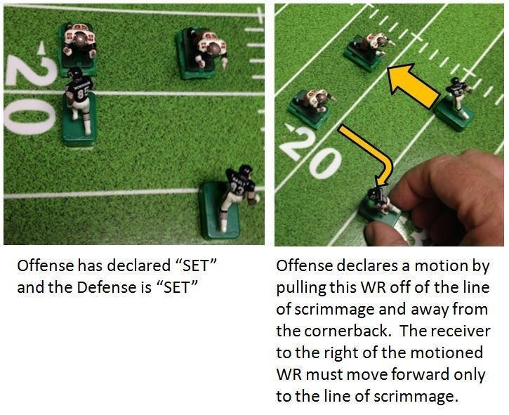
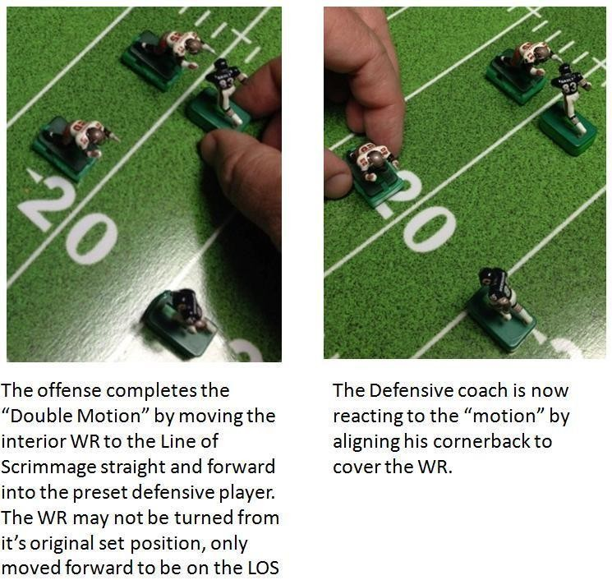
Example:

    - : QB Substitution
A mobile QB can be replaced with an immobile QB under the following 2 circumstances:
      - Upon the initial set-up of both the offense & defense and after the defense calls set, the offensive coach may simply substitute a mobile QB with an immobile QB during their pivot phase. This does not count as a pivot.
      - After all pivots have been made.
    - : The Defense may counter the mobile/immobile QB substitution by either bringing in a stationary or mobile safety. The incoming safety (mobile or immobile) may only enter the field with the exact orientation as the safety that is exiting the field.

: Stationary Defenders
Up to two stationary Defenders may be placed on the defensive side of the field at any position. The equipment restrictions for a stationary Defender are similar to that of immobile quarterbacks, to include the use of freeze frames. "To include the use of freeze frames obviously means that freeze frames are considered stationary figures. They shall be deployed in the following manner:
      - A maximum of 2 players can be set on stationary bases, or freeze frames.
      - Magnets or any adhesives cannot be used to hold stationary Defenders/freeze frames in place.
      - Stationary Defenders must also meet with current league weight and dimension requirements.
      - Stationary figures DO NOT count towards your total of 60 players maximum. They must also be painted in keeping with your team colors and numbered on the front and back of the jersey.
      - The rule of no use within 15 yards of the end zone has been removed.
When using stationery Defenders, the mobile players that will replace the stationery Defender(s) must be on the board facing the back of the end zone they are defending. That way they do not disrupt the play. Make sure the Defenders are on opposite sides of the end zone, so it is easily identified which Defender plays the left and the right side of the field.
      - IF n player on offense contacts a stationary figure (FREEZE FRAME) figure and falls down it is a tackle and not a fumble.

- The defensive team must have their stationary Defender(s) on the field of play with their mobile Defenders(s) aligned as stipulated in item five prior to the expiration of the defensive setup clock. If the defensive clock expires without this requirement being met the following applies:
  - If the mobile Defender(s) are on the field without the stationary Defender(s) in place, then the play is initiated with no further action.
  - If the stationary Defender(s) is placed on the field without the mobile Defender(s) in their designated area the Defender(s) shall remain stationary. They are eligible to make tackles, intercept the ball etc. If a stationary player intercepts the ball without a mobile player declared, the play is dead at that point of the interception.
- In the event that the offense brings in a stationary QB, the defense is allowed the last move to bring in a stationary Defender to match the offense's stationary QB. NO FREEZE FRAME FOR QB.
- Coaches MAY NOT use any felt, foam, rubber or other substances to hold a “pronged” base motionless; nor can these substances be placed under stationary figures/freeze frames.See rule 3.3.10.
- The numbers on the stationary figures DO NOT HAVE TO MATCH the player which they are being stationary for.; but they must be designated by placement in the back of the end zone in a corresponding "left and right" configuration.
- If your Stationary Defender becomes engaged with an offensive player (base to base) he cannot be adjusted later in the play.

- Plays from Scrimmage

- Start of Game/Coin Toss
    - : All games are to begin with a coin toss. The visiting coach will call “Heads” or “Tails” while the coin is in the air. The winner of the coin toss has three options:
- Elect to receive the opening kickoff
- Elect to kick off
- Defer to the opposing coach

    - : The team that loses the coin toss will select the end zone to defend for the first half.

    - : Before the snap of the ball the Offensive coach must declare “run, pass, or quarterback option”. The call must be made within 5 seconds after the defense is set, after motions and/or pivots.

    - : The ball carrier is considered tackled when any part of its base or platform touches an opposing player’s base or platform. This is referred to as “Any Touch” tackling.

    - : No player(s) on either the offense or the defense can stack ANYWHERE within the TACKLE BOX AREA (MFBCS defined as: The area on the field that extends laterally between the offensive tackles on either side of the offensive line). Notable exception: If the QB is directly under center, the defense may match by placing a MLB behind the Nose Guard/Defensive Tackle.

5.1.6:
e
back's base must be behind the back of quarterback’s base), a minimum of ONE Base Length behind t
ng
OFFENSE Stacking: Running backs must be positioned behind the quarterback (the front of the runni
h offensive linemen (remember that the QB can NEVER BE the Lead Blocker). If the quarterback is in a shotgun formation (at least ONE Base Length behind the back of the center), the running backs can be even with, or behind, the quarterback. No portion of any running backs base may extend outside of the tackle box. A lead running back and running back behind the lead running back must be separated by a base length as well.

defensive player can be stacked in the TACKLE BOX AREA is when the QB is directly under center. The defense may match by placing a MLB behind the Nose Guard/Defensive Tackle.

5.1.8: Stacking Exceptions: During any two yards or less play. (see running plays section). The Defense is
5.1.7: DEFENSE Stacking: If there is a defensive player on the line of scrimmage in the TACKLE BOX AREA any player behind him must be separated by a minimum of ONE Base Length between the players. The only time a

allowed to stack anywhere on the field in 2 yard or less situations. This includes two-point conversions.

  - - Position of the Offense Players at the Snap

    - : The offensive team must have the following in their formation:
- No more and no less than seven players on the line of scrimmage at the snap.
- All players lined up outside of the tackles must be no farther than 5 yards from the line of scrimmage at the snap.
- All guards, tackles and tight ends must be at least 1/2 yard behind the center and no more than 1 yard.
CLARIFICATION: The front of the base for the guards and tackles must be ½ yard from behind the front of the center’s base.
- Minimum offensive linemen spacing is 5/16” or an easier 1/3 of a Proline flat front base length.
Maximum spacing for linemen is one full base width of a Proline flat front base. This spacing is between the sides of the bases, and overlapping of arms or elbows or other appendages from tackle to tackle is not allowed, from base side to base side.
Definition of “base width and length” for simplicity throughout the rule set is defined in inches as being equal to 1-inch-long x ¾ wide. i.e. a 1/3 base width is equal to 5/16
- The QinBchcaens.be positioned under the center or up to a maximum of 15 yards from the line of scrimmage. A portion of the Quarterback’s base must be within 15 yards of the LOS at the start of the play.
Definition of “In Shotgun” means: The QB is at least a full base length from the back of the centers base.
- Running Backs Position – If the quarterback is under center the running back(s) can be no farther back than 15 yards. If the QB is at max distance from the LOS (15 yards), then the RB’s can be no further than the back of the QB’s base to start the play. If the Offensive Coach MOTIONS the QB up further towards the LOS, leaving his RB’s beyond the max distance, it will be an illegal formation penalty of 5 yards against the offense.
- See Offense Stacking rules 5.1.6.

- Position of the Defensive Players at the Snap

    - : The Defense is set up with a 1-yard neutral zone at the LOS. The defense can set up in any formation with the following exceptions:

      - The defense can only stack in accordance with rule 5.1.7.
Definition of “stacking”: Any player with any portion of the front of its base directly lined up against the
back of the base of the player in front of it.
      - For Stationary Defenders, refer to rule 4.3.7.

MMFFBBCCSS RRuulleebbooookk 22002211/22
1144

Running Plays

    - : A QB, or an offensive player representing the QB, must remain behind the center prior to the start of the play.

e
5.4.2: The quarterback may never be the lead blocker ahead of the ball carrier on any run play that runs into th
offensive line. If the Quarterback acts a lead blocker for the ball carrier, illegal procedure will be called, resulting in a 5-yard penalty and loss of down. The quarterback may only plunge into the offensive line as the third back in a short yardage situation (reference rule 5.4.9), or as the ball carrier.

    - : In order for a running back to carry the ball, with the QB is under center, the front of the designated runner’s base must be behind the back of the quarterback’s base. If the QB is in the shotgun, the runner can be even with the front of the QB’s base. (See also 5.2.1.f)

    - : Two backs can run in the same direction at any time as long as the third back is turned away.

    - : The QB can run into the LOS as a ball carrier but he cannot be pushed from behind by another offensive player. If this occurs, it will be a 5-yard penalty with loss of down.

    - : The QB may start the play facing forwards towards the line along with two other backs, to disguise the play call. Upon announcing a pass, the stationary QB may be substituted in. The defense will then be allowed to bring in one stationary defender in place of a mobile Defender to match. If a run is announced, the stationary QB can be substituted in to allow for only two running backs to plow into the line, or the moblie QB must be turned backwards to run away from the LOS. If the Offensive coach fails to do so, it is a 5-yard penalty on the Offense.

    - : The QB may start the play running backward toward his own end zone or sideways but on his own turn up field and run (i.e. bootleg or roll out). If the QB runs and his base is completely twenty (20) yards behind the LOS, the play is dead, AND the offense takes the twenty-yard loss. If a pass is called and the coach chooses to run the mobile QB between the tackles looking for an open receiver along with 2 other RB’s plowing into the line, the QB may only pass, if he chooses to run the QB in this scenario, it has violated the 3 players into the line clause and the result would be a penalty if the switch is handed to the defense coach. It is incumbent upon the Offense coach to manage that scenario.

    - : Only TWO players can plunge into the line on any given play unless there are 2 yards or less for a first down, touchdown or two-point conversion; then three may plunge. At no time can the QB be pushed or start out lead blocking.

: QB Options:
The QB has the option to Pass (see below), Pitch, or Keep. After both coaches have completed their formations and audibles have been conducted, the offensive coach will declare “quarterback option”. If the QB is on a stationary base and has an empty backfield the coach cannot call QB Option. Should the QB opt to Keep, the rules regarding Running Plays will be fully enforced (Rule 5.4).The following defensive options are available:

      - The stationary Defender(s) can be replaced prior to the switch being turned back on, can now be adjusted or pivoted towards the ball carrier. The Defensive Coach has only five (5) seconds to do so. Should the QB opt to Pass, the rules regarding Pass Plays will be fully enforced (rule section 5.5). The following additional defensive option is available.
      - The stationery Defender(s) cannot be replaced with the mobile Defender(s) until the pass is completed. Once a pass is completed, mobile defenders may be substitued in, and pivoted toward the ball carrier.

MMFFBBCCSS RRuulleebbooookk 22002211//2222
1155

Should the QB opt to Pitch, the following conditions must be met:

- There must be a clear path between the player who is pitching and the player who receives the pitch.
- No opponent's player(s) or team mate(s) base or appendages can be within the projected path between
the QB’s and receiver’s bases.
- If the QB has passed the LOS, rule 5.4.10 applies. Touching LOS is allowed. Read below for clarification.
- Neither the QB nor receiver can be engaged by an opponent's player(s).
- The receiver must be even with or slightly behind the QB’s base (most down field portions).
- The receiver must be within two base lengths (measured base to base) of the QB to receive the pitch.
- If the intended receiver is more than two base lengths behind the quarterback, you may pitch the ball by throwing the ball to that player (see Laterals 5.4.14).
- Once the pitch is completed, stationary defender(s) may be swapped per rule 5.4.9(a) and adjusted.

*All pitches are automatic (you do not have to throw the ball for the pitch). *

    - : Executing the quarterback Option Keeper
- The play starts with the quarterback or wildcat with the ball. After the initial stoppage the offense has 5 seconds to declare Pitch or Keep, if the offense keeps the ball the switch is turned over to the defensive coach.
- If the offensive coach allows the quarterback to cross the line of scrimmage on a declared option without
deciding to PITCH or KEEP within 5 seconds of the initial stoppage the ball is dead at the line of scrimmage.
- If the quarterback’s base COMPLETELY crosses the line of scrimmage the after the initial stoppage it is a
5 yard penalty/loss of down from the previous spot (see Rule 5.5.9)
- If the Quarterback ‘s base is has not CROSSED completely the line of scrimmage, the Pitch or Keep is still an option. Touching the LOS is still an option. Passing is an option if touching the LOS. Defense: 5.4.9(a)

: Executing the Quarterback Option Pass:
- The play starts with the quarterback or wildcat with the ball. Within five seconds after the field is turned
OFF, the offensive coach declares Pass. If the quarterback's base is past the LOS he may not pass.
- The 15 sec. pass clock starts (rather than 20 sec.), and the pass is attempted.
- The Offensive Coach may change his mind as many times as he chooses on his intended target within his 15 second passing window. He is NOT locked into his first choice. The 5 seconds is his Option Choice decision window only.
- If the pass is completed all unengaged defensive players are adjusted. Stationary Defenders that are
unengaged can be replaced; and are allowed to be adjusted to pivot toward the ball carrier.

: Executing the Quarterback Option Pitch:
- The Offensive Coach declares (by jersey number or by pointing to) the receiver of the pitch.
- The stationary defender(s) can be replaced prior to the switch being turned back on and can now be adjusted or pivoted towards the ball carrier. The Defensive Coach has only five (5) seconds to do so. 5.4.9(a).
- Engaged stationary defenders may not be replaced.
- The Offensive Coach then hands the switch to the Defensive Coach and the play runs to conclusion.
NOTE: The ball will ALWAYS be marked at the forward progress for the offense. You must turn off the switch to end the play. If you leave the switch on AFTER a tackle then forward progress continues, even if he scores! (This is the Ball carrier Dragging the Defender after contact).

MMFFBBCCSS RRuulleebbooookk 22002211/22

1166

: Executing the Lateral
The lateral pass will be allowed.
If a quarterback is within the tackle box and all receivers are engaged except for a receiver in the lateral position, the offensive coach must decide to take a coverage sack or throw the option pass. If the option pass is not attempted, then the play will result in a coverage sack. If the coach chooses to attempt the lateral pass, the following rules apply, and the coverage sack is no longer an option.

After an incomplete pass, it is the attempt of a lateral that will cause the fumble rule to be applied if the pass is missed. If the ball is in bounds after a missed pass, the fumble rule applies. If the ball is out of bounds after a missed pass, the ball is returned to the offense at the spot it crosses out of bounds. It is the location of the intended receiver that determines the new line of scrimmage after the coin toss is completed. This applies for pass placement and ball on a string as well (see below).

The offensive coach will have 5 seconds to decide to attempt a lateral pass or take the coverage sack (if QB is within the tackle box). If no decision is reach within the 5 seconds, the result of the play will be an automatic coverage sack at the spot of the QB.

Laterals Using TTQB (or other TTQB type passers): If complete, the normal pass rules resume. If the pass is incomplete it is considered a fumble and the fumble rules apply. If the defense wins the coin toss on the fumble the ball is turned over at the farthest forward part of the intended receivers base (facing the opponents end zone). If the offense wins the coin toss the ball is down at the farthest forward part of the intended receivers base (facing the opponents end zone). If no other receivers are open for a pass when the board is turned off except for the receiver in the lateral position, the coach has 5 seconds to elect to attempt to the lateral pass or take a coverage sack. If the coverage sack is elected the quarterback is down at the spot. A lateral may not be attempted if the intended receiver is beyond 20 yards behind the line of scrimmage (15 on a monster board).

Laterals using Pass Placement: At the time the offense declares the intent to make a lateral pass using the PP, coaches/referee will note the current location (yard mark) of the intended
receiver. The PP attempt will then proceed. In the event the pass is incomplete, it will be considered a fumble and the coin will be flipped to determine possession. The new line of scrimmage for the next possession of the winning roll/flip will come back to the noted location of the intended receiver prior to the pass attempt.

In the event the PP attempt is intercepted, normal interception rules apply. If the pass is completed, normal PP completion rules apply.
NOTE: For laterals using Pass Placement: If the Pass Placement mark places the ball on the positive side of the LOS, if will still be considered a fumble if the “lateral” is missed and the line of scrimmage will be where the receiver started before the PP attempt was made. It is the start of the play that makes this lateral determination which also allows for the use of the lateral. This rule applies to the PP to be consistent with the coaches who choose to use a TTQB.

- Passing

A coach must choose to use Pass Simulations or a Passing Quarterback (PQB) at the start of the game and must use the method chosen for the entire half. The coach may elect to switch to the alternate method of passing at halftime. If the coach chooses to switch methods from the first half, he must notify his/her opponent of his/her intent to do so. If this is not done, the same method as the first half must continue.

    - : Eligible Receivers
A forward pass is the forward movement of the ball to an eligible receiver. Eligible receivers are tight ends, wide receivers, running backs and quarterbacks who are either lateral with, or downfield from, the quarterback at the time the pass is to be executed.

    - : All players that are eligible receivers at the beginning of the play and remain inbounds and are unengaged at the time of a pass are declared eligible.

    - : Out-of-bounds Receivers: Are ineligible once identified. It is very important to make the declaration prior to the player being identified as the “intended receiver”. This will avoid interfering with the timing of the pass. If there is a dispute, with no third party to confirm one way or the other, then a coin (offense heads/ defense tails) will determine eligibility.

    - : The offensive coach must identify his intended receiver by number or name; verbally calling out the number or pointing directly at the receiver prior to the pass attempt.

    - : If Pass is declared initially, from the time the switch is turned off, the offense has 20 seconds to complete the pass. The referee or defense will run the 20-second clock. If the ball is not thrown to the intended receiver by the time the 20 seconds has elapsed, the pass is incomplete.

    - : For pass attempts the PQB shall be placed in the same space occupied by on field quarterback. After completion of the pass (or interception) the PQB will be replaced at the same spot with the original QB.

    - : During the running of the board on a pass play, if the QB falls over, he is still considered live and can attempt a pass. As soon as the QB falls over the board must be turned off. The QB can be sacked in this situation as well, by being touched by a defender.

    - : If a pass was declared prior to the start of the play and any part of the quarterback’s base advances past the line of scrimmage prior to the initial stoppage, it is considered an illegal forward pass resulting in a 5-yard penalty & loss of down. IF the QB's base is even with line, the pass attempt may still take place.

    - : If a pass is declared prior at the start of the play and the quarterback does not go past the line of scrimmage, then the quarterback can attempt a forward pass from the pocket or run without being pivoted. In the case where the QB will then run with the ball; the stationary Defender(s) can be replaced prior to the switch being turned back on and can now be adjusted or pivoted towards the ball carrier. The Defensive Coach has only five (5) seconds to do so. Per 5.4.9(a).

    - : Turn and Burn: Angling a receiver who has possession of the ball after a completed pass, i.e. - Turn and Burn, will be allowed after EVERY successful TTQB pass completion. The adjustment MUST be made within the original 20 second passing clock. If the pass is completed and the receiver is on a dial base, the coach may mark the player, and pick up and adjust the dial if the action is completed within the afforded 20 seconds. If it is not completed by the end of 20 seconds, the receiver is down at the spot of reception. If the 20 second passing clock expires as the pass is completed, no adjustment can be made to the receiver. There is NO adjustment AFTER stick passing “completions.” That adjustment occurred before the Stick Passing catch.

- Pass Completion
    - : A PQB pass is complete when the ball is thrown to an eligible receiver and hits the player or his base directly without hitting the playing field or another player first. It is up to the referee to determine if a pass is completed or not.

    - : A receiver, who is eligible, may catch a ball if he is unengaged with a defender. If the pass is not completed
to the intended receiver and hits another eligible receiver the pass is incomplete.
    - : After completion of the pass, Turn and Burn Rules apply (5.5.10). The defense then has 10 seconds to adjust all unengaged players. The offense can make no further adjustments beyond turning the receiver with the ball.

NOTE: Passing is to be done without the interference of your hands or the PQB itself with the players on the field. It is your responsibility to not interfere with any players. If the passing QB or the passing coaches’ hands KNOCKS DOWN any player (offense or defense) on the field while passing the ball, it is automatically incomplete. Incidental touching or contact with players should be avoided, however if any players are touched by incidental contact, the pass may still be attempted providing no players have been knocked over or moved completely from their original position while remaining upright.

: Ineligible receivers
In the event the pass hits an ineligible unengaged offensive player (OL) first, a 5-yard penalty will be assessed on the offense from the previous spot plus loss of down. Hitting an engaged OL first is considered an incomplete pass. An engaged lineman (OL) is defined as base to bases or any body parts touching.

    - : In the event the pass hits an engaged defensive player first, it is considered a knock down, not an
interception. This includes safeties and cornerbacks downfield “engaged” with an offensive player, since an engaged WR is also considered ineligible.

- Interceptions
    - : A PQB pass is intercepted whenever it hits any unengaged defensive player first while in the air. In the event the ball is intercepted, the defense is allowed to run the ball from the point the interception occurred. The Defense will then have 10 seconds to adjust all unengaged players to block. The defense will then pivot the player who made the interception in any direction within 10 seconds. The team who threw the interception will then have 10 seconds to adjust all unengaged players to tackle. The offense, which is now playing defense, will control the switch. Summary of events upon an interception:
      - Defense has 10 seconds to adjust all unengaged players
      - Defense has 10 seconds to adjust the intercepting player
      - Offense has 10 seconds to adjust all unengaged players
      - Offensive coach runs the switch until the play ends
NOTE: If a player intercepts the ball while on the ground (prongs not touching the field) the player is down at
that point.

- Sacks
There are three situations in which a sack can occur:

MMFFBBCCSS RRuulleebbooookk 22002211/22
1199

    - : A sack occurs when any part of a defensive player’s base touches any part of the quarterback’s base behind the line of scrimmage.

NOTE: If the QB has fallen, any part of the QB base and figure that is touched by a defender’s base is also considered a sack. If not, then the QB can pass to any eligible receiver.
    - : A coverage sack occurs when the switch is turned off and the quarterback is still inside the tackle box, and does not have an eligible receiver (unengaged) to throw to. An unengaged receiver who is behind the QB when the board is turned off is an eligible receiver; however, rule 5.4.13 will apply if the coach attempts a lateral pass. If the coach does not attempt the lateral, then per 5.4.13 and 5.8.2. Coverage sack rules apply and the ball is down where the QB is stopped (inside the tackle box). If the quarterback is outside the tackle box, then he may throw the ball away.

    - : The quarterback may drop back no farther than 20 yards behind the line of scrimmage. If his base completely exceeds the 20-yard distance from the line of scrimmage, it is a coverage sack and the quarterback may not throw a pass. He is considered down at that point beyond 20 yards. The sack yardage cannot exceed 20 yards under these circumstances.
Further Clarification:
      - If a defensive player’s base contacts a stationary QB and then falls over, it is still considered a sack. A broken tackle rule cannot apply since the QB is stationary.
      - If the QB was rolling out and contacts a defender and that defender falls over due to the impact, then it is considered a broken tackle and the QB may pass or run. If they both fall over after that contact, it is only a sack. The defender must remain standing for a fumble determination.
  - - Safety
A safety is worth 2 points. The following actions will result in a safety:

- When a defensive player tackles an offensive ball carrier in the offensive ball carrier’s own end zone.
- When any portion of an offensive ball carrier’s base crosses the back or side of the end zone or out-of- bound lines in the end zone.
- When a QB exceeds the 20 yards drop-back barrier while in his own end zone.
- When the QB’s base is completely in the end zone, inside the tackle box, on a mobile or stationary base, and
no receivers are eligible for a pass. The results in a coverage sack in the end zone which is also a safety.
- After a safety, the team surrendering the safety will then free kick from their 20 using the same rules as if they were performing a regular kick-off. Both the kicking team and receiving team will follow the SAFETY kick-off procedures as outlined in section 6.6.

- Drop Back Zone
    - : The quarterback may drop back no farther than 20 yards behind the line of scrimmage. If his base completely exceeds the 20-yard distance from the line of scrimmage, it is considered a coverage sack and the quarterback may not throw a pass. He is considered down at that point beyond 20 yards. The sack yardage cannot exceed 20 yards under these circumstances.

- Quarterback Set-up

    - : The QB can’t set up deeper than within 15 yards from the line of scrimmage before the snap of the ball.

- Pass Simulation
NOTE: If the coach uses pass simulation, he is responsible for supplying the equipment necessary for the process. A coach must declare at the beginning of EACH HALF if he will be using sticks to pass, and then use the sticks EXCLUSIVELY during that declared half.
    - : Ball on a String (BOS) may not be used as an alternative to the magnet ball as a target for Pass Simulation.
    - : Once the switch is turned off, the offensive coach will then measure the distance (center of helmet to center of helmet) from the quarterback to the intended receiver. Place the appropriate stick in place within 20 seconds.

    - : The following STICK measuring rules will apply. Helmet to helmet measuring stick is 11" long, with one half marked red (5 ½ “) and the other half marked white (5 ½”). The shortest ball placement stick is RED (2”), and the intermediate placement stick is WHITE (4”). The long distance placement stick is BLUE (6”).

    - : Upon Pass Stick simulation pass completion, NEITHER the offense nor defense can make any additional moves. The play will run until completion.

    - : Once the distance of the pass has been measured and determined, the offensive coach may pivot the intended receiver only. The offensive coach now places the appropriate passing stick on the field with one end making base contact with the intended receiver's front portion of the base and between the front corners. The passing stick may be angled in any desired direction from that point so long as the passing stick remains in contact with intended receiver's base as previously described and does not cause the eventual placed ball to contact any player. If the sticks cannot be placed flat on the field, a tourney official will handle the entire stick and ball placement procedures. You can always go up to a longer stick if you desire, during your pass simulation play. For example, if the distance measured works out to a white stick, but because of the distance you prefer to use the longer blue stick, that is allowed. Only ONE stick distance is allowed to be used.
    - : The referee or offensive coach will next place the PS ball on the field, so it contacts the opposite end of the passing stick. The closest point of the ball is centered on the end of the stick, and closest point of the ball is facing the quarterback to simulate a spiral pass from his direction. Once the offensive pass process is completed within the 20 second window, the defensive coach will have 10 seconds to pivot any two of his unengaged players, and only these two players have the opportunity to intercept the ball.
    - : Once the defensive coach pivots his unengaged players, from this point, no players may be pivoted to resolve the play unless the pass is intercepted (see Interception). The referee or offensive coach takes control of the switch and turns the board on until the pass is determined to be caught or incomplete.
NOTE: See Pass Interference Section Below. Eligible Receiver: Pass Simulation – The identified receiver.
    - : Catch: After the ball has been placed, and the board tuned on, the first player from either team to make unengaged base contact with the ball (any base contact), before the play is over has caught the ball. If using the sticks and magnetic ball, any part of the figure contacting the magnetic ball is a reception. This does not include engaged players, ineligible receivers, offensive linemen, and the quarterback, as these players are ineligible to catch the pass.

    - : Completion (For Pass Simulation): Any base contact with the ball constitutes a catch for all eligible players.

    - : Once a pass is completed to the intended receiver the referee will make the call and remove the placed ball. The ball can be advanced after the catch if that receiver is still unengaged. In such a case the referee will turn the board back on to resolve the play. Simultaneous touching of the ball between offensive and defensive players is awarded to the offense as a completion but the ball cannot be advanced even if no base contact between those 2 players is made (ball sometimes keeps bases from making contact on simultaneous contact). Simultaneous touching of the ball between offensive players will result in having the catch awarded to one of the involved offensive players chosen by the offensive coach, with priority in favor of the intended receiver over all others. Simultaneous touching of the ball between defensive players will be awarded to one of the involved defensive players chosen by the defensive coach. Simultaneous contact between players from the offensive team can be advanced so long as the player awarded the catch is the intended receiver.

    - : Incompletion (Pass Simulation): When the intended receiver goes past the ball, falls down or turns completely away from the ball then it is considered incomplete. If the intended receiver goes past the ball, the switch can be turned off immediately after the back of the base has gone past the ball.

NOTE: Any receiver other than the intended receiver catches the ball, the pass is incomplete. Therefore, if you leave the switch on after the intended receiver has cleared and the ball is intercepted it shall be considered a turnover.
    - : Interception (Pass Simulation): - A pass is intercepted if any player on defense contacts the ball as described above before any other player on offense. After an interception, the defense will have 10 seconds to adjust all unengaged players to block. The defense will then pivot the player who made the interception in any direction they choose within the 10 seconds. The team who threw the interception will have 10 seconds to adjust all unengaged players to make the tackle. The offense, which is now playing defense, will control the switch.

    - : Pass Interference (Pass Simulation): No unengaged player from either team may be pivoted to obstruct an unengaged opponent player's path to the ball without risking a penalty, even it was an unplanned defensive player. Obstructing an unengaged opponent player's path to the ball constitutes pass interference. if contact is made during play resolution it is pass interference, unless it happens within one base length radius (incidental/free contact area) around the placed ball.

    - : Running into the back of an opponent player's base does not constitute interference under any circumstances.

    - : On offense, only the intended receiver can cause offensive pass interference. On defense, any unengaged defensive player can cause pass interference. Any base contact within a base length or less is considered to be incidental contact and is not a penalty.

    - : If interference occurs, the new line of scrimmage is where the ball was placed for the pass and it is an automatic first down. If interference occurs and it was in the end zone, the new line oof scrimmage will be at the 1. One additional play will be given if interference takes place after the game clock has expired.

- Special Teams

- Kickoffs
    - : The kicking team lines up at their own 30-yard line (considered their line of scrimmage). The receiving team begins their formation at the kicking team’s 50-yard line.

    - : The kicking team may align all 11 defenders on the line of scrimmage. The receiving team may only have 5 players on the line of scrimmage. The receiving team’s second wave of blockers can be lined up no closer than 20 yards behind their first line of blockers, (at their 30-yard line). The receiving team must tell the kicking team which player will be used to return the kickoff.

    - : Prior to turning on the board, the kicking team dictates where the receiver will “catch” the ball in the end zone (between the numbers) prior to the kick. The receiver will be located next to the goal line, but in the end zone. IF NO DECLARATION OF POSITION OF THE RETURNER OCCURS THE DEFAULT POSITION OF THE RETURNER IS IN THE MIDDLE ON THE GOAL LINE.

    - : The receiving team may opt to forgo the kickoff process and take the ball on their 25-yard line but must announce this prior to setup of the kickoff play.

    - : The kickoff team players must all be in white jerseys.

    - : The game clock will only run IF the kick returner decides to take the ball "out" and only runs during the actual running return play. Game clock then stops for the 1 minute set up after kickoff.

- Kickoff Hang time

    - : There will be a 3 second hang time on kickoffs.

    - : After the board has been turned on for 3 seconds, the offense has 10 seconds to set their kick returner and angle him for the return, then pivot all unengaged blockers.

    - : The defense then has 10 seconds to adjust all unengaged players to make the tackle.
NOTE: You can either return the kick or take it from your own 20-yard line after both coaches have pivoted.

- Onside kicks
NOTE: Your team must be trailing in the game to attempt an onside kick. Onside kicks must also be declared prior to setup. Once the kicking team starts to setup they shall not be allowed to call onside kick.
    - : Once Onside Kick is declared, the kicking team will roll (2) six sided dice to determine if the ball travels far enough for the onside kick. A 10, 11, or 12 must be rolled for it to be successful (indicates the ball traveled 10, 11 or 12 yards). A roll under 10 is automatically recovered by the receiving team at the point of the roll (i.e. - a roll of 7 means that the ball was recovered by the receiving team 7 yards from where it was kicked - recovered at the 37 yard line).

If the inital roll of the die is successful (a 10, 11 or 12), then the following actions take place:

    - : A magnetic ball will be used for all onside Kicks. (BOS must touch the playing field)
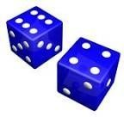
    - : The Kicking team lines 11 players on their own 30-yard line. May use dark and light jersey figures. 6.3.4: The receiving team lines up 11 players on their 50-yard line. May use dark and light jersey figures. 6.3.5: Two six-sided dice will be rolled a second time by the kicking team to determine ball placement. EXAMPLE: The initial Die roll was an 11 (successful onside). The second die roll show a "10"

MMFFBBCCSS RRuulleebbooookk 22002211/22
2233

    - : The kicking team will number their players 2-12 going left to right along their own 30-yard line.

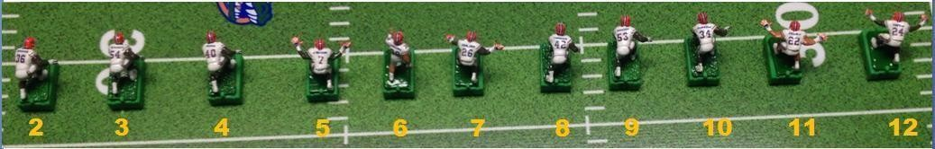
EXAMPLE: Kicking Team Numbering
SCENARIO: Based on the dice roll of "10" and the numbering of the kicking team 2-12, the ball on the string will be placed on the kicking teams' 41-yard line (11 yards, per the initial die roll of 11) with the ball in front of the figure identified as number "10" in the picture above.

    - : The kicking team will then have 5 seconds to aim any 3 figures at the ball.

    - : The receiving team will aim any 3 figures at the ball, in 5 seconds after the kicking team completes their adjustments identified in rule 6.3.6.

    - : The switch is then turned on for 3 seconds by a referee or by default the kicking team if a referee is unavailable. The first figure to touch the ball on the string will have assumed possession of the ball. In the event that the ball is not recovered after 3 seconds, the kicking team will have 5 seconds to pivot any unengaged player towards the football. The receiving team will then have 5 seconds to do likewise. Then the board is run for an additional 3 seconds.

    - : The switch will remain on until the ball carrier is tackled, scores, runs out of bounds or falls over.

    - : If the ball carrier is tacked and the ball carrier is knocked over, it is considered a fumble and the rules apply regarding fumbles in Section 9 of this rulebook.

    - : On onside kicks, both the Kicking & Receiving teams may use any player on their team.

- Extra points & Kicks
    - : Extra Point (1-Point Conversion): Each extra point kick will count as 1 point, after a touchdown is scored. The 1 point extra point must be kicked with the kicker, from the 20 yard line, unchallenged by the defense. The coach will have 20 seconds to attempt the kick, after declaring a 1 point try. If 20 seconds expire without a successful attempt, the extra point kick is no good. If the kick is no good, or if a team goes for a 2-point conversion that fails, their touchdown will only count as 6 points.

    - : Extra Point (2-Point Conversion): Two-point conversions are worth 2 points. Two-point conversions may be attempted after any touchdown. Following a touchdown, if the scoring team decides to go for a two- point conversion, they must line up at their opponents 5-yard line. The offensive team must score just as they do for any other touchdown for the conversion to be successful. If unsuccessful, only 6 points are awarded for the touchdown.

    - : Punts: Punts are automatic. If the punting team is Outside the 50-yard line the punt is 45 yards. If the punting team is Inside the 50-yard line is 35 yards. Any punt that lands inside the five-yard line is automatically placed on the 5-yard line to ensure the offense can line-up properly. If automatic punts distance lands the ball in the end zone the receiving team will take the ball on the 20-yard line as the punt is considered a touchback.

NOTE: Punting is an option, not a requirement. You may elect to go for it 4th down anywhere on the field and at any point in the game. Understand that you control your team’s destiny not the rules.

    - : Field Goals: As of the 2021/22 Season, Field Goals may now be attempted from the MAXIMUM of 69yds. This means the MAXIMUM LOS IS THE OPPOSITE 48YD LINE. FGs are worth 3 points and fakes are not allowed. The Kicking Team should make sure that a field goal device is within reach prior to declaring a Field Goal attempt.

    - : The following is the league approved sequence, particularly and specifically for end of Half situations.
      - "Field Goal" must be declared within 5-seconds of the conclusion of the previous play *and* a minimum of
5 OL on the LOS must be setup before time expires on the Game Clock.
      - If time expires before saying "Set" then no attempt can be made.
      - If the Kicking Team successfully sets up their 5 OL *and* says "Set" before time expires, the Kicker then will have 20-seconds to physically attempt the kick from *exactly* 7-yards from the LOS. They are allowed to move their players out of the way if they choose to do so, but the clock is running.
      - If the 20-second clock expires before the attempt, the ball is marked down at the spot of the kick.
        - If the unattempted kick occurred on 1st, 2nd or 3rd Down, the Kicking Team retains possession at that spot.
        - If the unattempted kick occurred on 4th Down, the defense gains possession of the ball.
      - The Game Clock does not stop until a score, change of possession or end of either Half occurs during the attempt.
      - Only subsequent FG attempts are allowed once FG is declared, obviously from 7yds further than the previous spot.
      - Should the new spot be out of field goal kicking range in accordance with the current league rulebook, the Kicking Team will lose possession regardless of Down, and possession is awarded to the defense at the new line of scrimmage.
      - In the event that less than 20 seconds are left on the game clock, the field goal kicking coach STILL HAS 20 seconds to kick his field goal; as long as he had previously placed his 5 men on the line of scrimmage.
        - Example: 00:05 seconds left in the first half, and coach calls a "field goal" and sets his 5 men on the line before the game clock expires. The 20 second kicking clock runs once he calls "field goal", so the coach will still have 15 seconds to kick his field goal AFTER the game clock has expired.
    - : The kick must clearly travel between the uprights and over the crossbar for the attempt to be successful; or hit the cutout above the crossbar.

    - : All Field Goal attempts will be kicked unopposed; only the Kicker and their 5 OL (unless moved) will be on the field.

    - : The board will be off during the kick unless using a Carl Coley automatic kicker where the board must be turned on for 1-second to activate the kicker.

- Missed kicks

    - : All missed kicks result in the defensive team obtaining possession of the ball automatically at the spot of the kick (7 yards behind LOS) unless that spot is less than 20 yards away from the defensive team's end zone. If that’s the case the defending team will start their possession at their own 20-yard line.

- Kickoffs for a Safety

    - : The kicking team will kick from their own 20, the receiving team will set 5 men on the kicking teams 30 yard line, the next wave of kick returners can be no closer than their own 40 yard line. The kickoff hang time will be 3 seconds. The return man will beset up at the 10-yard line.

- Overtime

7.0 - Overtime
    - : Overtime Coin toss: The winner of the coin toss has the choice of possession or to defer. The opposing team gets to choose which side the field they wish to play.

    - : Both teams must go in the same direction on offense.

    - : MFBCS overtime rules will mimic NCAA overtime rules with one exception. Each team will be given one possession opportunity per OT at the 25 yard line. The team on offense has a full possession and may gain one first down or more during that possession while attempting to score either a touchdown or field goal. After the second OT period if the game remains tied, both teams are required to attempt 2-point conversions after TD.

- Penalties

8.0 - Penalties
NOTE: Even if there is not a specific penalty listed, it does not mean it will not be called. Below are the
basics. An official can make other calls not listed so long as they are not contradictory to the format.

8.1.1: Unsportsmanlike Conduct: 15 yards from LOS + warning. Repeated acts will cause immediate disqualification of the offending coach. We are here for fun. Please behave accordingly.

8.2.1: Trash talking: Any attempt to humiliate or assault your opponent will not be tolerated. If the referee, after first warning a coach, feels that talk is excessive, he will call an unsportsmanlike conduct penalty and mark off fifteen yards. Repeated acts will cause immediate disqualification of the offending coach.

8.3.1: Abusive language: The goal of the League is to incorporate young people into the game of electric football. As men and women of this game, there is something to be said for a "clean mouth." Cursing will not be tolerated.

8.4.1: Arguing with the referee: A coach may dispute a call, but if he begins to get abusive toward the official, he will be flagged with an unsportsmanlike conduct penalty. If a second flag is thrown for this same offense (at the official’s discretion) then the violator will automatically forfeit the game.

8.5.1: Spectator Interference: Spectators not involved in a game may not argue with or taunt a referee during his/her duties of refereeing a game. If a spectator interferes with a referee, taunts the referee during the game or after, the spectator will be removed from the league facility and the league officials will conduct an inquiry into the member’s status within the league.

8.6.1: Offsides: 5 yards from LOS.

8.7.1: Delay of Game: 5 yards from LOS

8.8.1: Illegal Formation: 5 yards from LOS.

8.9.1: Illegal Receiver: 5 yards from LOS (Ball caught by ineligible receiver). Normally an Unengaged offensive
lineman.

8.10.1: Illegal Pivot: All illegally pivoted players will be removed from the board until that play is resolved. All pivots (after the play has begun) are to be made from the rear of the base using an approved spotting device, or with assistance of an official.

8.11.1: Illegal Forward Pass: 5 yards from LOS and loss of down.

8.12.1: Illegal Stacking: 5 yards from LOS, and repeat down.

- Fumbles

9.0 - Fumbles
9.1.1: A fumble occurs when the base of a defensive player makes direct contact with the base of the ball carrier that causes that player to fall over. Simply stated, the collision itself must cause the fumble.

9.2.1: The player is considered knocked over (fumbled) if none of the prongs (brushes) are in contact with the playing surface.

9.3.1: It does not matter if the player is leaning on another player, the determining factor shall be if there are no prongs (brushes) in contact with the playing surface.
9.4.1: Once a fumble is established, possession will be decided by a coin flip. The coach on Offense will flip the coin. Possession of the ball is awarded to offense with a Heads result and the defense with a Tails result..
Possession of the ball is kept at the spot of the fumble.
9.5.1: Should the ball carrier and the defender Both fall over during the attempted tackle/collision, it is a fumble and the offense keeps the ball at that spot.

- Broken Tackles

10.0 - Broken Tackles
    - : A broken tackle occurs when a defender falls down as a result of contact with the ball carrier. Simply stated, the collision itself must cause the tackler to fall down. The defender who fell during the tackle may not be placed upright and the play continues to its conclusion.

    - : If a broken tackle occurs, with the ball carrier knocking over the defender, that defender cannot make the tackle during any part of the continuing play by a subsequent touch.

- Fallen Players

11.0 - Fallen Players
Definition: Fallen players are players that have all prongs off the field. These players are considered fallen players and cannot make a tackle if they are still engaged with an offensive player (Pancaked). If unengaged and any part of the base comes into contact with the ballplayer, then it is considered a tackle.
11.1.1: All players must be set up on all prongs prior to the start of play. If a player is not upright at the start of the play he is not eligible and therefore removed from the field of play.

11.2.1: On pass plays and after the pass is completed, defensive players who have fallen may be placed upright to react to the ball carrier. Care should be taken, and markers used, so that the defender cannot be placed upright in a way to gain distance toward the ball carrier.

11.3.1: A fallen QB may still throw a forward pass as long as no contact has been made by a defender to the QB’s base or body which would result in a sack, and the board is turned off immediately after he falls.

11.4.1: On kick returns, both offense and defensive players that have fallen and are unengaged may be placed upright to block or react to the ball carrier.

- Duplicate Numbers

12.0 - Duplicate Numbers
    - : Duplicate numbered players are allowed but must never be on the field at the same time. This penalty only occurs after both coaches call set or after the play has started.
      - First Offense: 5-yard penalty from original line of scrimmage and loss of down.
      - Second Offense: Player Ejection: Opposing coach choice.

NOTE: It does not matter if the players were different from the first offense. The infraction is based upon player management (your actions).

- Forfeits/Stats

- Forfeits
    - : All games are to be played! Forfeiting a game for any reason beyond health or personal tragedy is to be discouraged.

    - : Coaches winning a forfeited game will receive a 7-0 final game score.
    - : If the trailing coach quits while on defense before the final 4 minutes of the game, the opposing coach will be awarded an additional 7 points.

    - : Penalties for Forfeits: On the first forfeit, the coach is ineligible for post season play, consideration of awards, and loss of voting privileges. Upon the second forfeit, the coach sustains a one year ban from the MFBCS and loss of rights to their existing team. Upon the third forfeit, the coach is banned permanently from the MFBCS. The above provisions are non-negotiable, to include the complete loss of dues.

13.1 – Stats
13.1.1: It is mandatory that stats are taken for all season and playoff games.

13.2.1: It is encouraged that an unbiased third party take stats during the game.

13.3.1: If an unbiased third party is unavailable to take stats during the game, then the defensive coach will always take the stats. This duty will rotate with every change of possession.

13.4.1: If an unbiased third party is unavailable to take stats during the game, then an additional 5 minutes of game time will be added to EACH half of the game. This means that each half will be 50 minutes, running clock.

13.5.1: The official stat sheet of the MFBCS will be used to take stats. The stat sheet can be found as Appendix 1 of the rulebook. Upon completion of the game, the stat sheet will be reviewed and signed by both coaches. Each conference may use an alternate stat sheet if they so choose.
13.6.1: At the conclusion of the game, the stat sheet will be forwarded to the Conference Commissioner. The commissioner will sign off on it, and enter the stats into the website database.

PAC - 12 Conference MFBCS

Game Date

Week #

Timeouts

1st Half 2nd Half
1 2 3 1 2 3

Defensive Statistics

Injuries

Legal Statistics Worksheet Ver 1.0
Team Names 1st
2nd 3rd 4th OT Final Time Scrambles 1st Half 2nd Half
1 |  |  |  |  |  |  |  |  |  |  | 2 | 1 | 2
1 |  |  |  |  |  |  |  |  |  |  | 2 | 1 | 2
1st Downs - Mark off one for each 1st Down Made Challenges 1st Half 2nd Half
1 2 3 | 4 5 | 6 7 8 9 | 10 | 11 | 12 13 14 15 16 | 17 18 19 20 21 22 23 |  |  |  | 1 | 2 | 1 | 2
1 2 3 | 4 5 | 6 7 8 9 | 10 | 11 | 12 13 14 15 16 | 17 18 19 20 21 22 23 |  |  |  | 1 | 2 | 1 | 2

Away Home
Game Official
1 2 3 1 2 3 Players Fumble Punts FG / PAT
# Tackles Sacks INT's Recv Blocked Blocked

Player No.

Time of Injury

Rushing Statistics Circle TDS
Mark "F" Next to Yardage for Fumble

Time Back In

Player 1 2 3 4 5 6 7
Player 1 2 3
4 5 6
Teams Kicking Statistics
XPA
Player No.

FGA
Time of Injury

Punt Yrds
XPA
Time Back In

FGA
Player No.

Quarterback
1 2
Incompl.
3 4 5 6
7 8 9 10 11 12 13
14 15
Punt Yrds
16 17 18 19
Time of Injury

Yards Sacks
Passing Statistics
Quarterback 1
2 3 4 5
INTS
6 7 8 9 10 11
12 13 14 15 16 17
18 19
Defensive Statistics Time Back In
Players Fumble Punts FG / PAT

Incompl. Yards Sacks
INTS
# Tackles Sacks INT's Recv Blocked Blocked
Player No.
Time of Injury

Receiving Statistics Circle TDS Mark "D" in Place of Yardage for Drops
Kick-Off Returns
Time Back In

Players # / Name 1 2 3
4 5 6
Players # / Name 1
2 3 4 5 6
Players # / Name 1 2 3 4 5 6 7
Total
Notes

Punt Returns
Players # / Name 1 2 3 4 5 6 7

Total

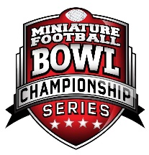

Penalty Yards

APPENDIX (1)

PAC - 12 Conference MFBCS
Standard Offensive Statistics Worksheet Ver 1.0
Team Names 1st 2nd 3rd 4th OT
Away Home
 | 1 | 2 | 3 | 1 | 2 | 3
 | 1 | 2 | 3 | 1 | 2 | 3
Scrambles 1st Half |  |  |  | 2nd Half
1 |  | 2 |  | 1 | 2
1 |  | 2 |  | 1 | 2
Challenges 1st Half |  |  |  | 2nd Half

Final

Game Date
Game
Time
Official

Week #
Timeouts
1st Half
2nd Half

1st Downs - Mark off one for each 1st Down Made
1 2 3 4 5 6 7 8 9 10 11 12 13 14 15 16 17 18 19 20 21 22 23 1 2 1 2
1 2 3 4 5 6 7 8 9 10 11 12 13 14 15 16 17 18 19 20 21 22 23 1 2 1 2

Rushing Statistics
Circle TDS
Mark "F" Next to Yardage

Player
1 2 3 4
5 6 7
Player
1 2 3 4 5 6
Teams

XPA FGA
FG Yards

Punt Yrds
Kicking Statistics

XPA FGA
FG Yards

Quarterback

1
Incompl.

2 3 4

5 6 7 8

9 10 11 12

13 14

Punt Yrds
15 16 17

18 19

Yards
Passing
Statistics

Sacks
Quarterback 1
Incompl.
2 3 4
5 6 7 8
9 10
INTS
11 12
13 14
15 16
17 18 19

Yards

Sacks
Receiving Statistics
Circle TDS
INTS
Mark "D" in Place of Yardage for Drops
Kick-Off Returns

Players # / Name
1 2 3 4
5 6 Players # / Name
1 2 3
4 5 6
Players # / Name 1 2 3 4 5 6 7
Total

Punt Returns
Players # / Name 1 2 3 4 5 6 7

Total

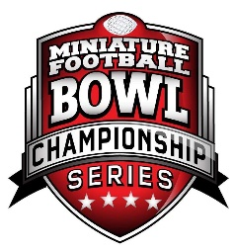

Penalty Yards

APPENDIX (1)

PAC - 12 Conference MFBCS
Standard Defensive Statistics Worksheet Ver 1.0
 |  | Defensive Statistics |  |  |  |  | 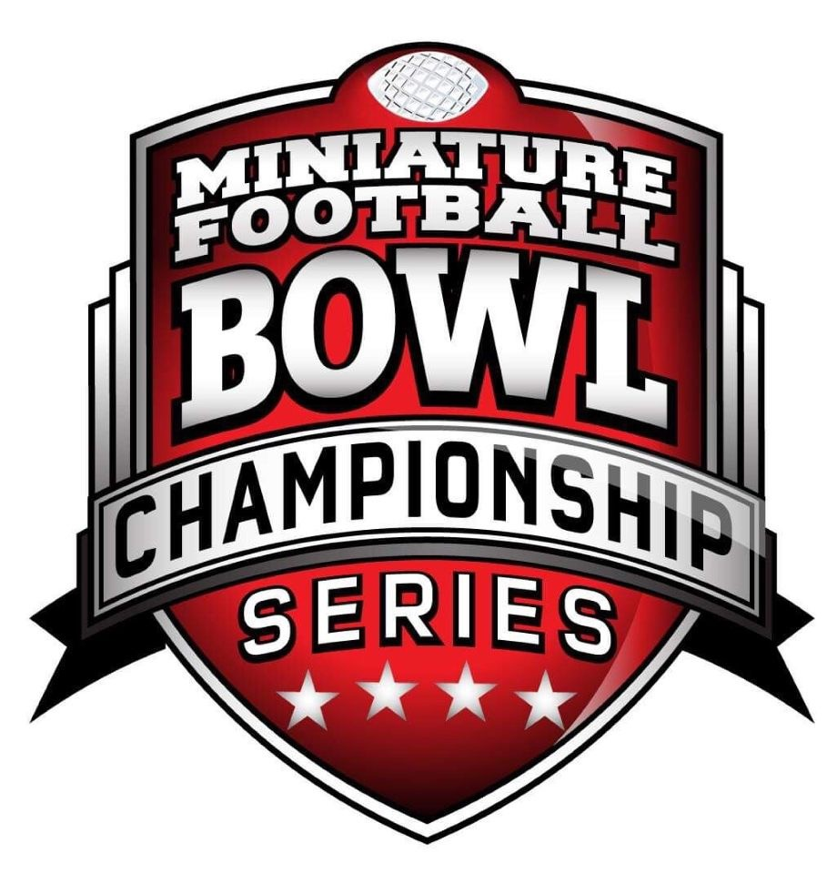 |  | Injuries
Players  # | Tackles | Sacks | INT's | Fumble Recv. | Punts Blocked FG/PAT Blocked
Player No.

Time of Injury

Time Back In
Player No.

Time of Injury

Time Back In
Player No.

Time of Injury

Time Back In
 |  | Defensive Statistics |  |  |  |  |  | Player No.  Time of Injury  Time Back In
Players  # | Tackles | Sacks | INT's | Fumble  Recv | Punts FG / PAT  Blocked Blocked |  |  | Player No.  Time of Injury  Time Back In

APPENDIX (1)

Figure Standards
(Appendix 2)
Weight:
Maximum allowable weight per individual figure with base attached is 4.0g. The Tournament of Champions (TOC) gives a latitude of .03g on a scale that measures out to hundredths of a gram, which we will allow. This means that on a scale that measures out to hundredths of a gram, the maximum allowable limit is 4.0g.

Figure Size:
The MFBCS utilizes the TOC Combine to measure figures height, width and depth. Figures cannot touch ANY of the “walls” of the Combine, while on a standard base.


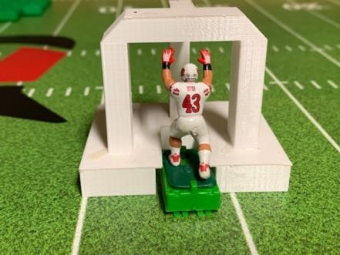

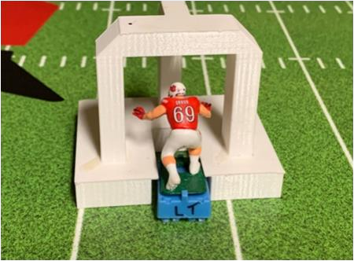

Maximum Figure Dimensions:
Height: 2 in. (51mm) This measurement is taken from the bottom of the base, to the highest point of the figure.
Width: 1 2/5 in. (36mm) This measurement is taken from fingertip to fingertip of outstretched arms.
Forward Reach: 5/16 in. (8mm) This measurement is taken from the point of the figure farthest forward out in front of the base, back to the front of the base.

Cover Corners – Any figure used to cover an eligible receiver:
Extended figures (forward) may not extend more than 5/16th of an inch (8mm) outside the figure's base, to include fitting in the Combine measuring device. The maximum distance the hands can be extended beyond its base is 5/16th inches (8mm). The maximum spacing width the hands can be spread apart from each other is 5/16th inches (8mm). This measurement is typically taken Thumb to Thumb. Defenders with wider spacing cannot be used as Cover Corners. These measurements can be determined using the Combine measuring device.

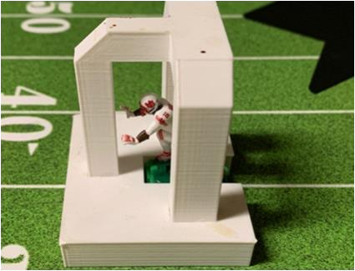

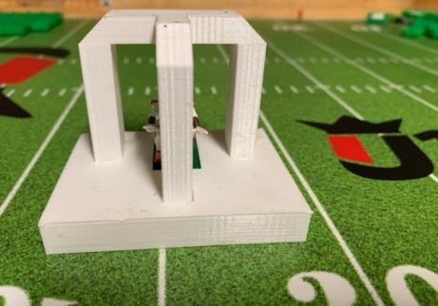

APPENDIX (2)

