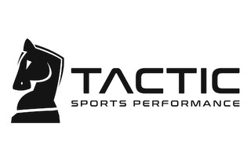

Glenview Stars Girls Off Ice Training & Nutrition Program

Tactic Sports Performance will proudly be running our 2018-19 off ice training program. With a training curriculum that will be geared specifically towards developing young hockey players, Tactic will focus on providing our girls with an age specific program that will focus on building strength, generating speed, and increasing endurance, in a fun, high intensive environment. Casey Tiesman, and his energetic staff of Professional Trainers, will also instruct and guide the girls on the importance of how rest and proper nutrition are essential to the overall development of an athlete.

Tactic Sports Performance
1886 Holste Rd
Northbrook
A few minutes away from Glenview Ice Center

Off Ice Training Sessions will take place on Thursday evenings starting on Thursday September 13th and will go thru February 28th

U10/U12 Girls – 5:00 – 6:00 pm
U14/U16 Girls – 6:00 – 7:00 pm

Note: Modifications to the schedules may be made during the course of the season, depending on pending team commitments and game schedules.

For any questions regarding Tactic or our training program, please visit http://tacticsp.com or contact Casey Tiesman @ 224-326-2367

Tactic will also offer a 20% discount on all additional training packages for the Stars organization and their family.

