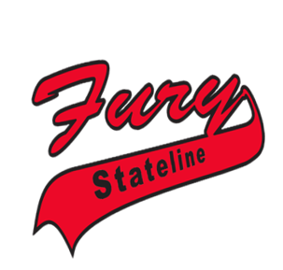

March 29, 2019

Dear Sponsor,

Thank you for taking the time to consider sponsoring our youth softball team. The Stateline Fury 13U is a travel softball team made up of girls from the surrounding Stateline area, and represents the Stateline Sports Group. Our team will compete in tournaments throughout Wisconsin, Illinois, Iowa and Indiana over the upcoming 2018/19 season, with the hope of playing for a National Championship this summer in Sacramento, CA.

It seems like every year, the cost of playing travel softball goes up, and this year is no different. On average, it will cost a family close to $2,500/player, plus the cost of family travel. It’s gotten to the point where traditional fundraising does not offset enough cost, and kids stop playing because their families can’t afford it.

Funds received from our sponsors help defray the cost of uniforms, equipment, tournaments, and training. Your support is greatly appreciated and instrumental in providing a healthy, constructive activity for our youth.

Any monetary donation would be greatly appreciated and would help our team tremendously in meeting our mission and goals. We would gladly accept donations of any denomination. Our sponsors are recognized in several ways, depending on their level of sponsorship:

* $500 - Sponsor’s company logo will be placed on our team banners (it will be the largest logo on the banners) and Stateline Fury website throughout the softball season; Sponsor will receive a will receive an appreciation plaque to hang on your wall honoring your business.
* $250 - Sponsor’s company logo will be placed on our team banner and Stateline Fury website throughout the softball season
* $150 - Sponsor will receive a thank you on our Stateline Fury website

Your **tax-deductible** donation and continuous support of our community will help make the 13U Fury softball team a success! Please make checks payable to Stateline Fury, and send to 7939 Burden Rd., Machesney Park, IL 61115.

**13U girls’ softball team**

Thank you in advance for supporting the Stateline Fury 13U Team and giving our girls a chance to play!!!

Mike Marszalec

Head Coach, Stateline Fury 13U Red

(815) 847-9345



7939 BURDEN RD • MACHESNEY PARK, IL 61115

PH: (815) 847-9345 • WWW.STATELINEFURY.COM



7939 BURDEN RD • MACHESNEY PARK, IL 61115

PH: (815) 847-9345 • WWW.STATELINEFURY.COM

Thanks again for your support,

Mike Marszalec

Company Name:

Address:

Phone:

Website:

Logo:

Sponsor Information:

Sponsorship Amount:

**13U girls’ softball team**